



United Nations Development Programme
Country: ARMENIA
PROJECT DOCUMENT

Project title: Building Armenia’s national transparency framework under Paris Agreement
Country: Republic of Armenia | Implementing Partner (GEF Executing Entity): Ministry of Environment |  |  | Execution Modality: NIM
Contributing Outcome (UNDAF/CPD, RPD, GPD): UNDAF Outcome 7: By 2020 Sustainable development principles and good practices for environmental sustainability resilience building, climate change adaptation and mitigation, and green economy are introduced and applied. UNDAF Agency Outcome 7.1: Number of innovative tools / approaches to promote environmental sustainability and resilience principles. CPAP Armenia Outcome 4.1 – Regulatory framework of social, environmental and economic sectors is updated to better address environmental sustainability and resilience principles.
UNDP Social and Environmental Screening Category:  Exempt from SESP (GEF-CBIT project). |  |  | UNDP Gender Marker: GEN2
Atlas Award ID: 00110252 |  |  | Atlas Project/Output ID: 00109279
UNDP-GEF PIMS ID number: 6332 |  |  | GEF Project ID number: 10138
LPAC meeting date: TBD
Latest possible date to submit to GEF: December 18, 2019 (submitted November 12, 2019)
Latest possible CEO endorsement date: April 18, 2020
Planned start date: September 2020 |  |  | Planned end date: August 2023
Expected date of posting of Mid-Term Review to ERC: N/A |  |  | Expected date of posting Terminal evaluation report to ERC: June 2023
Brief project description:
This project is in line with GEF-7 Program Objective CCM-3-8, “Foster enabling conditions for mainstreaming mitigation concerns into sustainable development strategies through capacity building initiative for transparency.” It follows from the commitments of the Government of Armenia under Paragraphs 7 to 10 of Article 13 of the Paris Agreement, which requires each Party to regularly provide a national inventory report, information necessary to track progress made in implementing and achieving its nationally determined contribution (NDC), information related to climate change impacts and adaptation, and information on support received. The project will provide support for building institutional and technical capacities to meet these enhanced transparency requirements as defined in Article 13 of the Paris Agreement. It will use a capacity strengthening approach to shift from ad hoc reporting to a continuous process of monitoring, reporting, and verification (MRV) that will capture transparency activities and allow the country to track its progress against its commitments under its NDC. The first project component will establish national institutional arrangements for an enhanced transparency framework, the second project component will introduce MRV systems that will support the enhanced transparency framework, and the third project component will provide capacity building for stakeholders that will be necessary to support transparency-related activities over time.
- Financing Plan
GEF Trust Fund |  |  | USD 990,000
- Total Budget administered by UNDP |  |  | USD 990,000
- confirmed co-financing
Ministry of Environment (in-kind) |  |  | USD 400,000
UNDP (in-kind) |  |  | USD 170,000
- Total confirmed co-financing |  |  | USD 570,000
- Grand-Total Project Financing (1)+(2) |  |  | USD 1,560,000
Signatures
Signature: Erik Grigoryan  Minister of the Environment of the Republic of Armenia |  | Agreed by Government Development Coordination Authority |  | Date/Month/Year:
Signature: Erik Grigoryan  Minister of the Environment of the Republic of Armenia |  | Agreed by Implementing Partner |  | Date/Month/Year:
Signature: Dmitry Mariyasin  Resident Representative in Armenia |  | Agreed by UNDP |  | Date/Month/Year:
Key GEF Project Cycle Milestones:
Project document signature: within 25 days of GEF CEO endorsement
First disbursement date: within 40 days of GEF CEO endorsement
Inception workshop date: within 60 days of GEF CEO endorsement
Operational closure: within 3 months of posting of TE to UNDP ERC
Financial closure: within 6 months of operational closure

Table of Contents
I. Table of Contents 3
II. Development Challenge 6
III. Strategy 8
IV. Results and Partnerships 10
V. Project Results Framework 22
VI. Monitoring and Evaluation (M&E) Plan 26
VII. Governance and Management Arrangements 29
VIII. Financial Planning and Management 33
IX. Total Budget and Work Plan 35
X. Legal Context 41
XI. Risk Management 42
XII. Mandatory Annexes 46
Annex 1: Project map 47
Annex 2: Multi Year Work Plan 48
Annex 3: Monitoring Plan: 51
Annex 4: Stakeholder Engagement Plan 57
Annex 5: UNDP Risk Log 68
Annex 6: Overview of Technical Consultancies 70
Annex 7: Terms of References 73
Annex 8: Gender Analysis and Gender Action Plan 81
Annex 8A: Gender Action Plan 87
Annex 9: Procurement Plan 89
Annex 10: Co-Financing Letters from the Ministry of Environment and UNDP 92
Annex 11: Theory of Change 94
Annex 12: GEF Core indicators 95
Annex 13: GEF 7 Taxonomy 96
Annex 14: Partners Capacity Assessment Tool and HACT assessment 107
Annex 15: UNDP Project Quality Assurance Report 155

List of Acronyms and Abbreviations

AFOLU Agriculture Forestry and Other Land Use
ArmCTCN Armenian Climate Technology Center and Network
Armstat Statistical Committee of the Republic of Armenia
BTR Biennial Transparency Report
BUR Biennial Update Report
CBIT Capacity Building Initiative for Transparency
CEPA Comprehensive and enhanced agreement between the European Union and the European Atomic Energy Community and their Member States, of the one part, and the Republic of Armenia, of the other part
E5P Eastern Europe Energy Efficiency and Environment Partnership
EaP Eastern Partnership
ETF Enhanced Transparency Framework
EU European Union
GDP Gross Domestic Product
GCF Green Climate Fund
GEF Global Environmental Facility
GEFSec Global Environmental Facility Secretariat
GHG Greenhouse Gas
ICA International Consultation and Analysis
INDC Intended Nationally Determined Contribution
IPPU Industrial Processes and Product Use
IRH [UNDP] Istanbul Regional Hub
LOA Letter of Agreement
MoU Memorandum of Understanding
MNP Ministry of Nature Protection (now the Ministry of Environment)
MSP Medium Sized Project
MRV Monitoring Reporting and Verification
NDC Nationally Determined Contribution
NEEAP National Energy Efficiency Action Plan
NTTF National Transparency Task Force
PIF Project Identification Form
PPG Project Preparation Grant
PIR Project Implementation Report
POPP Programme and Operations Policies and Procedures
RA Republic of Armenia
SECAP Sustainable Energy and Climate Action Plan
SSTrC South-South and Triangular Cooperation
STAP [GEF] Scientific and Technical Advisory Panel
QA/QC Quality Assurance / Quality Control
SREP Scaling Up Renewable Energy Program
TACCC Transparency, Accuracy, Completeness, Consistency, and Comparability
TNA Technology Needs Analysis
ToRs Terms of Reference
TRAC Target for Resource Assignment from the Core
UNDP GEF UNDP Global Environmental Finance Unit
UNFCCC United Nations Framework Convention on Climate Change
UNIDO United Nations Industrial Development Organization
USD United States Dollar

Development Challenge

Armenia is a small, mountainous, landlocked country located in the South Caucasus region of Eurasia with a population of approximately 2.9 million people. The country is exposed to numerous climate change-linked risks and impacts. Approximately 90% of the land is at least 1,000 m above sea level, with 40% higher than 2,000 m. A significant increase in temperature has been observed in recent decades. The annual average ambient air temperature increased by 0.40°C for the period of 1929-1996; by 0.85°C for the period of 1929-2007; and by 1.23°C for the period of 1929-2016.

A tendency towards decreased precipitation has also been observed: annual average precipitation has decreased by 6% for the period of 1935-1996, and by almost 9% for the period of 1935-2016. These climate trends have threatened Armenia’s water resources, which in turn pose a threat to sustainable development. Agriculture comprises approximately one fifth of the country’s GDP and 40% of total employment. However, between 2000 and 2005, climate-related agricultural losses cost Armenia USD 107 million. Armenia is also highly vulnerable to climate change in the energy sector: hydropower resources total around one third of the electricity generation mix.

Armenia ratified the United Nations Framework Convention on Climate Change (UNFCCC) in 1993, and the Paris Agreement within the UNFCCC in 2017. The Paris Agreement aims at strengthening the global response to the threat of climate change by keeping a global temperature rise below 2°C above pre-industrial levels and to pursue efforts to limit the temperature increase even further to 1.5°C. To this aim, the Paris Agreement requires all Parties to put forward their best efforts through nationally determined contributions (NDCs), while Article 13 of the agreement establishes an enhanced transparency framework in order to provide a clear understanding of climate change action through reporting on action and support received. The transparency framework shall build on and enhance the transparency arrangements under the Convention, including national communications, biennial update reports and international consultation and analysis. Paragraphs 7 to 10 of Article 13 require each Party to regularly provide a national inventory report, information necessary to track progress made in implementing and achieving its nationally determined contribution (NDC), information related to climate change impacts and adaptation, and information on support received. Article 13 also requires all Parties to establish institutions for ongoing monitoring.

At present, Armenia lacks the institutional arrangements and technical capacity to comply with enhanced transparency requirements. It also lacks a proper MRV infrastructure for assessing and reporting on mitigation and adaptation actions and policies and on support received. No formal arrangements are in place to ensure the maintenance of its GHG inventory on a continuous basis, and data collection and analysis for the inventory need strengthening. A more detailed description of barriers is presented in the baseline scenario in the following section. Taken as a whole, these barriers constrain the ability of the country to address climate change.

In order to comply with the Paris Agreement, Armenia must establish a functional transparency framework and gain the capacity to conduct transparency activities on an ongoing basis. If this objective is achieved, the country will do more than achieve compliance with Article 13: it will have the knowledge and capacity to take decisive steps to reduce vulnerability, undertake its ambitious strategic climate change goals, and pursue a path towards sustainability.

The project will improve the quality of reporting to the UNFCCC and is aligned with Armenia’s commitments to the Paris Agreement through setting appropriate formal arrangements and providing corresponding methodologies and tools to improve national GHG inventory, enhances tracking of progress in mitigation and adaptation actions and tracking of the strategies, policies and actions included in the (I)NDC.

BURs and NCs: The CBIT project is aligned with the needs and gaps provided in the first and second BURs, in the Third National Communication as well as identified by the ICA process of the BURs. The CBIT project is aimed to address these gaps and provide capacity building needs. Moreover, the approaches and sequence of steps for establishing MRV for mitigation measures described in the second BUR will be further elaborated and clarified.

(I)NDC: The proposed project will create the domestic monitoring system to assess the progress of implementation of the mitigation actions including the tracking of policy actions and will enhance the medium and long‐term climate change policy planning through better informing future decisions on how to best achieve Armenia’s climate change targets. The project clearly supports the NDC targets by improving the country’s ability to measure progress towards its mitigation targets, both in the preparatory phase and in subsequent phases. Furthermore, the project specifically supports the prioritization and assessment of adaptation measures as called for in the NDC.

Technology Needs Assessment (TNA): The CBIT project is aligned with recommendations for sustainable technologies under the TNA project. To ensure the mechanism of development and transfer of sustainable technologies in Armenia, it is required to further develop and strengthen the Armenian Climate Technology Center and Network (ArmCTCN), initiated under the GEF-funded "Technology Needs Assessment" (TNA) project, which is implemented by UN Environment and the UNEP DTU Partnership. The implementation of certain pilot projects for technology transfer, in parallel with the ongoing program, implemented by UNIDO Armenia and aimed at strengthening the ArmCTCN, will contribute to this aim as well.

The project is also consistent with national strategies and plans, and it will facilitate their successful implementation. The MRV systems and enhanced capacities established through this project will contribute to tracking the implementation of the National Energy Security Concept and the Scaling up Renewable Energy Program, which promotes, develops and invests in renewable energy as a means of achieving energy security. It will also support monitoring Armenia’s Sustainable Development Goals (SDGs) and its commitment under the Bonn Challenge of restoring 260,000 hectares of forest landscape.

Strategy

The goal of the project is to assist the country in mainstreaming and integration of climate change considerations into national and sectorial development policies by giving continuity to the institutional and technical capacity strengthening process, initiated and sustained by the UNFCCC reporting under the expanded transparency framework. The immediate objective of the project is to build institutional and technical capacities to meet enhanced transparency requirements as defined in Article 13 of the Paris Agreement.

The project approach is to shift from ad hoc reporting to a continuous process of MRV that will capture transparency activities and allow the country to track its progress against its commitments under its NDC. The first project component will establish national institutional arrangements for an enhanced transparency framework. The second project component will introduce MRV systems that will support the enhanced transparency framework, and the third project component will provide capacity building for stakeholders that will be necessary to support transparency-related activities over time.

The project is intended to achieve following five outcomes:
- Transparency activities in Armenia are governed by clear and formal roles and responsibilities;
- Armenia uses an integrated MRV system for continuous data collection and reporting under Article 13;
- Armenia is able to manage data for effective transparency reporting on GHG sources and sinks;
- Armenia is able to manage data for the framework for transparency of action and the framework for transparency of support under Article 13; and
- Armenia is able to track progress against its NDC and share its approaches and results at the international level.

The proposed CBIT project is essential to help Armenia meet enhanced transparency requirements and enhance its ability to implement the Paris Agreement. By establishing an effective framework for transparency of action, the country will be able to measure climate change mitigation more precisely, which ensures that its ambitious commitments to the Paris Agreement will be substantive and meaningful. By establishing an effective framework for transparency of support, the country will be able to identify successful mitigation and adaptation investments and to link support to national policy priorities in climate change more effectively. Both frameworks will also reduce overlap and duplication in climate change action, freeing resource for additional measures. Finally, support for gender mainstreaming and gender-disaggregated data in the project will provide decision-makers with a clearer picture of the differing impacts of climate change on women and men, ensuring that adaptation actions leverage this knowledge to provide optimal benefits.

A theory of change for the project, including assumptions, is provided in Annex 12 of this document. The project approach of supporting the transition to a permanent institutional framework for MRV and transparency has been selected as the most appropriate pathway to set and meet robust commitments to address climate change. The four components of the project, which support the legal/regulatory framework; the MRV system; supporting methodologies, tools, and training; and monitoring and evaluation and knowledge management, will provide the necessary elements of this framework.

The proposed project is directly aligned with GEF Focal Area CCM-3-8, “Foster enabling conditions for mainstreaming mitigation concerns into sustainable development strategies through capacity building initiative for transparency.” In addition, the project will directly support CCA-2, “Strengthen institutional and technical capacities for effective climate change adaptation” through Output 3.2.2.

Armenia has been making progress in implementing its reporting commitments under the UNFCCC, including the improvement of its GHG Inventory in terms of both completeness and accuracy, and in assessing long-term policy effects on GHG mitigation in the energy sector through scenario development. This progress has been possible due to ad hoc support for capacity building activities under each National Communication and more recently under the first and second BURs. However, the country still lacks the necessary institutional arrangements to formalize the process of continuous monitoring and reporting on climate change. Without an official, ongoing process for climate change MRV, it will not be possible to improve data availability and quality, nor will it be possible to generate the information necessary to inform climate-resilient policies and decision-making in Armenia. In the absence of this project, the government would be able to make limited improvements in narrow areas of its GHG inventory, and it would have a set of stand-alone national reports on climate change action on which to base its decisions. However, it would lack the formal arrangements necessary to establish a transparency framework, and its organizations and experts would not have sufficient tools and training to gather a holistic picture of mitigation and adaptation activities. Finally, it would be limited in the amount of information it could exchange with other parties to the Paris agreement, including tracking its progress towards its NDC, and it would not be able to adopt international good practice quickly. In summary, the country would not be able to participate meaningfully in the implementation of the Paris Agreement.

Results and Partnerships

Expected Results:

Component 1: National institutional arrangements for an enhanced transparency framework
Outcome 1.1 Transparency activities in Armenia are governed by clear and formal roles and responsibilities

This component will address institutional gaps and constraints resulted from the lack of the appropriate institutional arrangements in two ways: 1) the establishment of an MRV network enabling enhanced communication and engagement of key players to ensure sustainable operation of institutional arrangements; and 2) the formalization of data provision arrangements to ensure that continuous reporting will take place during and after project implementation.

Output 1.1.1: Institutional arrangements for a national transparency (MRV) framework are designed

This output focuses on the creation of a National Transparency Task Force (NTTF) for transparency-related activities. The NTTF will build on existing institutions, and it is proposed due to the need for a working-level, inter-agency group that will address MRV coordination on an ongoing basis, as opposed to the existing Inter-agency Council, which provides higher-level political guidance and oversight. Furthermore, to address the risks of overlooking mitigation actions or of double counting reductions, especially in the energy sector, this output will identify data providers and consider the roles and responsibilities of the relevant ministries and agencies involved. A clear institutional baseline will capture actions and support received to the greatest extent possible while avoiding double counting activities. Activities under this output will provide the information necessary to formulate institutional arrangements on data provision and reporting.

Proposed Activities
- Convene a National Transparency Task Force.
- Identify providers of data and information in the areas of mitigation actions, adaptation, and support received.
- Prepare a detailed institutional baseline for data provision on mitigation and adaptation actions covering all key sectors as well as on support received.
- Develop and share recommendations for data provision and reporting for Components 2 and 3 of the project.

Output 1.1.2: Legal and/or regulatory requirements for a national transparency framework are drafted and adopted

This output will result in proposed formal legal and/or regulatory arrangements between ministries and other data providers. Mandates for data collection and provision will result in data and information that are provided on a regular basis in the format needed for effective reporting. It is likely that the government will be able to use a Memorandum of Understanding (MoU) model for most data collection (as is the case of the energy balance) and for data sharing arrangements, although other legal and regulatory arrangements will be explored where necessary.

Proposed activities
- Draft formal arrangements for data provision for relevant ministries and other data providers identified within Output 1.1.1 in the areas of the GHG inventory, mitigation actions, adaptation, support received, and other necessary areas, taking gender-disaggregated data into consideration.
- Discuss and adopt the proposed formal arrangements.
- Update arrangements as necessary (e.g. pending anticipated guidance on enhanced transparency from the Paris Rulebook).

Component 2: MRV systems in support of an Enhanced Transparency Framework
Outcome 2.1: Armenia uses an integrated MRV system for continuous data collection and reporting under Article 13

This project component focuses on the technical element of the enhanced transparency framework. It is designed to produce a system that will allow experts to collect, analyze, and report on data and information under the framework for transparency of action and the framework for transparency of support. This component also supports the development of a technical means of sharing data and information at a national and international level in the form of an on-line portal.

Output 2.1.1: MRV system (hardware and software) with tracking tools designed and launched
This output will result in technical element of the MRV framework for Armenia taking into account the requirements of the Paris Agreement for an enhanced transparency framework including all of its component and considering national priorities and circumstances. The information system that underpins the MRV framework will use open source coding in order to ensure that it can be adapted easily over time.

Proposed activities
- Assess the baseline data provision that has been identified in climate change-related sectors in terms of the technical and system specifications for data exchange.
- Commission an information system that will allow for integrated data collection in all key transparency areas (inventories, mitigation, adaptation, and support received).
- Engineer interfaces for existing databases and institute data input protocols for data that are collected and stored off-line.
- Commission a user interface for the system that will allow for advanced data visualization, integration with GIS software, and publishing that conforms with international reporting templates (e.g. UNFCCC, International Energy Agency).
- Pilot the MRV system and make updates as needed.

Output 2.1.2: On-line portal to provide access to data and information established

While Output 2.1.1 focuses on a system to collect and report data under UNFCCC and Paris Agreement commitments, Output 2.1.2 focuses on sharing information with the public and with other parties to the Convention. Activities under this output will result in the design of a web portal that will provide public access to climate change reporting and information from Armenia. The portal that is developed under this output will provide information in key languages, and it will provide climate-change-related news and information in addition to key national reports. Under this output, the project will assess existing websites as potential hosts for the on-line portal, keeping in mind that the new portal should avoid duplication and should be managed in a way that can be maintained following the conclusion of the project. The primary output – the on-line portal – will be operated and maintained through activities under Output 3.3.2.

Proposed activities
- Commission a website to serve as an on-line portal for transparency initiatives (MRV, BUR, NC, NDC, GHG inventory, and from 2024, Biennial Transparency Reports, or BTRs).
- Engineer a system interface with the national MRV system to provide accessibility to data and reports.

Component 3: Capacity building to support transparency-related activities over time

The third component of the project focuses on the provision of tools, training, and assistance for meeting the provisions stipulated in Article 13 of the Agreement and expanded information sharing among parties to the Paris Agreement. This component will ensure that Armenian experts have the capacity to use the MRV framework that is established and to communicate their transparency activities. The provision of tools, training, and assistance will focus on three areas: 1) Improvements in the GHG inventory; 2) Improvements in the frameworks for transparency of action and support; and 3) International information and knowledge exchange. The project will work to achieve equal participation by women in training and capacity strengthening activities, and it will develop guidance on mainstreaming gender considerations into the three areas listed above.

Outcome 3.1: Armenia is able to manage data for effective transparency reporting on GHG sources and sinks
In 2017, the International Consultation and Analysis (ICA) process for the first BUR was carried out. The capacity building needs identified within that process will be addressed with the help of this CBIT project, which will result in substantial improvements in the quality of GHG inventory. Training and capacity strengthening activities will involve focal points in line ministries, other data providers, and key experts. These activities will strengthen capacity to report under the UNFCCC at present (through National Communications and BURs), but they will also keep in mind and follow the development of guidance regarding reporting after 2022; specifically, on the format of the Biennial Transparency Report that all parties to the Paris Agreement must submit no later than December 31, 2024.

Output 3.1.1: Sectoral templates and consistency guidelines on data collection and reporting are developed for the GHG inventory

This output will cover general training for data providers on the MRV system developed under Component 2. Activities under this output will be coordinated closely with work conducted under other project components to ensure that the templates and consistency guidelines are incorporated into the technical specifications of the MRV information system and the formal arrangements with data providers. Templates and training will be based on the use of IPCC 2006 Good Practice Guidelines as specified in the modalities, procedures, and guidelines (MPGs) of the “Paris Rulebook,” and they will take the 2019 IPCC modification of these guidelines into account where relevant.

Proposed activities
- Produce sectoral templates for reporting.
- Draft consistency guidelines for data provision.
- Conduct a training assessment for data providers.
- Develop and carry out training for data providers on the templates and guidelines.
- Maintain training documentation for project stakeholders.

Output 3.1.2: Sectoral emissions estimates are strengthened for selected sectors and sources

This output will allow Armenia to address capacity needs related to specific aspects of the GHG inventory identified in the course of the ICA. While the GEF-funded Enabling Activity will support the improvement of GHG inventory analysis through conducting key category analysis – trend assessment, the CBIT project will support refining estimates of emissions from the Agriculture Forestry and Land Use (AFOLU) sector where data on firewood and manure burned, which are obtained from different data providers, differ to a great extent. The project will also improve the estimates of emissions from the AFOLU sector with the special attention to the Lands and Aggregate sources and non-CO₂ emission sources from land categories. Improvements will address both the quality of activity data in terms of their completeness and accuracy and the application of higher-tier methods for key categories. Specifically, the project will support moving from Tier 1 to Tier 2 for N₂0 (3C4) Direct Emissions and (3C5) Indirect Emissions from managed soils.

In addition, the project will provide training and support for MRV measures in the forestry sector related to afforestation in order to strengthen emissions estimates and track commitments under the Bonn Challenge. Finally, the CBIT project will also support improving the accuracy and completeness of F-gases emissions estimates through elaborating procedures for the collection of activity data on F-gases consumption in the country.

Proposed activities
- Review AFOLU emissions estimates and draft recommendations for improving the estimates based on international good practice.
- Identify relevant experts in the AFOLU sector and provide training in approaches for estimates of firewood and manure burned.
- Commission peer review of the new estimates by an international expert.
- Provide support for MRV planning, training, and improved activity data collection in the forestry sector, including land cover data relevant to the Bonn Challenge.
- Draft recommendations on improving collection of the activity data on F-gases based on international good practice.
- Identify relevant experts and provide training.
- Commission peer review of the new estimates by an international expert.

Output 3.1.3: Analysis of the GHG inventory is enhanced

This output is designed to put measures into place that will improve the GHG inventory management system according to the TACCC principles. These activities will also address capacity needs identified by the ICA, and they will move the compilation of GHG inventories to a continuous process, rather than a project-by-project initiative.

Proposed activities
- Prepare detailed guidelines for the uncertainty assessment for key sources.
- Develop QA/QC procedures for all sectors of GHG inventory.
- Develop and conduct trainings for GHG inventory experts and data providers that cover the new procedures and guidelines.
- Archive procedures in the form of detailed documentation.

Outcome 3.2: Armenia is able to collect and process data for the framework for transparency of action and the framework for transparency of support under Article 13

The training and capacity strengthening activities included in this part of the project will allow project stakeholders to collect and analyze data related to climate change mitigation, adaptation, and support received that will form the core of the information system developed under Component 2.

Output 3.2.1: Sectoral templates and guidelines for assessing and reporting on mitigation policies and actions and their effects developed and related training provided

Mitigation-related reporting activities under this project will start by focusing on the energy sector because of its strategic importance, its dominant role in GHG emissions (approximately 70% of total GHG emissions), and the fact that it has the highest mitigation potential. Activities under this output will develop a common approach for assessing GHG emissions reductions from mitigation measures in the energy sector. Reporting templates will be differentiated depending on the nature of the mitigation action. It will also provide training that will allow data providers to produce and report the necessary data on implemented, adopted and planned mitigation policies and measures in a transparent, accurate, complete, consistent and comparable manner.

Proposed activities
- Develop sectoral templates and guidelines for assessing and reporting on mitigation policies and actions and their effects.
- Propose a common approach for assessing GHG emissions reductions from mitigation measures in the energy sector.
- Provide trainings to stakeholders on the common approach.
- Develop and define methodologies and assumptions for estimating GHG impacts of mitigation actions in other selected sectors.
- Provide training and ongoing capacity strengthening for data providers in those sectors.

Output 3.2.2: Methodologies for assessing and prioritizing adaptation actions, policies and their effects identified and applied

This output will contribute to building awareness regarding the importance of adaptation considerations in all sectors of economy It will also help decision-makers and experts to understand adverse impacts in the absence of adaptation measures and how those impacts may affect men and women differently. The methodologies developed under this output will support the assessment of the impact of policies and their effects, including cost-benefit analysis and impact assessment, with a gender sensitive approach. Project experts will coordinate closely with the experts assigned to produce the National Adaptation Plan when they are appointed.

Proposed activities
- Identify and agree upon methodologies for assessing the impact of adaptation actions and policies in Armenia.
- Conduct a cost-benefit analysis of key adaptation actions, using a gender-sensitive approach.
- Provide training experts and policy-makers in the area of adaptation.
- Update guidance on adaptation reporting and provide supplementary training as needed.

Output 3.2.3: Methodology for reporting on support received developed and related training provided

This output will adopt guidelines on reporting support received for climate change mitigation and adaptation activities and will improve coordination on reporting from various sources. Different agencies, local governments, the private sector, and NGOs currently receive support for climate related activities. These efforts are not coordinated, and therefore not all of them can be captured. While compiling the BURs, the project team used mitigation-related finance information collected by the OECD, project-level data gained from publicly available sources (project documents, reports, country program snapshots), and information received from implementing/financing entities in response to a Ministry of Environment inquiry.

Project experts will focus on reporting methods that are consistent and relatively easy to use to ensure support received to the greatest extent possible. Experts who will draft guidance under this output will look carefully at approaches to reporting that are currently being developed in other developing country parties.

Proposed activities
- Review, discuss, and approve appropriate templates and guidelines for reporting on support received.
- Develop a plan for collecting information on support received.
- Provide training for data/information providers as needed.

Output 3.2.4: Gender issues mainstreamed into transparency activities

The CBIT project represents an opportunity to mainstream gender issues into participation in project activities, the kinds of data and information that are collected, and the way in which they are used. This output will allow for a coordinated overview of gender mainstreaming in all project activities.

Proposed activities
- Provide recommendations on institutional arrangements and the MRV information system that will maximize the consideration of gender in transparency activities.
- Provide training and ongoing capacity strengthening for data providers and project experts on gender considerations in data collection and analysis.
- Develop and implement a plan that will support equal opportunities for women in project training and capacity strengthening activities.
- Summarize findings on gender and climate reporting in a publication and make that information available on the on-line portal developed under Output 2.1.2.

Outcome 3.3: Armenia is able to track progress against its NDC and share its approaches

The associated outputs focus on knowledge capture and exchange. The NDC is the primary summary of Armenia’s stated contribution to the Paris Agreement, and a tracking tool on the on-line portal will allow different in-country stakeholders and the public to understand the progress that is being made in climate change action. Participation in global on-line portals and workshops will bring two benefits: 1) It will allow experts in Armenia to identify best practice in MRV and avoid having to re-invent or duplicate guidance and tools; and 2) It will allow experts in Armenia to share effective approaches and methodologies generated by the project with other parties to the Paris Agreement.

Output 3.3.1: Progress against the NDC tracked

This output will enable Armenia to measure its progress towards the goals in its NDC. It will also coordinate closely with in-country efforts to develop a roadmap for NDC implementation.

Proposed activities
- Develop recommendations on tracking progress towards the NDC.
- Conduct an annual briefing for decision-makers on progress towards the NDC.
- Publish progress towards the NDC on the on-line information portal established in Output 2.1.2.

Output 3.3.2: On-line portal for transparency initiatives maintained and knowledge shared

This output will support the operations and maintenance of the on-line portal that is designed and established under Output 2.1.2. Activities will focus on maintaining timely content and all key climate change information and reports from Armenia as they become available. This output will also take steps to ensure that the operation of the web portal will continue even after the proposed project finishes.

Proposed activities
- Launch on-line portal for transparency initiatives and publicize its resources.
- Maintain and update the portal as new reports and relevant content are published.
- Develop a post-project management plan for the on-line portal.

Component 4: Monitoring and Evaluation and Knowledge Management

Component 4 includes both standard M&E activities and the capture and sharing of project knowledge for use at the national, regional, and global level. Knowledge capture and sharing will take place throughout the project.

Output 4.1.1: Project results and outcomes monitored and evaluated

This output focuses on standard GEF and UNDP M&E activities, which are described in detail in Section VI.

Proposed activities
- Conduct inception workshop and confirm project baseline and indicators
- Monitor project implementation and results as they affect both women and men on an ongoing basis
- Conduct an annual financial audit of the project
- Present project status and lessons learned to the Project Manager and Project Steering Committee and to the GEF in the form of a Project Implementation Report (PIR) annually in order to inform management decision-making.
- Conduct an independent terminal evaluation approximately three months prior to the completion of project.
- Prepare and submit a final report to UNDP and the implementing partner.

Output 4.1.2: Lessons learned and best practices shared with other Parties through the Global Coordination Platform and other cooperation networks

This output will support knowledge management to capture, document, and share the broad variety of data, information, and knowledge generated by project activities. It will also enable Armenia to contribute and be an active partner of the CBIT Global Coordination Platform, by exchanging information with other countries as well as actively participating in CBIT workshops. Sharing lessons learned and experiences through the global platform will ensure that Armenia’s CBIT project is aligned with other national, regional and global transparency initiatives.

Proposed activities
- Capture lessons learned from the project throughout implementation.
- Share templates, lessons learned, and best practices with all relevant stakeholders in Armenia.
- Share templates, lessons learned, and best practices with other Parties through the Global Coordination Platform and other regional and global cooperation networks.
- Participate in selected CBIT regional and global workshops.

Partnerships:

There are a number of projects and other initiatives in Armenia currently under implementation or in the approval process that could provide synergies with the proposed CBIT project. The most relevant projects are as follows:
GEF Projects
- “Development of Armenia’s Fourth National Communication to the UNFCCC and Second Biennial Report” (GEF ID 9474). The CBIT will work closely with this ongoing GEF Enabling Activity, which is scheduled to run from 2016 to 2020. Project activities will complement those of the proposed project, and a summary of how capacity strengthening will be addressed across the two projects is provided in Section II.1a.
- “Mainstreaming Sustainable Land and Forest Management in Mountain Landscapes of North-Eastern Armenia” (GEF ID 5353). This project, which is implemented by UNDP, started in 2016. It supports carbon stock assessment and development of country-specific coefficients for the main types of forests as part of a long-term strategy for the establishment of a carbon stock monitoring system in the country. The CBIT project will cooperate with this project to improve the Forestry sector GHG Inventory, and it will complement this project’s activities by providing capacity-building on GHG inventories in the Forestry sector.
- “Sustainable Land Management for Increased Productivity in Armenia” (GEF ID 8005). This project, which is scheduled to run from 2016 to 2022, is implemented by the International Fund for Agricultural Development (IFAD) and focuses on enhancing the overall resilience of rural communities living in risk-prone areas of Armenia. The proposed project will communicate with this project on its activities supporting climate-resilient agricultural management systems and integrated water management under reporting on adaptation measures.
Other Donor-Supported Projects
- ”Scaling up Renewable Energy Programme (SREP).” This project identifies renewable energy technologies and projects that can best contribute to Armenia’s goals in the areas of energy, economic development, and environment. It also outlines the activities that must be carried out for the realization of the projects. The investment priorities have been identified according to the economically viable projects in following order: geothermal power, utility-scale solar PV, geothermal heat pumps and solar-thermal. The CBIT project will provide capacity-building and guidelines to the relevant technical specialists involved in the reporting on mitigation actions effect assessment to formalize the relationship with these projects and improve reporting on mitigation action as a part of the MRV.
- “De-risking and Scaling-up Investment in Energy Efficient Building Retrofits” funded by the Green Climate Fund (GCF). The project started in 2017. It is designed to facilitate the sustainable reduction of energy consumption and greenhouse gases emissions from the existing buildings in Armenia. The Project will support in setting up the MRV system for building sector including development of the guidelines and monitoring methodologies. The CBIT project will coordinate the efforts with this initiative to obtain clear understanding and specifics on MRV system for building sector which will complement the tracking of building sector’s mitigation initiatives in the planned transparency framework.
- Energy-efficiency lending facilities. The CBIT project will cooperate with GGF within the framework of an on-going program implemented through Armenia’s commercial banks aimed at boosting EE financing in Armenia (a USD 24.4 million loan facility) and the Caucasus Sustainable Energy Finance Facility, branded as Energocredit (a USD 21.5 million loan facility). These loan facilities provide loans to private entities and individuals for EE improvements and/or small renewable energy projects. The CBIT project will provide capacity-building and guidelines to the relevant technical specialists involved in assessing climate change mitigation in order to formalize the relationship with these projects and improve reporting on mitigation actions under the enhanced transparency framework on action.
- Covenant of Mayors. In Armenia, 24 cities, including the capital of Yerevan as well as second and third biggest cities of Gyumri and Vanadzor, have joined the EC Covenant of Mayors, and 11 of them have developed action plans, including 10 Sustainable Energy Action Plans (SEAP) and 1 Sustainable Energy and Climate Action Plan (SECAP). Covenant signatories that joined the Initiative before 2016 voluntarily commit to implement actions aimed at climate change mitigation (reduction of GHG emission by at least 20% by 2020), while cities that joined the Covenant after 2016 have to ensure GHG emission reduction by at least 30% by 2030 and improve climate change resilience by assessing climatic risks and proposed adaptation measures. The European Commission “CoM East” project, which was launched in 2011, has been providing technical and expert support to signatories of the Covenant in the Eastern Partnership (EaP) region. One of the key tasks of the project is to ensure that their emission reductions are monitored and reported properly via the online reporting platform of the Covenant in the context of other transparency activities.
- “Sustainable management of pastures and forest in Armenia to demonstrate climate change mitigation and adaptation benefits and dividends for local communities.” This pilot project, which is implemented through the EU-funded ClimaEast initiative, is supported by EUR 1 million from the EU and USD 100,000 from UNDP. The objectives of the project include reducing carbon emissions by introducing sustainable farming practices and building adaptive capacity in local communities to climate changed-related risks. The proposed CBIT project will communicate with this pilot project on assessing and reporting adaptation benefits.
- The Eastern Europe Energy Efficiency and Environment Partnership (E5P). This partnership consists of Eastern Partnership countries, the European Commission, bilateral donors, and multilateral development banks, and it envisages EUR 20 million in grant financing to implement high-priority energy efficiency projects. The project will communicate with the E5P in Armenia and share guidance on assessing and reporting the GHG mitigation effects of energy efficiency projects there.
- EU4Climate. This European Commission-funded project implemented by UNDP also focuses on Eastern Partnership Countries. The project will run from 2019 to 2022, and it has a total budget of EUR 8 million for the six participating countries. The EU4Climate project will complement this project, as it can provide support for the development and revision of NDCs, while this GEF-CBIT project will provide support for tracking progress of the NDCs. The projects will communicate on an ongoing basis regarding legislative and regulatory support to the Government of Armenia on climate-related matters, including the EU4Climate’s activities on adaptation planning. Finally, this project will use information and analysis developed under the EU4Climate’s planned work with the European Institute on Gender Equality.
- The National Adaptation Plan and Programming Project, which is funded under the GCF Readiness programme implemented by UNDP, focuses on supporting the Government of Armenia to advance medium and long-term adaptation planning. The Project will run from 2019-2022 and will complement this Project in the area of MRV system capacity building aimed at the effective integration of climate change adaptation into national and sectorial planning and management.

Government Initiatives
- The Energy Balance. Close cooperation with the Ministry of Territorial Development and Infrastructure (the former Ministry of Energy Infrastructures and Natural Resources has been merged with the Ministry of Territorial Development and Administration) and Statistics Committee which are responsible for the development and publication of the RA Energy Balance on annual basis. In 2017 and 2018, the Statistics Committee published the Energy Balance of Armenia for 2015 and 2016, correspondingly. The CBIT project will cooperate with the team in charge of the energy balance preparation to ensure QA/QC of data applied in Energy Balance thus contributing to the improvement and sustainability of Energy sector GHG Inventory.
- The National Energy Efficiency Action Plan (NEEAP -- Phase II). The project will cooperate with the Ministry of Territorial Development and Infrastructure which is responsible for tracking progress in implementation of Phase II of the NEEAP and development of the Phase III of the NEEAP. The CBIT project will develop appropriate templates for collecting data on EE measures and provide capacity-building and guidelines to the relevant technical specialists to ensure the provision of information in a complete, transparent and comparable manner.

Risks:

Table 1 below provides an overview of project risks and the proposed steps to mitigate them during project implementation. A detailed project risk log is provided in Annex 5.

Table 1: Overview of Project-related Risks

Risk | Type of Risk | Level of Risk | Mitigation Alternative
Political Will: High level political support is essential to ensure an active involvement of the relevant ministries in the design, setting and proper operation of the MRV framework. There is a risk of insufficient government support for the establishment of the MRV framework. | Political | L | The fact that the RA Government Decision states that the MRV system shall be established and the Ministry of Environment is responsible for coordination of that process provides a strong motivation. The formal arrangements that will be developed and proposed within the project shall be validated by the highest officials. This step will allow the government to enforce arrangements regarding ministries and other data providers to produce and report the necessary data in the required time and manner.
Critical legislation or regulatory elements supporting the MRV framework fail to be adopted: If data providers are not required to deliver data on an ongoing basis and to monitor their activities, these activities will not take place. | Regulatory | L-M | Component 1 of the project will focus on using the model of a Memorandum of Understanding (MoU), which does not require legislation and has worked successfully in gathering data from different providers for the Energy Balance.
Staff turnover: Considering that the CBIT project includes targeted capacity building, there is a risk of losing the capacity and skills acquired due to staff turnover. | Organiza-tional | L-M | Capacity strengthening activities will involve a carefully selected group of relevant experts within each ministry and agency to ensure that capacity can be retained, and succession planning will be discussed as a part of training. Guidelines and methodologies will be produced in written format, and the MRV system and operating procedures will be documented extensively, which will also contribute to retaining institutional memory.
Coordination: Lack of proper coordination among institutions involved in the implementation of mitigation measures will limit the ability of the transparency framework to measure and report on mitigation. Because different government organizations work independently, the project may not be able to identify all of the necessary data providers. | Organiza-tional | M | The use of the Inter-agency Council (which must be reorganized due to changes in the structure of the Government that were made in June 2019) for coordination among government agencies and the introduction of clearly-defined reporting obligations and data providers that are binding will ensure the engagement of key players and reduce the risk of overlap.

Stakeholder engagement plan:

A summary of stakeholder involvement in the project to date and the stakeholder engagement plan for the project is provided in Annex 4. A summary of the stakeholder validation workshop and a list of participants is provided in Annexes 4A and 4B, respectively.

Gender Equality and Women’s Empowerment:

The project “Building institutional and technical capacities to enhance transparency in the framework of the Paris Agreement in Armenia” will be a meaningful entry point for training, awareness-raising and capacity-building efforts to ensure women’s equal engagement in and benefit from climate change actions. It will help to understand how both men and women are involved in managing their environments, and it will clarify the overall picture of the effects of climate change on different groups of citizens, increasing transparency.

A survey of Armenia’s reporting to the UNFCCC and its NDCs found the following:
- The most recent National Communication submitted does not mention gender issues related to climate change.
- The most recent Biennial Update Report does not mention gender issues related to climate change.
- Armenia’s NDC does not explicitly mention women or gender issues related to its contribution.

Output 3.2.4 of the proposed project (“Gender issues mainstreamed into transparency activities”) will ensure that gender issues are taken into consideration in all project activities and into subsequent national reporting under the UNFCCC and the Paris Agreement. Gender will also be addressed in each of the project components: the project will monitor the participation of women in the institutional arrangements surrounding transparency arrangements (Component 1); it will ensure the collection of gender-disaggregated data where necessary (Component 2); it will monitor the differentiated effects of climate impacts, mitigation and adaptation activities, and support received for those activities on women and men (Component 2); and it will exchange information and knowledge on good practice in gender mainstreaming with other parties to the Paris Agreement (Component 3).

In terms of overall project approach, the project is aligned with the UNDP in Armenia 2016-2020 Gender Equality Strategy. The project will leverage UNDP Armenia’s experience as a country office that has received the UNDP Gender Equality Seal after undergoing a corporate certification process. The project team will utilize the country office gender focal point where relevant and will align project communications and outreach with the country office approach to gender mainstreaming in its communications policy, including the use of guidelines on gender-neutral language.

Gender is also seen as a key component of the project’s holistic approach for results-based management, and it will be addressed throughout the project cycle in the following way:

- The project will monitor the share of women and men who are direct project beneficiaries, and it will also monitor the nature of these benefits.
- Four of the project’s outcome indicators measure gender considerations directly.
- Gender-sensitive targets and activities will be monitored in project reporting, both in annual reports and PIRs and in the terminal evaluation.
- A national gender consultant will provide support to gender-related activities and M&E.
- The project will take into account the Gender Responsive National Communications Toolkit developed by the Global Support Programme through UNDP and in collaboration with UNEP and GEF, including the planned updated version of the toolkit.

The project includes gender-responsive measures to address gender gaps or promote gender equality and women’s empowerment. The project is expected to contribute to gender equality in the area of improving women’s participation and decision making. The project's results framework includes gender-responsive indicators. The Atlas gender marker for this project is 2. An initial gender analysis and gender action plan are provided in Annex 8 and Annex 8A, respectively.

South-South and Triangular Cooperation (SSTrC): Learning opportunities and technology transfer from peer countries will be further explored during project implementation. To present opportunities for replication in other countries, the project will codify good practices and facilitate dissemination through global ongoing South-South and global platforms, such as the CBIT Global Platform, the UN South-South Galaxy knowledge sharing platform, and PANORAMA.

In addition, to bring the voice of Armenia to global and regional fora, the project will explore opportunities for meaningful participation in specific events where UNDP could support engagement with the global development discourse on transparency-related issues. The project will furthermore provide opportunities for regional cooperation with countries that are implementing CBIT initiatives in geopolitical, social and environmental contexts relevant to the proposed project in Armenia. The user-friendly on-line portal that is developed under Component 2 of the project will enhance general awareness on transparency initiatives and to make climate change-related data and information accessible for south-south learning among many different kinds of stakeholders. Under Component 3, methodologies, guidance and training will be carefully documented, and lessons learned will be captured and shared with other developing country parties to the Paris Agreement. Progress against the NDC targets will also be assessed and shared with people in Armenia and with all other countries in the agreement.

Innovativeness, Sustainability and Potential for Scaling Up:

Innovativeness: The project represents a series of significant innovations in Armenia. Under Component 1, the project will introduce technical working groups in the form of the National Transparency Task Force, which will allow for more flexible and responsive inter-agency cooperation on climate change MRV. Under Component 2, the project, will establish formal, continuous arrangements for climate change MRV in the country.
Under Component 3, the project will also undertake the new step of working with different stakeholders to include community-level mitigation activities under the Covenant of Mayors in overall reporting on climate action. It will also undertake the new step of working with different stakeholders to include community-level mitigation activities under the Covenant of Mayors in overall reporting on climate action for the NDC under Outcome 3.3. The widespread nature of the CoM program (more than 18 municipalities in Armenia have signed the CoM, and 8 of them have submitted a Sustainable Energy Action Plan (SEAP)) means that it should be possible to consider reporting by cities as good practice in MRV in participating municipalities in Armenia. In the capital city, Yerevan, the SEAP was developed with support of UNDP, and the city is an Implementing Partner in the UNDP-GCF project on scaling energy efficiency in the building sector, which has a component on MRV. The CBIT project will encourage a two-way exchange of information with cities participating in the CoM program. From their side, the participating cities will share good practices and support tools from the CoM network regarding MRV with the CBIT project. The project, in turn, will share guidance and findings from its networks (e.g. the CBIT Global Platform) with the CoM cities. This cooperation may also extend to MRV related to adaptation activities, as the CoM has developed an adaptation support tool for its participating cities. Armenia can serve as an important source of experience for other countries on monitoring SEAPs, particularly those participating in the European Union’s European Neighborhood Instrument—East, and the project will encourage the participating cities to share innovations in the CoM international good practice database. Furthermore, the approaches that will be designed under the project to address a lack of data in certain sectors and for certain sources represent innovative methods that may be highly relevant to other countries in the same global sub-region.

Finally, activities under several components and the gender plan provided in Annex 9A will mainstream gender into national reporting and NDC tracking. Finally , the approaches designed under this project to address the lack of data in certain sectors and for certain sources will represent innovative methods that may be highly relevant to other countries in the same global sub-region.

Sustainability: The project will ensure sustainability in several ways. In the area of institutional sustainability, the project will build upon existing institutions and bodies, such as the Inter-agency Council, to underpin the new MRV framework. Second, the government mandates regarding climate change data collection, management, and reporting will remain in place after the project finishes. Third, extensive documentation and succession planning for data providers will allow these activities to continue even when there are staff changes at government agencies. In the area of financial sustainability, the project will receive significant government in-kind support and will involve a broad variety of in-country stakeholders and donors in its work. The project will work with both of these groups to identify post-project financing for climate change MRV activities. Furthermore, the MRV system will be based on open-source software in order to avoid costs associated with proprietary software, allowing the project to build on and modify its MRV system at a minimum cost. Finally, the project will develop a post-project data management plan under Output 3.3.2 that will allow project-related data and documentation to be preserved.

Potential for scaling up: At the country level, the methodologies used to estimate emission reductions from mitigation activities may be used to assess public investments in a variety of sectors and to prioritize investments for international co-financing. Innovations in applied approaches and estimates for emissions of |GHG precursors in the IPPU sector may also benefit estimates of primary pollutants. At the international level, there are a number of project activities that may be adapted for use in other countries. For example, the proposed MRV framework-- the complete information system or selected components or software--may serve as an example for replication in developing countries with similar national circumstances/existing arrangements. Guidance developed under the project may also be relevant to these countries, particularly Armenia´s experience in data collection, reporting on municipal sustainable energy and climate plans, and the assessment of mitigation measures in Energy sector. The activities related to regional peer exchanges and regional capacity building under Component 4 will directly support scaling up the project’s findings to other countries.

Project Results Framework

This project will contribute to the following Sustainable Development Goal (s): SDG 13: Take urgent action to combat climate change and its impacts
This project will contribute to the following country outcome (UNDAF/CPD, RPD, GPD): CPAP Outcome 7: By 2020, Sustainable development principles and good practices for environmental sustainability resilience building, climate change, adaptation and mitigation, and green economy are introduced and applied.
 | Objective and Outcome Indicators  (no more than a total of 21 indicators) | Baseline | End of Project Target
Project Objective:  Building institutional and technical capacities to meet enhanced transparency requirements as defined in Article 13 of the Paris Agreement | Mandatory Indicator 1: # direct project beneficiaries disaggregated by gender (individual people) | 0 | 120 (of those, 65 women)
 | CBIT Core Indicator 2: Quality of MRV Systems*  Rubric based on CBIT tracking tool (10-point scale) | 5 | 7
 | CBIT Core Indicator 3 Institutional Capacity for Transparency-Related Activities**  Rubric based on CBIT tracking tool (4-point scale) | 2 | 3
Project component 1 | National institutional arrangements for an enhanced transparency framework (ETF)
Project Outcome 1.1  Transparency activities in Armenia are governed by clear and formal roles and responsibilities | Indicator 4: Presence of institutional arrangements for a national transparency framework | There are currently no formal institutional arrangements for a national transparency framework. | By the end of the project, an inter-agency working group and/or other body is meeting at least twice a year to communicate on MRV issues.
 | Indicator 5: Presence of legal and/or regulatory requirements for a national transparency framework | Data sharing for reporting on climate change among different institutions is currently done on an informal, voluntary basis. | By the end of the project, data sharing agreements in the form of MoUs or legal/regulatory mandates are in place for at least two key reporting sectors.
Outputs to achieve Outcome 1.1 | - Institutional arrangements for a national transparency (MRV) framework are designed  1.1.2 Legal and/or regulatory requirements for a national transparency framework are drafted and adopted
Project component 2 | MRV systems in support of an ETF
Outcome 2.1 | Indicator 6: Presence of an operational MRV system that is being used for continuous data collection and reporting to the UNFCCC and the Paris Agreement with gender disaggregated data where relevant. | Data are currently collected on an ad hoc, project-by-project basis | By the end of the project, an MRV system for climate data and information will be operational and used for data collection and reporting to the UNFCCC and the Paris Agreement with gender-disaggregated data where relevant.
Outputs to achieve Outcome 2.1 | 2.1.1 MRV system (hardware and software) with tracking tools designed and launched  2.1.2 On-line portal to provide access to data and national reports established
Project component 3 | Capacity building to support transparency-related activities over time
Outcome 3.1  Armenia is able to manage data for effective transparency reporting on greenhouse gas (GHG) sources and sinks | Indicator 7: Use of sectoral templates for GHG data collection in key sectors of the inventory | Different approaches are used for data collected by different entities. | By the end of the project, inventory experts in at least two key sectors are using sectoral templates for GHG data collection and reporting
 | Indicator 8: Number of sub-sectors where emissions estimates are more robust. | Certain discrepancies in sub-sector data exist, particularly in the AFOLU sector. | By the end of the project, the national GHG inventory will have more robust estimates (i.e. moving from Tier 1 to Tier 2) in at least two sub-sectors.
Outputs to achieve Outcome 3.1 | 3.1.1 Sectoral templates and consistency guidelines on data collection and reporting are developed for the GHG inventory  3.1.2 Sectoral emissions estimates are strengthened for selected sectors and sources  3.1.3 Analysis of the GHG inventory is enhanced
Outcome 3.2  Armenia is able to manage data and information for the framework for transparency of action and the framework for transparency of support under Article 13 | Indicator 9: Use of standardized methodologies and guidelines in transparency reporting. | No common methodology is used for assessing and reporting on mitigation policies and actions, support received, and adaptation to climate change. | By the end of the project, at least one national climate change reporting document uses methodology developed by the project for reporting in three areas: 1) mitigation policies and actions; 2) support received; and 3) adaptation to climate change.
 | Indicator 10: Coverage of gender issues in climate change reporting | Gender and climate change issues are not mentioned in national climate change documents such as the NCs and BURs | By the end of the project, an analysis of gender issues will be included in at least one national climate change report.
Outputs to achieve Outcome 3.2 | 3.2.1 Sectoral templates and guidelines for assessing and reporting on mitigation policies and actions and their effects developed and related training provided  3.2.2 Methodologies for assessing and prioritizing adaptation actions, policies and their effects identified and applied  3.2.3 Methodology for reporting on support received developed and related training provided  3.2.4 Gender issues mainstreamed into transparency activities
Outcome 3.3  Armenia is able to track progress against its Nationally Determined Contribution (NDC) and share its approaches and results at the international level | Indicator 11: Armenia is able to track its progress towards its NDCs | No tracking system or report exists for NDCs. | By the end of the project, Armenia will release a status report on its progress towards its NDCs.
 | Indicator 12: Accessibility of information regarding transparency initiatives and climate change reporting in Armenia. | Climate change reports from Armenia are available in different locations on the Internet. Information on transparency initiatives in Armenia is partially available in different locations. | By the end of the project, Armenia’s climate reports, NDCs, and lessons learned from this project will be available on a national climate change portal and the CBIT Global Coordination Platform or other global transparency website as appropriate.
 | Indicator 13: Consideration of gender issues in progress towards the NDC | Gender and climate change issues are not mentioned in the current NDC. | By the end of the project, the tracking system for the NDC will monitor gender considerations related to the NDC, such as the differentiated impact of proposed measures on women and men.
Outputs to achieve Outcome 3.3 | 3.3.1 Progress against the NDC tracked  3.3.2 On-line portal for transparency initiatives maintained and knowledge shared

* The rating for CBIT Core Indicator 3 is based on a 10-point scale developed by GEF Sec as follows:

- Very little measurement is done, reporting is partial and irregular and verification is not there;
- Measurement systems are in place, but data is of poor quality and/or methodologies are not very robust; reporting is done only on request or to limited audience or partially; verification is not there;
- Measurement systems are in place for a few activities, improved data quality and methodologies, but not cost or time efficient; wider access to reporting is still limited and information is partial; verification is rudimentary/non-standardized;
- Measurement systems are strong in a limited set of activities however, analyses still need improvement; periodic monitoring and reporting although not yet cost/time efficient; verification is only upon specific request and limited;
- Measurement systems are strong for a limited set of activities and periodically report on key GHG related indicators i.e. mainstreamed into the activity implementation; reporting is improved through few pathways but limited audience and formats; verification limited;
- Measurement systems are strong and cover a greater percentage of activities – feedback loops exist even if they are not fully functioning; reporting is available through multiple pathways and formats but may not be complete/transparent; verification is done through standard methodologies but only partially (i.e. not all data is verifiable);
- Measurement regarding GHG is broadly done (with widely acceptable methodologies), need for more sophisticated analyses to improve policy; Reporting is periodic with improvements in transparency; verification is done through more sophisticated methods even if partially;
- Strong standardized measurements processes established for key indicators and mainstreamed into institutional policy implementation; reporting is widely available in multiple formats; verification is done for a larger set of information;
- Strong Monitoring and Reporting systems – robust methodologies, cost effective and efficient, periodic; verification done to a significant degree;
- Strong MRV systems that provide quality GHG-related information in a transparent, accurate and accessible to a wide audience, with feedback of information from MRV flowing into policy design and implementation

** The rating for CBIT Core Indicator 4 is based on a 4-point scale developed by GEF Sec as follows:

- No designated transparency institution to support and coordinate the planning and implementation of transparency activities under Article 13 of the Paris Agreement exists.
- Designated transparency institution exists, but with limited staff and capacity to support and coordinate implementation of transparency activities under Article 13 of Paris Agreement. Institution lacks authority or mandate to coordinate transparency activities under Article 13.
- Designated transparency institution has an organizational unit with standing staff with some capacity to coordinate and implement transparency activities under Article 13 of the Paris Agreement. Institution has authority or mandate to coordinate transparency activities under Article 13. Activities are not integrated into planning or budgeting activities.
- Designated transparency institution(s) has an organizational unit with standing staff with some capacity to coordinate and implement transparency activities. Institution(s) has clear mandate or authority to coordinate activities under Article 13 of the Paris Agreement, and activities are integrated into planning and budgeting activities.

Monitoring and Evaluation (M&E) Plan

The project results, corresponding indicators and mid-term and end-of-project targets in the project results framework will be monitored annually and evaluated periodically during project implementation. If baseline data for some of the results indicators is not yet available, it will be collected during the first year of project implementation. The Monitoring Plan included in Annex 3 details the roles, responsibilities, frequency of monitoring project results.

Project-level monitoring and evaluation will be undertaken in compliance with UNDP requirements as outlined in the UNDP POPP and UNDP Evaluation Policy. The UNDP Country Office is responsible for ensuring full compliance with all UNDP project monitoring, quality assurance, risk management, and evaluation requirements.

Additional mandatory GEF-specific M&E requirements will be undertaken in accordance with the GEF Monitoring Policy and the GEF Evaluation Policy and other relevant GEF policies. The costed M&E plan included below, and the Monitoring plan in Annex, will guide the GEF-specific M&E activities to be undertaken by this project.

In addition to these mandatory UNDP and GEF M&E requirements, other M&E activities deemed necessary to support project-level adaptive management will be agreed during the Project Inception Workshop and will be detailed in the Inception Report.

Additional GEF monitoring and reporting requirements:

Inception Workshop and Report: A project inception workshop will be held within 60 days of project CEO endorsement, with the aim to:
- Familiarize key stakeholders with the detailed project strategy and discuss any changes that may have taken place in the overall context since the project idea was initially conceptualized that may influence its strategy and implementation.
- Discuss the roles and responsibilities of the project team, including reporting lines, stakeholder engagement strategies and conflict resolution mechanisms.
- Review the results framework and monitoring plan.
- Discuss reporting, monitoring and evaluation roles and responsibilities and finalize the M&E budget; identify national/regional institutes to be involved in project-level M&E; discuss the role of the GEF OFP and other stakeholders in project-level M&E.
- Update and review responsibilities for monitoring project strategies, including the risk log; SESP report, Social and Environmental Management Framework and other safeguard requirements; project grievance mechanisms; gender strategy; knowledge management strategy, and other relevant management strategies.
- Review financial reporting procedures and budget monitoring and other mandatory requirements and agree on the arrangements for the annual audit.
- Plan and schedule PSC meetings and finalize the first-year annual work plan.
- Formally launch the Project.

GEF Project Implementation Report (PIR):
The annual GEF PIR covering the reporting period July (previous year) to June (current year) will be completed for each year of project implementation. Any environmental and social risks and related management plans will be monitored regularly, and progress will be reported in the PIR. The PIR submitted to the GEF will be shared with the PSC. The quality rating of the previous year’s PIR will be used to inform the preparation of the subsequent PIR.

Knowledge management: The project team will ensure extraction and dissemination of lessons learned and good practices to enable adaptive management and upscaling or replication at local and global scales. Results will be disseminated to targeted audiences through relevant information sharing fora and networks. The project will contribute to scientific, policy-based and/or any other networks as appropriate (e.g. by providing content, and/or enabling participation of stakeholders/beneficiaries)

GEF Core Indicators:
The GEF Core indicators included as Annex will be used to monitor global environmental benefits and will be updated for reporting to the GEF prior to the terminal evaluation (TE). Note that the project team is responsible for updating the indicator status. The updated monitoring data should be shared with TE consultants prior to required evaluation missions, so these can be used for subsequent ground-truthing. The methodologies to be used in data collection have been defined by the GEF and are available on the GEF website.

An independent TE will take place upon completion of all major project outputs and activities. The terms of reference, the evaluation process and the final TE report will follow the standard templates and guidance prepared by the UNDP IEO for GEF-financed projects available on the UNDP Evaluation Resource Center.

The evaluation will be ‘independent, impartial and rigorous’. The consultants that will be hired by UNDP evaluation specialists to undertake the assignment will be independent from organizations that were involved in designing, executing or advising on the project to be evaluated. Equally, the consultants should not be in a position where there may be the possibility of future contracts regarding the project being evaluated.

The GEF Operational Focal Point and other stakeholders will be actively involved and consulted during the terminal evaluation process. Additional quality assurance support is available from the UNDP-GEF Directorate.

The final TE report and TE TOR will be publicly available in English and posted on the UNDP ERC by September 2022. A management response to the TE recommendations will be posted to the ERC within six weeks of the TE report’s completion.

Final Report:
The project’s terminal GEF PIR along with the terminal evaluation (TE) report and corresponding management response will serve as the final project report package. The final project report package shall be discussed with the PSC during an end-of-project review meeting to discuss lesson learned and opportunities for scaling up.

Agreement on intellectual property rights and use of logo on the project’s deliverables and disclosure of information: To accord proper acknowledgement to the GEF for providing grant funding, the GEF logo will appear together with the UNDP logo on all promotional materials, other written materials like publications developed by the project, and project hardware. Any citation on publications regarding projects funded by the GEF will also accord proper acknowledgement to the GEF. Information will be disclosed in accordance with relevant policies notably the UNDP Disclosure Policy and the GEF policy on public involvement.

Monitoring and Evaluation Plan and Budget:

GEF M&E requirements | Responsible Parties | Indicative costs (US$) | Time frame
Inception Workshop | Implementing Partner  Project Manager | 10,000 | Within 60 days of CEO endorsement of this project.
Inception Report | Project Manager | None | Within 90 days of CEO endorsement of this project.
Monitoring of indicators in project results framework | Project Manager will oversee national institutions/agencies charged with collecting results data. | None | Annually prior to GEF PIR. This will include GEF core indicators.
GEF Project Implementation Report (PIR) | GSP Coordinator  UNDP Country Office  Project Manager | None15 | Annually, typically between June-August
Monitoring all risks  (Atlas risk log) | Project Manager | None | On-going.
Monitoring of stakeholder engagement plan | Project Manager | None | On-going.
Monitoring of gender action plan | Project management unit, gender consultant | 4,000 | On-going.
Project Steering Committee Meetings | Implementing Partner  Project Manager | None | Annually.
Reports of Project Steering Committee Meetings | Implementing Partner  Project Manager | None | Annually.
Lessons learned and knowledge generation | Project Manager | 4,000 | Annually.
Supervision missions | UNDP Country Office14 | None | Annually
Oversight missions | GSP Coordinator and UNDP-GEF Directorate | None15 | Troubleshooting as needed
Terminal GEF Core indicators | Project Team | None | Before terminal evaluation mission takes place
Independent Terminal Evaluation (TE) and management response | UNDP Evaluation Specialists and independent evaluation consultants. | 20,000 | Q11 and Q12 of project implementation
TOTAL indicative COST  Excluding oversight/project assurance costs. Project implementation costs. |  | 38,000

Governance and Management Arrangements

Roles and responsibilities of the project’s governance mechanism:

The project will be implemented following the national implementation modality, according to the Standard Basic Assistance Agreement signed between UNDP and the Government of Armenia in 1995 and the 2016-2020 Country Programme Action Plan.

Implementing Partner: The Implementing Partner of this project is the Ministry of Environment. The Implementing Partner will assume full responsibility and accountability for the effective use of project resources and the delivery of outputs, as set forth in this document.

The Ministry of Environment, as the Implementing Partner of the project, will approve and sign the multiyear workplan of the project and the combined delivery report at the end of each year.

Responsible Party: n/a

UNDP will be accountable to GEF for the implementation of this project. This will include oversight of project execution to ensure that the project is carried out in accordance with agreed standards and provisions. UNDP will be responsible for delivering GEF project cycle management services, comprising project approval and start-up, project supervision and oversight, and project completion and evaluation. UNDP will have the Project Assurance role within the Project Board/Steering Committee. A strict firewall will be maintained between project oversight costs and personnel (called implementation by the GEF) and implementation of the project costs and personnel (called execution by the GEF).

UNDP will also provide project cycle management services that will include, but not be limited to, the following:
- Providing financial and audit services to the project
- Overseeing financial expenditures against project budgets,
- Ensuring that activities including procurement and financial services are carried out in strict compliance with UNDP/GEF procedures,
- Ensuring that the reporting to GEF is undertaken in line with the GEF requirements and procedures,
- Facilitating project learning, exchange and outreach within the GEF family,
- Commissioning the project’s final evaluation and triggering additional reviews and/or evaluations as necessary and in consultation with the project counterparts.

Project stakeholders and target groups: The primary project stakeholders are government agencies that collect, process, and report on climate change data and analysis. Key government agencies will be represented on the project steering committee, and all relevant agencies will be involved in project governance through the National Transparency Task Force, as they have valuable knowledge and experience related to the data collection process and procedures in Armenia, thus increasing effective and efficient implementation of planned project activities.

Project organisation structure:

Climate Change Programme Coordinator,
Project Manager
Project Steering Committee
Development Partners
Climate Change Inter-Agency Council
Project Executive

Ministry of Environment

Beneficiary Representatives
Ministry of Environment

Project Assurance:
UNDP ARM (Programme Officer)
UNDP IRH (Climate Technical Advisor)

Project Support
Team

Project Organization Structure
Team A
Institutional Arrangements

Team C
Capacity Building

Team B
MRV System

Project Steering Committee (PSC): The PSC is responsible for taking corrective action as needed to ensure the project achieves the desired results. In order to ensure UNDP’s ultimate accountability, PSC decisions should be made in accordance with standards that shall ensure management for development results, best value money, fairness, integrity, transparency and effective international competition.

In case consensus cannot be reached within the PSC, the UNDP Resident Representative (or their designate) will mediate to find consensus and, if this cannot be found, will take the final decision to ensure project implementation is not unduly delayed.

Specific responsibilities of the Project Steering Committee include:
- Provide overall guidance and direction to the project, ensuring it remains within any specified constraints;
- Address project issues as raised by the project manager;
- Provide guidance on new project risks, and agree on possible mitigation and management actions to address specific risks;
- Agree on project manager’s tolerances as required, within the parameters set by UNDP-GEF, and provide direction and advice for exceptional situations when the project manager’s tolerances are exceeded;
- Advise on major and minor amendments to the project within the parameters set by UNDP-GEF;
- Ensure coordination between various donor and government-funded projects and programmes;
- Ensure coordination with various government agencies and their participation in project activities;
- Track and monitor co-financing for this project;
- Review the project progress, assess performance, and appraise the Annual Work Plan for the following year;
- Appraise the annual project implementation report, including the quality assessment rating report;
- Ensure commitment of human resources to support project implementation, arbitrating any issues within the project;
- Review combined delivery reports prior to certification by the implementing partner;
- Provide direction and recommendations to ensure that the agreed deliverables are produced satisfactorily according to plans;
- Address project-level grievances;
- Approve the project Inception Report and Terminal Evaluation reports and corresponding management responses;
- Review the final project report package during an end-of-project review meeting to discuss lesson learned and opportunities for scaling up.

The composition of the Project Steering Committee (PSC) must include the following roles:

- Project Executive: Is an individual who represents ownership of the project and chairs the PSC. The Executive is normally the national counterpart for nationally implemented projects. The Project Executive is: Deputy Minister of the Ministry of Environment.

- Beneficiary Representative(s): Individuals or groups representing the interests of those who will ultimately benefit from the project. Their primary function within the PSC is to ensure the realization of project results from the perspective of project beneficiaries. Often civil society representative(s) can fulfil this role. The Beneficiary representative is: Head of Climate Change Department of the Ministry of Environment

- Development Partner(s): Individuals or groups representing the interests of the parties concerned that provide funding and/or technical expertise to the project. The Development Partner is: the Climate Change Inter-Agency Council.

- Project Assurance: UNDP performs the quality assurance role and supports the PSC and Project Management Unit by carrying out objective and independent project oversight and monitoring functions. This role ensures appropriate project management milestones are managed and completed. The PSC cannot delegate any of its quality assurance responsibilities to the Project Manager. UNDP provides a three-tier oversight services involving the UNDP Country Office and UNDP at regional and headquarters levels. Project assurance is totally independent of the Project Management function.

Project Manager: The Project Manager has the authority to run the project on a day-to-day basis on behalf of the Implementing Partner within the constraints laid down by the Project PSC. The Project Manager will be selected through competitive selection procedure and must be different from the Implementing Partner’s representative in the PSC.

The Project Manager’s primary responsibility is to ensure that the project produces the results specified in the project document, to the required standard of quality and within the specified constraints of time and cost. The Project Manager will inform the PSC and the Project Assurance roles of any delays or difficulties as they arise during implementation so that appropriate support and corrective measures can be adopted. The Project Manager will remain on contract until the Terminal Evaluation report and the corresponding management response have been finalized and the required tasks for operational closure and transfer of assets are fully completed.
Specific responsibilities include:
- Manage the overall conduct of the project.
- Plan the activities of the project and monitor progress against the approved workplan.
- Execute activities by managing personnel, goods and services, training and low-value grants, including drafting terms of reference and work specifications, and overseeing all contractors’ work.
- Monitor events as determined in the project monitoring plan and update the plan as required.
- Provide support for completion of assessments required by UNDP, spot checks and audits.
- Manage requests for the provision of UNDP financial resources through funding advances, direct payments or reimbursement using the FACE form.
- Monitor financial resources and accounting to ensure the accuracy and reliability of financial reports.
- Monitor progress watch for plan deviations and make course corrections when needed within PSC-agreed tolerances to achieve results.
- Ensure that changes are controlled and problems addressed.
- Perform regular progress reporting to the PSC as agreed with the PSC, including measures to address challenges and opportunities.
- Prepare and submit financial reports to UNDP on a quarterly basis.
- Manage and monitor the project risks – including social and environmental risks - initially identified and submit new risks to the PSC for consideration and decision on possible actions if required; update the status of these risks by maintaining the project risks log;
- Capture lessons learned during project implementation.
- Prepare revisions to the multi-year workplan, as needed, as well as annual and quarterly plans if required.
- Prepare the inception report no later than one month after the inception workshop.
- Ensure that the indicators included in the project results framework are monitored annually in advance of the GEF PIR submission deadline so that progress can be reported in the GEF PIR.
- Prepare the GEF PIR;
- Assess major and minor amendments to the project within the parameters set by UNDP-GEF;
- Monitor implementation plans including the gender action plan, stakeholder engagement plan, and any environmental and social management plans;
- Monitor and track progress against the GEF Core indicators.
- Support the Terminal Evaluation process.

In order to ensure the smooth startup and successful implementation of its activities, the project will use the knowledge, expertise, and capacities that have been accumulated by the UNDP Climate Change Programme, which operates under the coordination of the Ministry of Environment and is located in the premises of the Ministry. This project will also and coordinate its activities with the on-going UNDP-GEF BUR3 and EU4Climate projects, which are managed by that unit.

Financial Planning and Management

The total cost of the project is USD 1,560,000. This is financed through a GEF grant of USD 990,000 and USD 570,000 in other co-financing. UNDP, as the GEF Implementing Agency, is responsible for the oversight of the GEF resources and the cash co-financing transferred to UNDP bank account only.

Confirmed Co-financing: The actual realization of project co-financing will be monitored during the terminal evaluation process and will be reported to the GEF. Co-financing will be used for the following project activities/outputs:

Co-financing source | Co-financing type | Co-financing amount | Planned Co-financing  Activities/Outputs | Risks | Risk Mitigation Measures
Government of the Republic of Armenia | In kind  (recurrent expenditures) | USD 400,000 | Office space and utilities, staff time, meeting venue etc. | Changes in the Implementing Partner (IP) might affect delivery (risk level = very low) | Project design is based on several successful projects with the IP
UNDP | In kind  (recurrent expenditures) | USD 170,000 | Supervision, M&E of activities, ensuring quality assurance assessment, logistical support, mission support, transportation services | None at present | Not applicable.

Implementing Partner (IP) request for UNDP to provide country support services: n/a

Budget Revision and Tolerance: As per UNDP requirements outlined in the UNDP POPP, the PSC will agree on a budget tolerance level for each plan under the overall annual work plan allowing the project manager to expend up to the tolerance level beyond the approved project budget amount for the year without requiring a revision from the PSC. Should the following deviations occur, the Project Manager and UNDP Country Office will seek the approval of the UNDP-GEF team to ensure accurate reporting to the GEF: a) Budget re-allocations among components in the project with amounts involving 10% of the total project grant or more; b) Introduction of new budget items/or components that exceed 5% of original GEF allocation.

Any over expenditure incurred beyond the available GEF grant amount will be absorbed by non-GEF resources (e.g. UNDP TRAC or cash co-financing).

Audit: The project will be audited as per UNDP Financial Regulations and Rules and applicable audit policies. Audit cycle and process must be discussed during the Inception workshop.

Project Closure: Project closure will be conducted as per UNDP requirements outlined in the UNDP POPP. On an exceptional basis only, and if there is no increase of the project budget, one extension of the operational closure date beyond the initial duration of the project may be approved by the UNDP-GEF Directorate. However, all costs incurred to close the project must be included in the project closure budget and reported as final project commitments presented to the PSC during the final project review. The only costs a project may incur following the final project review are those included in the project closure budget.

Operational completion: The project will be operationally completed when the last UNDP-financed inputs have been provided and the related activities have been completed. This includes the final clearance of the Terminal Evaluation Report (that will be available in English) and the corresponding management response, and the end-of-project review PSC meeting. Operational closure must happen with 3 months of posting the TE report to the UNDP ERC. The Implementing Partner through a PSC decision will notify the UNDP Country Office when operational closure has been completed. At this time, the relevant parties will have already agreed and confirmed in writing on the arrangements for the disposal of any equipment that is still the property of UNDP.

Transfer or disposal of assets: In consultation with the Implementing Partner and other parties of the project, UNDP is responsible for deciding on the transfer or other disposal of assets. Transfer or disposal of assets is recommended to be reviewed and endorsed by the PSC following UNDP rules and regulations. Assets may be transferred to the government for project activities managed by a national institution at any time during the life of a project. In all cases of transfer, a transfer document must be prepared and kept on file. The transfer should be done before Project management Unit (team) complete their assignments.

Financial completion (closure): The project will be financially closed when the following conditions have been met: a) the project is operationally completed or has been cancelled; b) the Implementing Partner has reported all financial transactions to UNDP; c) UNDP has closed the accounts for the project; d) UNDP and the Implementing Partner have certified a final Combined Delivery Report (which serves as final budget revision).

The project will be financially completed within 6 months of operational closure or after the date of cancellation. Between operational and financial closure, the implementing partner will identify and settle all financial obligations and prepare a final expenditure report. The UNDP Country Office will send the final signed closure documents including confirmation of final cumulative expenditure and unspent balance to the UNDP-GEF Unit for confirmation before the project will be financially closed in Atlas by the UNDP Country Office.

Refund to GEF: Should a refund of unspent funds to the GEF be necessary, this will be managed directly by the UNDP-GEF Directorate in New York. No action is required at CO level on the actual refund from UNDP project to the GEF Trustee.

Total Budget and Work Plan

Total Budget and Work Plan
Atlas Award ID: | 00110252 | Atlas Output Project ID: | 00109279
Atlas Proposal or Award Title: | Building Armenia’s Transparency Framework under Paris Agreement
Atlas Business Unit | ARM10
Atlas Primary Output Project Title | Capacity Building Initiative for Transparency
UNDP-GEF PIMS No. | 6332
Implementing Partner | Ministry of Environment

Atlas Activity (GEF Component) |  |  |  | Atlas Implementing Agent (IP) |  |  | Atlas Fund ID | Donor Name/  Code |  | Atlas Budgetary Account Code | ATLAS Budget Account Description |  |  |  | Amount 1st Year (USD) |  |  | Amount 2nd Year (USD) |  |  | Amount 3rd Year (USD) |  | Total (USD) | See Budget Note:
COMPONENT 1:  National institutional arrangements for an enhanced transparency framework (ETF)  1.1. Transparency activities in Armenia are governed by clear and formal roles and responsibilities. |  |  |  | MoE |  |  | 62000 | GEF TF
 |  |  |  |  |  |  |  |  |  | 71200 | International Consultants |  |  |  | 14,000.00 |  |  | 12,000.00 |  |  | 0.00 |  | 26,000.00 | 1
 |  |  |  |  |  |  |  |  |  | 71300 | Local Consultants |  |  |  | 14,000.00 |  |  | 14,000.00 |  |  | 14,000.00 |  | 42,000.00 | 2
 |  |  |  |  |  |  |  |  |  | 71600 | Travel |  |  |  | 2,000.00 |  |  | 2,000.00 |  |  | 0.00 |  | 4,000.00 | 3
 |  |  |  |  |  |  |  |  |  | 72100 | Contractual services - Companies |  |  |  | 15,000.00 |  |  | 20,000.00 |  |  | 0.00 |  | 35,000.00 | 4
 |  |  |  |  |  |  |  |  |  | 74200 | Audio Visual & Printing Production Costs |  |  |  | 3,000.00 |  |  | 3,000.00 |  |  | 3,000.00 |  | 9,000.00 | 5
 |  |  |  |  |  |  |  |  |  | 75700 | Training, Workshop and Conferences |  |  |  | 6,000.00 |  |  | 4,000.00 |  |  | 4,000.00 |  | 14,000.00 | 6
 |  |  |  |  |  |  |  |  |  |  | Total Outcome 1 |  |  |  | 54,000.00 |  |  | 55,000.00 |  |  | 21,000.00 |  | 130,000.00
COMPONENT 2:  MRV systems in support of an ETF  2.1. Armenia uses an integral MRV system for continuous data collection and reporting under the Article 13. |  |  |  | MoE |  |  | 62000 | GEF TF
 |  |  |  |  |  |  |  |  |  | 71200 | International Consultants |  |  |  | 0.00 |  |  | 23,000.00 |  |  | 0.00 |  | 23,000.00 | 7
 |  |  |  |  |  |  |  |  |  | 71300 | Local Consultants |  |  |  | 14,000.00 |  |  | 24,000.00 |  |  | 12,000.00 |  | 50,000.00 | 8
 |  |  |  |  |  |  |  |  |  | 71600 | Travel |  |  |  | 2,000.00 |  |  | 2,000.00 |  |  | 1,000.00 |  | 5,000.00 | 3
 |  |  |  |  |  |  |  |  |  | 72100 | Contractual services - Companies |  |  |  | 20,000.00 |  |  | 50,000.00 |  |  | 20,000.00 |  | 90,000.00 | 9
 |  |  |  |  |  |  |  |  |  | 72400 | Communication & Audio-Visual Equipment |  |  |  | 4,000.00 |  |  | 15,000.00 |  |  | 0.00 |  | 19,000.00 | 10
 |  |  |  |  |  |  |  |  |  | 72800 | Information Technology Equipment |  |  |  | 2,000.00 |  |  | 2,000.00 |  |  | 2,000.00 |  | 6,000.00 | 11
 |  |  |  |  |  |  |  |  |  |  | Audio Visual & Printing Production Costs
 |  |  |  |  |  |  |  |  |  | 74200 |  |  |  |  | 2,000.00 |  |  | 2,000.00 |  |  | 2,000.00 |  | 6,000.00 | 5
 |  |  |  |  |  |  |  |  |  | 75700 | Training, Workshop and Conferences |  |  |  | 3,000.00 |  |  | 5,000.00 |  |  | 3,000.00 |  | 11,000.00 | 6
 |  |  |  |  |  |  |  |  |  |  | Total Outcome 2 |  |  |  | 47,000.00 |  |  | 123,000.00 |  |  | 40,000.00 |  | 210,000.00
COMPONENT 3:  Capacity building to support transparency-related activities over time  3.1. Armenia is able to manage data for effective transparency reporting on greenhouse gas (GHG) sources and sinks.  3.2. Armenia is able to manage data and information for the framework for transparency of action and the framework for transparency of support under Article 13.  3.3. Armenia is able to track progress against its NDC and share its approaches and results at the national and international level |  |  |  | MoE |  |  | 62000 | GEF TF
 |  |  |  |  |  |  |  |  |  | 71200 | International Consultants |  |  |  | 15,000.00 |  |  | 20,000.00 |  |  | 15,000.00 |  | 50,000.00 | 12
 |  |  |  |  |  |  |  |  |  | 71300 | Local Consultants |  |  |  | 19,000.00 |  |  | 30,000.00 |  |  | 26,000.00 |  | 75,000.00 | 13
 |  |  |  |  |  |  |  |  |  | 71400 | Contractual services - Individuals |  |  |  | 40,000.00 |  |  | 40,000.00 |  |  | 40,000.00 |  | 120,000.00 | 14
 |  |  |  |  |  |  |  |  |  | 71600 | Travel |  |  |  | 5,000.00 |  |  | 7,000.00 |  |  | 8,000.00 |  | 20,000.00 | 3
 |  |  |  |  |  |  |  |  |  | 72100 | Contractual services - Companies |  |  |  | 30,000.00 |  |  | 60,000.00 |  |  | 50,000.00 |  | 140,000.00 | 15
 |  |  |  |  |  |  |  |  |  | 72500 | Supplies |  |  |  | 1,000.00 |  |  | 1,000.00 |  |  | 1,000.00 |  | 3,000.00 | 16
 |  |  |  |  |  |  |  |  |  | 72400 | Communication & Audio-Visual Equipment |  |  |  | 8,000.00 |  |  | 15,000.00 |  |  | 8,000.00 |  | 31,000.00 | 10
 |  |  |  |  |  |  |  |  |  | 72800 | Information Technology Equipment |  |  |  | 2,000.00 |  |  | 5,000.00 |  |  | 3,500.00 |  | 10,500.00 | 11
 |  |  |  |  |  |  |  |  |  | 73400 | Rental and Maintenance of Other Equipment |  |  |  | 2,000.00 |  |  | 2,000.00 |  |  | 2,000.00 |  | 6,000.00 | 17
 |  |  |  |  |  |  |  |  |  | 74200 | Audio Visual & Printing Production Costs |  |  |  | 4,000.00 |  |  | 4,000.00 |  |  | 6,000.00 |  | 14,000.00 | 5
 |  |  |  |  |  |  |  |  |  | 74500 | Miscellaneous Expenses |  |  |  | 500.00 |  |  | 500.00 |  |  | 500.00 |  | 1,500.00 | 18
 |  |  |  |  |  |  |  |  |  | 75700 | Training, Workshop and Conferences |  |  |  | 15,000.00 |  |  | 16,000.00 |  |  | 20,000.00 |  | 51,000.00 | 6
 |  |  |  |  |  |  |  |  |  |  | Total Outcome 3 |  |  |  | 141,500.00 |  |  | 200,500.00 |  |  | 180,000.00 |  | 522,000.00
COMPONENT 4:  Monitoring and Evaluation and Knowledge Management  4.1. Monitoring and evaluation of the project outcomes and outputs done.  4.2. Lessons learned drafted. |  |  |  | MoE |  |  | 62000 | GEF TF
 |  |  |  |  |  |  |  |  |  | 71200 | International Consultants |  |  |  | 0.00 |  |  | 0.00 |  |  | 20,000.00 |  | 20,000.00 | 19
 |  |  |  |  |  |  |  |  |  | 71300 | Local Consultants |  |  |  | 4,000.00 |  |  | 1,000.00 |  |  | 3,000.00 |  | 8,000.00 | 20
 |  |  |  |  |  |  |  |  |  | 71600 | Travel |  |  |  | 0.00 |  |  | 0.00 |  |  | 2,000.00 |  | 2,000.00 | 3
 |  |  |  |  |  |  |  |  |  | 74200 | Audio Visual & Printing Production Costs |  |  |  | 2,000.00 |  |  | 0.00 |  |  | 1,000.00 |  | 3,000.00 | 5
 |  |  |  |  |  |  |  |  |  | 75700 | Training, Workshop and Conferences |  |  |  | 4,000.00 |  |  | 0.00 |  |  | 1,000.00 |  | 5,000.00 | 6
 |  |  |  |  |  |  |  |  |  |  | Total Outcome 4 |  |  |  | 10,000.00 |  |  | 1,000.00 |  |  | 27,000.00 |  | 38,000.00
Project Management Cost (PMC) |  |  |  | MoE |  |  | 62000 | GEF TF
 |  |  |  |  |  |  |  |  |  | 71400 | Contractual services - Individuals |  |  |  | 26,000.00 |  |  | 26,200.00 |  |  | 26,000.00 |  | 78,000.00 | 22
 |  |  |  |  |  |  |  |  |  | 72400 | Communication & Audio-Visual Equipment |  |  |  | 4,500.00 |  |  | 1,500.00 |  |  | 0.00 |  | 6,000.00 | 23
 |  |  |  |  |  |  |  |  |  | 74100 | Professional Services |  |  |  | 2,000.00 |  |  | 2,000.00 |  |  | 2,000.00 |  | 6,000.00 | 21
 |  |  |  |  |  |  |  |  |  |  | Total Outcome 5 |  |  |  | 32,500.00 |  |  | 29,500.00 |  |  | 28,000.00 |  | 90,000.00
 |  |  |  |  |  |  |  |  |  | PROJECT TOTAL |  |  |  |  | 285,000.00 |  |  | 409,000.00 |  |  | 296,000.00 |  | 990,000.00
Summary of Funds:
 |  |  |  |  |  |  |  |  |  |  |  | Amount  Year 1 | Amount  Year 2 |  |  | Amount  Year 3 |  |  | Total
 |  |  |  |  |  |  | GEF |  |  |  |  | $285,000 | $409,000 |  |  | $296,000 |  |  | $990,000
 |  |  |  |  |  |  | Ministry of Environment (In-kind) |  |  |  |  | $140,000 | $130,000 |  |  | $130,000 |  |  | $400,000
 |  |  |  |  |  |  | UNDP (In-kind) |  |  |  |  | $60,000 | $50,000 |  |  | $60,000 |  |  | $170,000
 |  |  |  |  |  |  | TOTAL |  |  |  |  | $485,000 | $589,000 |  |  | $486,000 |  |  | $1,560,000

Budget Note | Budget Note Description
1 | IC/International consultant (45 days at $550/day – Approximately) to support shaping the national legal framework in order to strengthen the ability of the country to meet reporting requirements; legal framework for establishment of MRV in the context of the commitments of the country under CEPA and UNFCCC climate change requirements; enhancing coordination mechanism between national agencies for reporting and verification purposes under transparency framework, with consideration of gender aspects
2 | National legal expert ($200x50 days – Approximately) to support in drafting legal and regulatory requirements for the transparency framework according to the national context.  Mitigation expert ($150x180 days – Approximately) for identification and assessment of institutional functions, comparative strength and weaknesses of corresponding institutions as data providers.  Communications expert ($140x80 days – Approximately) for establishing links with other development programs, drafting and implementation of communication strategy with beneficiaries
3 | Travel expenses for in country meetings with communities/ signatories of Covenant of Mayors; to attend relevant/trainings/capacity building workshops; to cover international experts travel
4 | Costs associated with contracting of professional services company/institution to support in drafting legislation for transparency framework and provide targeted support to the Interagency Council and technical working group specialists.
5 | Translation/ interpretation, proofreading, publication and printing costs (newsletters, brochures, fact sheets, etc.),
6 | Relevant trainings, workshops, consultations for ministries and agencies, support for task force meetings
7 | IC/international consultant ($575x40 days) to support in establishing on-line systems with hierarchical system of data users in accordance with requirements for open source and propriety data, and correspondence with different reporting purposes
8 | IC/National environmental expert ($140x160 days – Approximately) for identification of the data providers, data flow, support International MRV consultant and Project manager in development of reporting protocols, including compliance with key national reporting content and time frames for NDC;  IC/IT expert ($160x70 days – Approximately) responsible for designing the ToR for on-line portal requirements, including integration with GIS software and visualization possibilities, ensuring the data security and long-term data storage, assure support to users of database and troubleshooting recommendations for administering the portal.  IC/National GHG inventory expert ($140x60 days – Approximately) to support stakeholders in using the on-line system, draft the usage procedures and instructions, make recommendations on refinement of the system.  IC/National expert ($180x40 days – Approximately) on information systems responsible for developing technical specifications for suitable hardware, software and licensing and/or subscription, particularly for visualization data for AFOLU sector.
9 | Costs associated with contracting professional services company for preparation of the requirements for data provision protocols, development of off-line and online data design interface, website design and engineered system for practical implementation of the transparency framework
10 | Costs related to communication and IT equipment, server and relevant supporting equipment for information system.
11 | Costs related to IT technology supplies, including displays, keyboards, cartridges, etc.
12 | IC/International consultant ($600x40 days– Approximately) to support in establishing MRV system for tracking NDC progress on mitigation and adaptation actions and their effects, including methodologies, templates and training packages.  IC/International consultant ($800x30 days– Approximately) on training on new requirements for GHG reporting and improving uncertainty assessment.
13 | National climate change experts ($160x140 days – Approximately) to support in enhancing the GHG inventory activity data collection process, improvement of the QA/QC mechanisms, development of reporting protocols, including compliance with key national reporting content and time frames; support in development of toolkits and templates for mitigation.  National environmental experts ($140x170 days – Approximately) to support adaptation MRV plan, identification of indicators for adaptation actions, AFOLU data needs assessments, development of data collection protocol and training plan for key stakeholders.  National expert on gender ($120x60 days – Approximately) to support in developing recommendations on gender consideration in data and actions effect assessment, plan and organize trainings on disaggregated data collection and assessment.  National expert on information systems ($180x50 days – Approximately) responsible for developing technical specifications for suitable hardware, software and licensing and/or subscription, particularly for visualization data for AFOLU sector.  National expert on assessing support received ($200x50 days – Approximately), development of templates and guidelines to be negotiated and agreed with data providers, as well as test them according to the MRV system requirements.
14 | SC/Programme Coordinator (30%) Project manager/Technical expert (50%), expert team assistant (100%)
15 | Costs associated with contracting of professional company/institution for design and programming of information systems as per specifications; for development of country specific emissions factors necessary for additional requirements as per current and future reporting requirements and conducting training sessions. Professional company/institution for enhancement of the Forest sector MRV transparency system, including GHG inventory and assessment of the actions effect to track progress on Bonn Challenge
16 | Supplies
17 | Costs related to equipment rental and repair
18 | Miscellaneous expenses
19 | International independent consultant for terminal evaluation
20 | National expert on monitoring and evaluation of the project outcomes and lessons learned
21 | Financial audits as per UNDP and GEF requirements
22 | SC/ Project manager/Technical expert (50%), Programme finance and admin assistant
23 | Costs related to communication and IT equipment for project

Work Plan

The multi-year work plan for the project is included as Annex 2.

Legal Context

This project document shall be the instrument referred to as such in Article 1 of the Standard Basic Assistance Agreement between the Government of Armenia and UNDP, signed on March 8, 1995. All references in the SBAA to “Executing Agency” shall be deemed to refer to “Implementing Partner.”

This project will be implemented by the Ministry of Environment (“Implementing Partner”) in accordance with its financial regulations, rules, practices and procedures only to the extent that they do not contravene the principles of the Financial Regulations and Rules of UNDP. Where the financial governance of an Implementing Partner does not provide the required guidance to ensure best value for money, fairness, integrity, transparency, and effective international competition, the financial governance of UNDP shall apply.

The designations employed and the presentation of material on this map do not imply the expression of any opinion whatsoever on the part of the Secretariat of the United Nations or UNDP concerning the legal status of any country, territory, city or area or its authorities, or concerning the delimitation of its frontiers or boundaries.

.

Risk Management

- Consistent with the Article III of the SBAA, the responsibility for the safety and security of the Implementing Partner and its personnel and property, and of UNDP’s property in the Implementing Partner’s custody, rests with the Implementing Partner. To this end, the Implementing Partner shall:
- put in place an appropriate security plan and maintain the security plan, taking into account the security situation in the country where the project is being carried;
- assume all risks and liabilities related to the Implementing Partner’s security, and the full implementation of the security plan.

- UNDP reserves the right to verify whether such a plan is in place, and to suggest modifications to the plan when necessary. Failure to maintain and implement an appropriate security plan as required hereunder shall be deemed a breach of the Implementing Partner’s obligations under this Project Document.

- The Implementing Partner agrees to undertake all reasonable efforts to ensure that no UNDP funds received pursuant to the Project Document are used to provide support to individuals or entities associated with terrorism and that the recipients of any amounts provided by UNDP hereunder do not appear on the list maintained by the Security Council Committee established pursuant to resolution 1267 (1999). The list can be accessed via http://www.un.org/sc/committees/1267/aq_sanctions_list.shtml.

- The Implementing Partner acknowledges and agrees that UNDP will not tolerate sexual harassment and sexual exploitation and abuse of anyone by the Implementing Partner, and each of its responsible parties, their respective sub-recipients and other entities involved in Project implementation, either as contractors or subcontractors and their personnel, and any individuals performing services for them under the Project Document.
(a) In the implementation of the activities under this Project Document, the Implementing Partner, and each of its sub-parties referred to above, shall comply with the standards of conduct set forth in the Secretary General’s Bulletin ST/SGB/2003/13 of 9 October 2003, concerning “Special measures for protection from sexual exploitation and sexual abuse” (“SEA”).
(b) Moreover, and without limitation to the application of other regulations, rules, policies and procedures bearing upon the performance of the activities under this Project Document, in the implementation of activities, the Implementing Partner, and each of its sub-parties referred to above, shall not engage in any form of sexual harassment (“SH”). SH is defined as any unwelcome conduct of a sexual nature that might reasonably be expected or be perceived to cause offense or humiliation, when such conduct interferes with work, is made a condition of employment or creates an intimidating, hostile or offensive work environment.
- a) In the performance of the activities under this Project Document, the Implementing Partner shall (with respect to its own activities), and shall require from its sub-parties referred to in paragraph 4 (with respect to their activities) that they, have minimum standards and procedures in place, or a plan to develop and/or improve such standards and procedures in order to be able to take effective preventive and investigative action. These should include: policies on sexual harassment and sexual exploitation and abuse; policies on whistleblowing/protection against retaliation; and complaints, disciplinary and investigative mechanisms. In line with this, the Implementing Partner will and will require that such sub-parties will take all appropriate measures to:
  - Prevent its employees, agents or any other persons engaged to perform any services under this Project Document, from engaging in SH or SEA;
  - Offer employees and associated personnel training on prevention and response to SH and SEA, where the Implementing Partner and its sub-parties referred to in paragraph 4 have not put in place its own training regarding the prevention of SH and SEA, the Implementing Partner and its sub-parties may use the training material available at UNDP;
  - Report and monitor allegations of SH and SEA of which the Implementing Partner and its sub-parties referred to in paragraph 4 have been informed or have otherwise become aware, and status thereof;
  - Refer victims/survivors of SH and SEA to safe and confidential victim assistance; and
  - Promptly and confidentially record and investigate any allegations credible enough to warrant an investigation of SH or SEA. The Implementing Partner shall advise UNDP of any such allegations received and investigations being conducted by itself or any of its sub-parties referred to in paragraph 4 with respect to their activities under the Project Document, and shall keep UNDP informed during the investigation by it or any of such sub-parties, to the extent that such notification (i) does not jeopardize the conduct of the investigation, including but not limited to the safety or security of persons, and/or (ii) is not in contravention of any laws applicable to it. Following the investigation, the Implementing Partner shall advise UNDP of any actions taken by it or any of the other entities further to the investigation.
- The Implementing Partner shall establish that it has complied with the foregoing, to the satisfaction of UNDP, when requested by UNDP or any party acting on its behalf to provide such confirmation. Failure of the Implementing Partner, and each of its sub-parties referred to in paragraph 4, to comply of the foregoing, as determined by UNDP, shall be considered grounds for suspension or termination of the Project.
- Social and environmental sustainability will be enhanced through application of the UNDP Social and Environmental Standards (http://www.undp.org/ses) and related Accountability Mechanism (http://www.undp.org/secu-srm).
- The Implementing Partner shall: (a) conduct project and programme-related activities in a manner consistent with the UNDP Social and Environmental Standards, (b) implement any management or mitigation plan prepared for the project or programme to comply with such standards, and (c) engage in a constructive and timely manner to address any concerns and complaints raised through the Accountability Mechanism. UNDP will seek to ensure that communities and other project stakeholders are informed of and have access to the Accountability Mechanism.
- All signatories to the Project Document shall cooperate in good faith with any exercise to evaluate any programme or project-related commitments or compliance with the UNDP Social and Environmental Standards. This includes providing access to project sites, relevant personnel, information, and documentation.
- The Implementing Partner will take appropriate steps to prevent misuse of funds, fraud or corruption, by its officials, consultants, responsible parties, subcontractors and sub-recipients in implementing the project or using UNDP funds. The Implementing Partner will ensure that its financial management, anti-corruption and anti-fraud policies are in place and enforced for all funding received from or through UNDP.

- The requirements of the following documents, then in force at the time of signature of the Project Document, apply to the Implementing Partner: (a) UNDP Policy on Fraud and other Corrupt Practices and (b) UNDP Office of Audit and Investigations Investigation Guidelines. The Implementing Partner agrees to the requirements of the above documents, which are an integral part of this Project Document and are available online at www.undp.org.

- In the event that an investigation is required, UNDP has the obligation to conduct investigations relating to any aspect of UNDP projects and programmes in accordance with UNDP’s regulations, rules, policies and procedures. The Implementing Partner shall provide its full cooperation, including making available personnel, relevant documentation, and granting access to the Implementing Partner’s (and its consultants’, responsible parties’, subcontractors’ and sub-recipients’) premises, for such purposes at reasonable times and on reasonable conditions as may be required for the purpose of an investigation. Should there be a limitation in meeting this obligation, UNDP shall consult with the Implementing Partner to find a solution.

- The signatories to this Project Document will promptly inform one another in case of any incidence of inappropriate use of funds, or credible allegation of fraud or corruption with due confidentiality.

Where the Implementing Partner becomes aware that a UNDP project or activity, in whole or in part, is the focus of investigation for alleged fraud/corruption, the Implementing Partner will inform the UNDP Resident Representative/Head of Office, who will promptly inform UNDP’s Office of Audit and Investigations (OAI). The Implementing Partner shall provide regular updates to the head of UNDP in the country and OAI of the status of, and actions relating to, such investigation.

- UNDP shall be entitled to a refund from the Implementing Partner of any funds provided that have been used inappropriately, including through fraud or corruption, or otherwise paid other than in accordance with the terms and conditions of the Project Document. Such amount may be deducted by UNDP from any payment due to the Implementing Partner under this or any other agreement. Recovery of such amount by UNDP shall not diminish or curtail the Implementing Partner’s obligations under this Project Document.

Where such funds have not been refunded to UNDP, the Implementing Partner agrees that donors to UNDP (including the Government) whose funding is the source, in whole or in part, of the funds for the activities under this Project Document, may seek recourse to the Implementing Partner for the recovery of any funds determined by UNDP to have been used inappropriately, including through fraud or corruption, or otherwise paid other than in accordance with the terms and conditions of the Project Document.

Note: The term “Project Document” as used in this clause shall be deemed to include any relevant subsidiary agreement further to the Project Document, including those with responsible parties, subcontractors and sub-recipients.

- Each contract issued by the Implementing Partner in connection with this Project Document shall include a provision representing that no fees, gratuities, rebates, gifts, commissions or other payments, other than those shown in the proposal, have been given, received, or promised in connection with the selection process or in contract execution, and that the recipient of funds from the Implementing Partner shall cooperate with any and all investigations and post-payment audits.

- Should UNDP refer to the relevant national authorities for appropriate legal action any alleged wrongdoing relating to the project, the Government will ensure that the relevant national authorities shall actively investigate the same and take appropriate legal action against all individuals found to have participated in the wrongdoing, recover and return any recovered funds to UNDP.

- The Implementing Partner shall ensure that all of its obligations set forth under this section entitled “Risk Management” are passed on to each responsible party, subcontractor and sub-recipient and that all the clauses under this section entitled “Risk Management Standard Clauses” are included, mutatis mutandis, in all sub-contracts or sub-agreements entered into further to this Project Document.

Mandatory Annexes

- Project Map and geospatial coordinates of the project area
- Multiyear Workplan
- Monitoring Plan
- Stakeholder Engagement Plan (as annex or in main body)
- UNDP Atlas Risk Log
- Overview of technical consultancies/subcontracts
- Terms of Reference for Technical services to be provided by UNDP, the PSC, Project Manager, Chief Technical Advisor and other positions as appropriate
- Gender Analysis and Gender Action Plan
- Procurement Plan
- Co-Financing Letters
- Theory of Change
- GEF Core Indicators
- GEF-7 Taxonomy
- Partners Capacity Assessment Tool and HACT assessment
- UNDP Project Quality Assurance Report (to be completed in UNDP online corporate planning system)

Annex 1: Project map
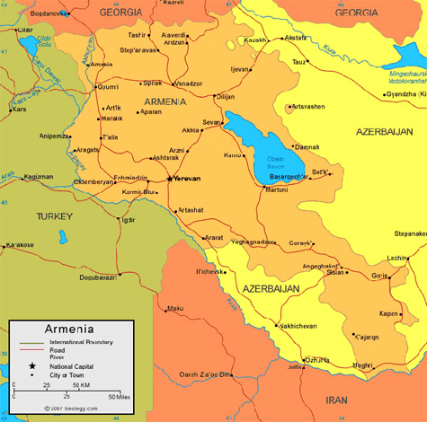
Note: The proposed project is a national-level project.

Annex 2: Multi Year Work Plan

Outcomes | Outputs | Activities | Year 1 |  |  |  | Year 2 |  |  |  | Year 3
Outcomes | Outputs | Activities | Q1 | Q2 | Q3 | Q4 | Q1 | Q2 | Q3 | Q4 | Q1 | Q2 | Q3 | Q4
Outcome 1.1  Transparency activities in Armenia are governed by clear and formal roles and responsibilities | 1.1.1 Institu-tional arrangements for a national transparency (MRV) framework are designed | 1.1.1.1 | x | x | X | x | x | x | x | x | x | x | x | X
 |  | 1.1.1.2 | x | x
 |  | 1.1.1.3 | x | X
 |  | 1.1.1.4 |  |  | X |  |  |  |  |  |  |  | X
 | 1.1.2 Legal and/or regulatory requirements for a national transparency framework are drafted and adopted | 1.1.2.1 | x | x | X | x | X
 |  | 1.1.2.2 | x | x | x | x | X
 |  | 1.1.2.3 |  |  |  |  | x |  |  |  | X
Outcome 2.1  Armenia uses an integrated MRV system for continuous data collection and reporting under Article 13 | 2.1.1 MRV system (hardware and software) with tracking tools designed and launched | 2.1.1.1 | x
 |  | 2.1.1.2 | x | x | x
 |  | 2.1.1.3 |  |  | x | x | x | x
 |  | 2.1.1.4 |  |  |  |  | x | x | x
 |  | 2.1.1.5 |  |  |  |  |  | x | x | x |  | x |  | x
 | 2.1.2 On-line portal to provide access to data and national reports established | 2.1.2.1 | x | x | x
 |  | 2.1.2.2 |  |  | x | x | x
Outcome 3.1  Armenia is able to manage data for effective transparency reporting on greenhouse gas (GHG) sources and sinks | 3.1.1 Sectoral templates and consistency guidelines on data collection and reporting are developed for the GHG inventory | 3.1.1.1 | x | x | x | x
 |  | 3.1.1.2 |  |  | x | X
 |  | 3.1.1.3 |  |  | X
 |  | 3.1.1.4 |  |  |  |  | x |  |  | x |  |  | x
 |  | 3.1.1.5 |  |  |  |  | x | x | x | x | x | x | x | X
 | 3.1.2 Sectoral emissions estimates are strengthened for selected sectors and sources | 3.1.2.1 | x | x
 |  | 3.1.2.2 |  | x | x |  | X
 |  | 3.1.2.3 |  |  |  |  |  | x |  |  |  | x
 |  | 3.1.2.4 |  |  |  | X
 |  | 3.1.2.5 | x | x | x |  |  |  | x |  |  |  | X
 |  | 3.1.2.6 | X |  | x |  |  | x |  |  |  | x
 |  | 3.1.2.7
 | 3.1.3 Analysis of the GHG inventory is enhanced | 3.1.3.1 | X | X | X
 | 3.1.3 Analysis of the GHG inventory is enhanced | 3.1.3.2 | x | x | X
 | 3.1.3 Analysis of the GHG inventory is enhanced | 3.1.3.3 |  |  |  | x |  |  |  | x |  |  |  | X
 | 3.1.3 Analysis of the GHG inventory is enhanced | 3.1.3.4 |  |  |  | x | x | x | x | x | x | x | x | x
Outcome 3.2  Armenia is able to manage data and information for the framework for transparency of action and the framework for transparency of support under Article 13 | 3.2.1 Sectoral templates and guidelines for assessing and reporting on mitigation policies and actions and their effects developed and related training provided | 3.2.1.1 | x | x | x | x
 |  | 3.2.1.2 |  |  |  | x | x | x
 |  | 3.2.1.3 |  | x | x | x
 |  | 3.2.1.4 |  |  |  |  | x |  |  |  | x
 |  | 3.2.1.5
 | 3.2.2 Methodo-logies for assessing and prioritizing adaptation actions, policies and their effects identified and applied | 3.2.2.1 | x | x | x | X
 |  | 3.2.2.2 |  |  |  | x | x | X
 |  | 3.2.2.3 |  |  |  | X
 |  | 3.2.2.4 |  |  |  |  |  |  | x |  | x |  | X
 | 3.2.3 Methodology for reporting on support received developed and related training provided | 3.2.3.1 |  | x | X
 |  | 3.2.3.2 |  |  | X
 |  | 3.2.3.3 |  |  |  | x |  |  |  | x |  |  |  | X
 | 3.2.4 Gender issues mainstreamed into transparency activities | 3.2.4.1 | X
 |  | 3.2.4.2 | x |  |  |  | x |  |  |  | X
 |  | 3.2.4.3 | x |  |  |  | x |  |  |  | X
 |  | 3.2.4.4 |  |  |  |  |  |  |  |  | x | x
Outcome 3.3  Armenia is able to track progress against its Nationally Determined Contribution (NDC) and share its approaches and results at the international level | 3.3.1 Progress against the NDC tracked | 3.3.1.1 | x | x | x
 | 3.3.1 Progress against the NDC tracked | 3.3.1.2 |  |  |  | X |  |  |  | x |  |  |  | X
 | 3.3.1 Progress against the NDC tracked | 3.3.1.3 |  |  |  | x |  |  |  | x |  |  |  | x
 | 3.3.2 On-line portal for transparency initiatives maintained and knowledge shared | 3.3.2.1 |  |  |  |  | x | x
 |  | 3.3.2.2 |  |  |  |  |  | x | x | x | x | x | x | x
 |  | 3.3.2.3 |  |  |  |  |  |  |  |  | x
M&E | 4.1.1 Project results and outcomes monitored and evaluated | M&E | x | x | x | x | x | x | x | x | X | x | x | x
M&E | 4.1.2 Lessons learned and best practices shared with other Parties through the Global Coordination Platform and other cooperation networks | KM | x | x | x | x | x | x | x | x | x | x | x | x
Project Management |  | PM | x | x | x | x | x | x | x | x | x | x | x | X

Annex 3: Monitoring Plan:
This Monitoring Plan and the M&E Plan and Budget in Section VI of this project document will guide monitoring and evaluation at the project level for the duration of project implementation.

Monitoring | Indicators | Targets | Descrip-tion of indica-tors and targets | Data source/Collection Methods | Fre-quency | Responsi-ble for data collection | Means of verifica-tion | Risks/ Assump-tions
Project objective from the results framework | Indicator 1  # direct project beneficiaries disaggregated by gender (individual people) | 120, 65 of those women by the end of the project | Quantitative GEF CBIT core indicator | As per UNDP and GEF methodology | Annu-ally | Project Manager | Project Documentation  Participant lists for all project events | Risks: Stakeholders may not participate in project events as estimated  Assumption: Motivation to attend project events for professional development will remain high.
Project objective from the results framework | Indicator 2  Quality of MRV Systems | Rating of 7 by the end of the project | UNDP CBIT core indicator | Rubric based on 10-point CBIT capacity assessment scale; self- assessment based on expert judgment | At TE | Project Manager in conjunction with Terminal Evaluator | Terminal evaluation findings  Review of national reports and data sharing arrangements | Risk: Government might not allocate sufficient staff to transparency activities  Assumption: Stakeholders will apply training and guidance received to their daily work related to transparency
Project objective from the results framework | Indicator 3 Institutional Capacity for Transparency-Related Systems | Rating of 3 by the end of the project | UNDP CBIT core indicator | Rubric based on 4-point CBIT capacity assessment scale; self-assessment based on expert judgment | At TE | Project Manager in conjunction with Terminal Evaluator | Terminal evaluation findings  Government decrees, MoUs, and climate-related laws, policies, and measures | Risk: Government policies could lack necessary regulations and/or by-laws for implementation  Assumption: The Government will enact the necessary sub-legislation
Project Component 1 | Indicator 4  Presence of institutional arrangements for a national transparency framework | By the end of the project, an inter-agency working group and/or other body is meeting at least twice a year to communicate on MRV issues. | Yes / No indicator (evidence- based) | Document review (Inter-Agency Working Group minutes) | Annually, and at TE | Project Manager, Terminal Evaluator | Government documentation | Risks: Working group could be delayed if the over-arching body does not provide incentives to meet.  Assumptions: Members perceive direct benefits to participation
Project Component 1 | Indicator 5 Presence of legal and/or regulatory requirements for a national transparency framework | By the end of the project, data sharing agreements in the form of MoUs or legal/regulatory mandates are in place for at least two key reporting sectors. | Yes / No indicator  (evidence- based) | Document review  (MoUs) | Annually, and at TE | Project Manager, Terminal Evaluator | Government documentation | Risks: arrangements may be delayed in sectors if the approval process is slow  Assumption: Stakeholders perceive benefits of these agreements due to example of the Energy Balance.
Project Component 2 | Indicator 6  Presence of an operational MRV system that is being used for continuous data collection and reporting to the UNFCCC and the Paris Agreement with gender disaggregated data where relevant. | By the end of the project, an MRV system for climate data and information will be operational and used for data collection and reporting to the UNFCCC and the Paris Agreement with gender-disaggregated data where relevant. | Target is conditional on features listed; gender is explicitly considered | Review of MRV system and associated technical documentation | Annually, and at TE | MRV System Team  Project Manager | System test | Risks: The MRV system may duplicate existing environmental information systems in Armenia.  Assumptions: The MRV system will capitalize upon existing data and databases and will emphasize interfaces.
Project Component 3 | Indicator 7 Use of sectoral templates for GHG data collection in key sectors of the inventory | By the end of the project, inventory experts in at least two key sectors are using sectoral templates for GHG data collection and reporting | Yes / no indicator supported by narrative examples | Review of the NIR, interviews with stakeholders | Annually, and at TE | Project Manager, Terminal Evaluator | NIR | Risks: Staff may not have sufficient time to introduce new templates  Assumptions: New templates will build upon existing good practice.
Project Component 3 | Indicator 8 Number of sources and sectors where emissions estimates are more robust. | By the end of the project, the national GHG inventory will have robust estimates in at least three two sub-sectors | Yes / no indicator supported by narrative examples | Review of the NIR, interviews with stakeholders | Annually, and at TE | Project Manager, Terminal Evaluator | NIR | Risks: Staff may not have sufficient time to apply improved practice and QA/QC protocols  Assumptions: New estimates will build upon existing good practice.
Project Component 3 | Indicator 9 Use of standardized methodologies and guidelines in transparency reporting. | By the end of the project, at least one national climate change reporting document uses methodology developed by the project for reporting in three areas: 1) mitigation policies and actions; 2) support received; and 3) adaptation to climate change. | Yes / no indicator supported by narrative examples | Document review (NC and BUR) | Annually, and at TE | Project Manager, Terminal Evaluator | Most recent NC and BUR | Risks: Reports will not have sufficient time to incorporate revised methodologies  Assumptions: Methodologies will remain in place for future reports until superseded by updated guidance.
Project Component 3 | Indicator 10 Coverage of gender issues in climate change reporting | By the end of the project, an analysis of gender issues will be included in at least one national climate change report. | Yes/no indicator supported by document review | Document review (NC and BUR) | Annually, and at TE | Project Manager, Terminal Evaluator | Most recent NC and BUR | Risks: Reports will not have sufficient time to incorporate gender findings  Assumptions: Gender will continue to feature in subsequent national reports
Project Component 3 | Indicator 11 Armenia is able to track its progress towards its NDCs | By the end of the project, Armenia will release a status report on its progress towards its NDCs. | Yes/no indicator supported by document review | Document review (NDC Status Report) | Annually, and at TE | Project Manager, Terminal Evaluator | NDC Status Report | Risks: NDCs may be updated  Assumptions: Tracking system will allow for the development of more robust targets
Project Component 3 | Indicator 12 Accessibility of information regarding transparency initiatives and climate change reporting in Armenia. | By the end of the project, Armenia’s climate reports, NDCs, and lessons learned from this project will be available on a national climate change portal. | Yes/no indicator supported by website review | Documentation review (website) | Annually, and at TE | Project Manager, Terminal Evaluator | MRV Portal | Risks: Portal will be linked to a time-limited organization  Assumptions: Portal will be included in data archiving strategy for the national MRV/ transparency system
Project Component 3 | Indicator 13 Consideration of gender issues in progress towards the NDC | By the end of the project, the tracking system for the NDC will monitor gender considerations related to the NDC, such as the differentiated impact of proposed measures on women and men. | Yes/no indicator supported by document review | Document review (NDC Status Report) | Annually, and at TE | Project Manager, Terminal Evaluator | NDC Status Report | Risks: Gender considerations may be difficult to derive from the NDC as they are not mentioned explicitly  Assumptions: gender-CC methodology will be sufficient to allow for extrapolation from the existing NDC
Gender Action Plan | Indicator G1: Number of organized consultative meetings involving representatives of gender organizations. | By the end of the project, at least four meetings will involve representatives of gender organizations | Yes / No indicator (evidence- based) | Document review (meeting minutes) | Annually, and at TE | Project Manager, gender consultant | Project documentation | Risks: Insufficient interest in attendance at meetings  Assumptions: Stakeholders perceive direct benefits to participation
Gender Action Plan | Indicator G2 Number of participants at trainings the implementing partner, data providers and project experts. | Target number of participants to be determined prior to project inception workshop. | Sum total of participants, not including trainers, at gender mainstreaming training | Following gender mainstreaming training | Annually, and at TE | Project Manager, gender consultant | Project documentation | Risks: Stakeholder organizations may not consider the training to be relevant to their interests.  Assumptions: Project management will conduct sufficient outreach to contextualize the training
 | Indicator G3  Ratio of women and men at trainings (with contextual information provided) | The average ratio of women to men in project capacity-strengthening activities over the course of the project will be at least 1:1. | Ratio of documented participants calculated by participant lists. | Annually | Annually, and at TE | Project Manager, gender consultant | Project documentation | Risks: It may be difficult to achieve gender equality in participation in sectors that are traditionally male-dominated  Assumptions: Project stakeholders will be made aware of the need to consider qualified women candidates for participation.

* The rating for CBIT Core Indicator 3 is based on a 10-point scale developed by GEF Sec as follows:

- Very little measurement is done, reporting is partial and irregular and verification is not there;
- Measurement systems are in place, but data is of poor quality and/or methodologies are not very robust; reporting is done only on request or to limited audience or partially; verification is not there;
- Measurement systems are in place for a few activities, improved data quality and methodologies, but not cost or time efficient; wider access to reporting is still limited and information is partial; verification is rudimentary/non-standardized;
- Measurement systems are strong in a limited set of activities however, analyses still need improvement; periodic monitoring and reporting although not yet cost/time efficient; verification is only upon specific request and limited;
- Measurement systems are strong for a limited set of activities and periodically report on key GHG related indicators i.e. mainstreamed into the activity implementation; reporting is improved through few pathways but limited audience and formats; verification limited;
- Measurement systems are strong and cover a greater percentage of activities – feedback loops exist even if they are not fully functioning; reporting is available through multiple pathways and formats but may not be complete/transparent; verification is done through standard methodologies but only partially (i.e. not all data is verifiable);
- Measurement regarding GHG is broadly done (with widely acceptable methodologies), need for more sophisticated analyses to improve policy; Reporting is periodic with improvements in transparency; verification is done through more sophisticated methods even if partially;
- Strong standardized measurements processes established for key indicators and mainstreamed into institutional policy implementation; reporting is widely available in multiple formats; verification is done for a larger set of information;
- Strong Monitoring and Reporting systems – robust methodologies, cost effective and efficient, periodic; verification done to a significant degree;
- Strong MRV systems that provide quality GHG-related information in a transparent, accurate and accessible to a wide audience, with feedback of information from MRV flowing into policy design and implementation

** The rating for CBIT Core Indicator 4 is based on a 4-point scale developed by GEF Sec as follows:

- No designated transparency institution to support and coordinate the planning and implementation of transparency activities under Article 13 of the Paris Agreement exists.
- Designated transparency institution exists, but with limited staff and capacity to support and coordinate implementation of transparency activities under Article 13 of Paris Agreement. Institution lacks authority or mandate to coordinate transparency activities under Article 13.
- Designated transparency institution has an organizational unit with standing staff with some capacity to coordinate and implement transparency activities under Article 13 of the Paris Agreement. Institution has authority or mandate to coordinate transparency activities under Article 13. Activities are not integrated into planning or budgeting activities.
Designated transparency institution(s) has an organizational unit with standing staff with some capacity to coordinate and implement transparency activities. Institution(s) has clear mandate or authority to coordinate activities under Article 13 of the Paris Agreement, and activities are integrated into planning and budgeting activities.

Annex 4: Stakeholder Engagement Plan

The proposed project is the product of nearly two decades of cooperation between UNDP Armenia and the Ministry of Environment (previously the Ministry of Natural Resources). It developed from cooperation with the ministry on several GEF-funded national reporting projects, including the ongoing project supporting the compilation of the country’s most recent NC and BUR (GEF ID 9474).

At the project concept development stage, consultations were held with the most active relevant NGOs (Ecolur, Sustainable Human Development, Save Energy Foundation, Khazer, and Armenian Women for Health and Healthy Environment). All of these NGOs, which are led by active women with scientific backgrounds, welcomed the objective of the project, which will contribute to the environmental information transparency in the country through open data-sharing portals accessible for the public and the scientific community. In particular, the NGOs consulted stressed the importance of the involvement of civil society at all stages of the project.
During the project preparation phase, the project preparation team organized a stakeholder validation workshop in Yerevan on September 4, 2019. The protocol from the workshop is provided below in Annex 4A. A total of 59 participants attended the workshop, which consisted of two parts: sessions on current topics in transparency, such as institutional arrangements and MRV and transparency systems in practice, and a review of the proposed project with a session for soliciting feedback. A participant list from the workshop is included below as Annex 4B. Stakeholders were also presented with the option of submitting written comments to the projet team following the workshop.
The consensus among workshop participants was that the project would be very helpful in supporting Armenia in meeting its obligations under the Paris Agreement. No significant criticisms of the project activities or its potential impacts were raised by stakeholders during the consultation process.
Key findings include the following:
- Activity data collection, data collection and analysis from projects and policies, and spatial data for the forestry sector were cited as areas where the proposed UNDP-GEF project could be particularly helpful.
- The transparency frameworks developed should be accessible to the public, and they should enable the public to be informed about climate finance, climate-related loans, and how commitments under the Paris Agreement are being implemented in Armenia.
- The Paris Rulebook and new requirements regarding MRV and transparency present an opportunity to put solid frameworks in place that can also support other national reporting requirements in priority areas (e.g. Energy Charter requirements to align MRV with the EU monitoring mechanism regulation, and the Bonn Forest Challenge)
- It will be necessary to work closely with initiatives that support the revision and/or strengthening of the NDCs in order to ensure sure that the NDC tracking mechanism is effective.

Findings from the workshop have been reflected in the project activities, particularly in the area of providing capacity strengthening in the AFOLU sector (under Component 3) and in the principles of open data and non-proprietary software that will guide the development of the MRV system developed under Component 2.

Stakeholder Engagement Roles and Monitoring

The project manager will be responsible for monitoring and supporting ongoing stakeholder involvement during project implementation through project management mechanisms, such as the PSC, and through the two-way exchange of information with stakeholders. The portal developed in Component 3 of the project will also be used to disseminate information to stakeholders on an ongoing basis. The project will track participation in the Interagency Coordinating Council and Task Force, user statistics for the transparency portal, and participation in project events on an ongoing basis in order to monitor stakeholder participation.

Stakeholder overview and engagement plan

Table A4.1 below provides an overview of project stakeholders, their relevance to the project, and their proposed role in project implementation.

Table A4.1: Stakeholder Overview and Engagement Plan

Organization | Relevance to Project and Role in Project Formulation | Planned Role in Project Implementation
Ministry of Environment: | The Ministry, formerly the Minstry of Nature Protection, is the main coordinator of climate change activities and focal point of the UNFCCC. It is in charge of developing GHG inventories, reporting to the UNFCCC, following up on Armenia's NDC, and coordinating Inter‐ministerial interaction. It has been involved in the project design, and the Minister, who serves as the GEF Operational and Political Focal Point for Armenia, endorsed the project on August 3, 2018. The Ministry co-chaired the September 2019 Stakeholder Validation Workshop, and the Deputy Minister and several other representatives participated in the presentations and questions and answers. | The Ministry will be the implementing partner of the CBIT project and will also be responsible for coordinating the design and implementation of the transparency framework.  Office space will be provided by the Ministry as part of the government’s in-kind contribution, as well as premises for meetings, means of communication and other utilities, along with information and time of civil servants and governmental officials involved in Inter-agency Coordinating Council and Task Force.
Ministry of Territorial Development and Infrastructure | This ministry is a member of the Inter-agency Coordinating Council on Climate Change. It is responsible for the development and implementation of the state policy on energy saving and renewable energy and for the development of the annual energy balance, as well as for coordination of works under Covenant of Mayors and transport policy. These functions make the Ministry a key partner in the design of the transparency framework and a key actor in the MRV framework. A ministry representative participated in the stakeholder validation workshop in September 2019. | The Ministry will both provide information and participate in training and capacity strengthening during the CBIT project.
Ministry of Transport, Communication and Information Technologies | This ministry is a member of the Inter-agency Coordinating Council on Climate Change. | The Ministry (along with the Statistics Committee) will be involved in identifying a means of addressing the lack of official statistics on liquid fuel annual consumption by sub-category. It is expected that the Ministry of Transport will be a member of the MRV network mandated to develop and track relevant indicators for the transport sector to tracking the progress on mitigation measures in the sector, as the transport sector is a key source of GHG emissions. It will provide information and participate in training and capacity strengthening activities within the CBIT project.
Scientific Research Institute of Energy | This institute developed the Energy Balance for 2016 and 2017. At present, it is developing the Energy Balance for 2017 and assessing the results of the national energy efficiency action plan (Phase II) implementation. Several representatives of the Institute participated in the stakeholder validation workshop in September 2019. | The Institute will be involved in discussions and consultations aimed at the selection of the best available way to collect data on energy efficiency measures and at the improvement of the methodologies applied in the calculation of the Energy Balance to ensure the comparability of the data provided in the Energy Balance and in the Energy Sector estimates in the GHG Inventory. The Institute will also provide information and participate in training and capacity-strengthening activities within the CBIT project.
Ministry of Agriculture | This ministry is a member of the Inter-agency Coordinating Council on Climate Change, and it is the main source of data on agriculture, livestock and land use data for the AFOLU sector of the GHG Inventory. | Experts from this ministry will be key to improving the Agriculture sector GHG emissions estimate and reinforcing adaptation monitoring and reporting. They will participate in training and capacity strengthening activities within the CBIT project.
Ministry of Finance | This ministry is a member of the Inter-agency Coordinating Council on Climate Change. It is responsible for tracking overseas development assistance (ODA) to Armenia. | It is expected that the Ministry of Finance will be the member of the MRV network mandated to provide information on climate finance. It will provide information and participate in training and capacity strengthening activities within the CBIT project.
Ministry of Economy | The ministry oversees economic policy in general and sectoral policies, such as agrarian policy and policies regarding foreign direct investment in Armenia. It is also involved in agricultural statistics. Representatives of the ministry participated in the stakeholder validation workshop in September 2019.
Statistics Committee | The committee is a member of the Inter-agency Coordinating Council on Climate Change and one of the main data providers for the National GHG Inventories. The committee participated in the stakeholder validation workshop in September 2019. | The Statistics Committee will be involved in identifying a means of overcoming inconsistencies in the activity data that it collects internally and from other sources, such as data on wood removals. It will also be involved in identifying an approach to addressing the lack of official statistics on liquid fuel annual consumption by sub-category. The committee will provide information and participate in training and capacity strengthening activities within the CBIT project.
Public Services Regulatory Commission | The commission is a member of the Inter-agency Coordinating Council on Climate Change, and it serves as an independent regulatory body. Among other responsibilities, it sets tariffs for gas and electricity and establishes the rules for electricity markets. | The Commission will provide information and participate in discussions within the CBIT project.
Committee of the Real Estate Cadaster | This committee is a member of the Inter-agency Coordinating Council on Climate Change. It maintains and publishes the land balance, including information on land use change. | The Committee will provide information and participate in training and capacity strengthening activities within the CBIT project.
Committee of Forest of the Ministry of Environment | This committee includes a department for forestry and land management, and it has a division that oversees the national forest inventory. A representative of the Committee participated in the stakeholder validation workshop in September 2019. | The committee will be involved in identifying a means of addressing inconsistencies in activity data obtained from the Statistics Committee on wood removals, as well as in identifying an approach to reduce uncertainty in forest data.
International organizations | Multilateral and bilateral agencies, such as the World Bank, the European Commission, the European Bank for Reconstruction and Development (EBRD), KfW, USAID, and others are funding projects related directly or indirectly to climate change. Representatives of several donor-funded projects presented their work at the stakeholder validation workshop, and other agencies attended as observers (UNIDO, UNECE, and FAO). | The project will maintain ongoing, two-way communication with these agencies, and it will include them in the data-sharing system and MRV network, particularly regarding reporting on mitigation activities, support received, and support for NDC revision and/or strengthening. Coordination with individual donor-funded projects is summarized in Section IV of this project document.
Non-Governmental Organizations (NGOs) | Universities, research institutions, and environmental NGOs will participate in workshops during the CBIT project and will play an important role in communicating findings from transparency activities to the research community, to students, and to the broader public. Several NGO representatives attended the September 2019 stakeholder validation workshop. | The project portal will be designed in order to maximize public access to climate change-related data and information, including information on Armenia’s progress towards meeting its NDCs.  An NGO representative will be invited to Inter-agency Coordinating Council meetings.
The Private Sector | Private sector enterprises contribute to national emissions of GHGs in certain sectors, such as Industrial Processes and Product Use (IPPU) for certain sources, such as fluorinated gases (F-gases). At the same time, private sector investments in areas such as renewable energy can reduce GHG emissions. | The private sector will be involved in the project in two ways: First, it will be involved through the provision of activity data in relevant sectors. It will also be involved indirectly in reporting on mitigation when private sector investment results in GHG emission reductions. The proposed project will take steps to strengthen capacity in key government organizations to work effectively with the private sector on activity data collection.  Individual enterprise-level reporting for key emitting industries, such as cement factories, copper and molybdenum re-processing, and glass production is ensured through draft reporting formats formally requested by the Ministry of Environment. There is an intention to strengthen the quality of reporting in the IPPU sector through operationalizing the draft Roadmap for Improving the GHG Inventory Process, which was developed in close cooperation between the Statistical Committee and Ministry of Environment. The project will establish links with professional associations, such as the Chamber of Commerce and Industry of Armenia and the Union of Manufacturers and Businessmen in order to reach a broader audience of actors involved in processing industries and particularly in the context of the increasing emissions trend of F-gases.  In addition, the project will involve the banking sector. Commercial banks play an active role in financing investments in renewable energy and energy efficiency and in small and medium-size enterprises in the service sector, processing industries, and agriculture. It is therefore important to establish a two-way communication channel for influencing climate-oriented lending activities and supporting the measurement of impacts and finance flows to promote climate-responsive investments.  Under Component 3, A banking sector specialist will be involved in training sessions covering proper tracking of the environmental impacts of investment instruments, and other representatives from the private sector will be invited to participate in project activities that are relevant to them, such as reporting on investments that generate mitigation benefits. Data on financial flows through com commercial banks for climate-related investments will inform the enhanced transparency framework on support received.

Annex 4A: Stakeholder Validation Workshop Protocol

 |  | 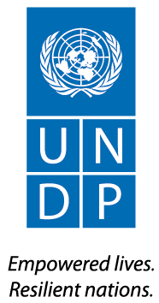
“Enabling Activities for the Preparation of Development of Armenia’s Fourth National Communication to the UNFCCC and Second Biennial Update Report” UNDP-GEF project

W O R K S H O P

Leading on Climate Change:
Putting Transparency Frameworks and the Paris Agreement into Action
“Tigran the Great” conference hall of “Marriot” hotel
4 September 2019

PARTICIPANTS: 59 participants (see the list attached) attended the workshop.
PURPOSE: The purpose of the workshop was to share with stakeholders the relevant information on Measurement, Reporting, Verification System and National Transparency Framework requirements under the Paris Agreement, as well as present and discuss key objectives of “Capacity Building Initiative for Transparency” UNDP-GEF project.

I. Presentations

The workshop proceeded mainly in accordance with the agenda (see attached).
All the presentations are uploaded to the website and the link is shared with the participants.

First Deputy Minister of Environment Irina Ghaplanyan and UNDP Deputy Resident Representative Mihaela Stojkoska delivered welcoming remarks.
In her welcoming speech, Ms. Irina Ghaplanyan outlined that the Ministry of Environment, as national authorized entity for coordination of climate change policy and programs, oversees variety of activities related to preparation and reporting of greenhouse gas (GHG) inventory, progress towards limitation of GHG emissions, adaptation to climate change, as well as identification of financial and institutional capacity needs.
She also noted that Paris Agreement brings new challenges and requirements, including one related to transparency of domestic actions. With increasing pressure on climate change related actions, it is more important than ever to ensure a proper coordination in the country.
In her welcoming speech, Ms. Mihaela Stojkoska outlined that climate change is an issue that is both urgent and extremely serious, and it poses a global threat to human development. UNDP is proud to have been an active partner with the Government of Armenia for more than two decades in the area of climate change. Armenia has been a leader among developing countries in the areas of reporting on climate change and in taking innovative steps to join different actors to fight climate change.
The Paris Agreement present a new challenge for Armenia, but it also presents a new opportunity in the form of additional financial mechanisms, such as the Green Climate Fund.
The systems that Armenia develops will make climate information more robust and accessible and will allow it to set and meet targets that are more ambitious.
UNDP is proud to support the Government of Armenia in this new “Capacity Building Initiative for Transparency” project, for which the Global Environmental Facility has already committed nearly one million dollars. This project will directly support the development of a system for reporting on action on climate change mitigation and adaptation in a way that is transparent. The project will also allow the Government to track the progress of its Nationally Determined Contribution to the Paris Agreement.
Then presentations proceeded according to the agenda, following by questions and answers.

II. Questions and recommendations

1. Anahit Simonyan, UNIDO Country Representative in Armenia, asked if there is any UN-interagency cooperation agreement for NDCs.
To which Mr. Michael Vardanyan, expert of the Ministry of Environment, answered that there is no document signed at the moment, while the NDC partnership team is working on this kind of an agreement.
2. Aram Gabrielyan, “Khazer” NGO, suggested that transparency should become a key issue in terms of involvement and information sharing with the civil society. There should be a participation mechanism for the population, as a stakeholder to track how loans, climate finance funds are used and how commitments of the country under Paris Agreement are implemented.
To which Diana Harutyunyan, UNDP Climate change program coordinator, answered that a platform for the transparency should be established not only for reporting to the UNFCCC, but also making all information transparent for all layers of stakeholders in the country.
3. Evgeniya Atayan, Adviser in the Urban Development Committee, asked about Energy Management Information System that should be established. She noted that development efforts for Identification System for Buildings are already underway by Committee, aimed at presenting buildings’ typology, technical condition, energy parameters, conditions and other data on buildings. In this regard, there may be some overlap in Identification System for Buildings and Energy Management Information System.
To which Mr. Tigran Sekoyan, UNDP Expert on Energy/Energy efficiency, answered that issues will be coordinated through operational charters between coordinating national entities, in a way that those systems will complement each other. Unlike the Identification System for Buildings, the Energy Management Information System will get information on energy spent in terms of volume of natural gas or electricity daily or weekly. Therefore, this system will solve the problem of current operation and the operator will be able to interfere in case if there is overspending of energy in a certain public building․
4. Yurik Poghosyan, UNECE SESP Project manager, noted that SESP project is ready to cooperate in terms of data integrity and quality assurance. Within the frames of the development of GHG Inventory data road map following recommendation from UN Statistics Division, an action plan was developed and consulted with GHG Inventory Team, pending its approval by the Statistical Committee, which will address improvement in data collecting and publishing process, thus cooperation in the frames of CBIT project is most welcomed. The water data portal development under SESP project is in process and it will contribute to that process.
To which Diana Harutyunyan, UNDP Climate change program coordinator, replied that CBIT project will strongly contribute to the improvement of GHG Inventory activity data collection and quality process. Unfortunately, the biggest problem exists in AFOLU sector. However, the problems in forestry sector data collection improvement need more holistic and comprehensive approach, which can’t be addressed in CBIT project, while other support mechanisms have to be identified for that purpose.

III. Decision:

Susan Legro, international consultant, while summing up the workshop, noted that the objective for stakeholders’ consultation were met as key partners were present and have opportunity to share their views. Further communication can be maintained and suggestions can be sent concerning the linkages and possible cooperation possibilities to UNDP CC Programme. Recommendations of the stakeholders will be taken into account for better transparency efforts and will be considered during the preparation of CBIT project document and action plan.

Annex 4B: Stakeholder Validation Workshop List of Participants

List of Participants
Leading on Climate Change:
Putting Transparency Frameworks and the Paris Agreement into Action
4 September, 2019

 | Name | Organization, position
 | Ministry of Environment
 | Irina Ghaplanyan | Deputy minister
 | Samvel Sahakyan | Acting chairman of the Committee of Forest of the Ministry of Nature Protection (MNP)
 | Lara Sargsyan | Acting Head of protection policy of climate change and atmosphere division
 | Meruzhan Galstyan | Director of “Environmental project implementation unit” State Agency
 | Qnarik Eghiazaryan | Ozone project
 | Hovhannes Poghosyan | Ozone project
 | Davit Abovyan | Hayantar
 | Anna Papikyan | Monitoring and communications center
 | Arusyak Siradeghyan | Forestry committee
Ministries, Agencies
 | Ashot Giloyan | Ministry of Territorial Administration and Infrastructure, Head of Territorial Administration Policy Department
 | Varsik Martirosyan | Ministry of economy  (Agriculture)
 | Anush Veranyan | Ministry of economy
 | Artak Baghdasaryan | Ministry of economy, Head of Department of Strategic Planning and Monitoring
 | Nelly Baghdasaryan | Statistical Committee Board member
 | Yevgenya Atayan | Urban Development Committee
 | Tatevik Revazyan | Chairman of the Civil Aviation Committee
 | Narek Mkhitaryan | Civil Aviation Committee
 | Zarmandukht Petrosyan | Ministry of Emergency Situations, Hydromet
 | Yelena Khalatyan | Hydromet
 | Mikayel Tevosyan | Transport Project Implementation Unit
 | Georgi Afyan | Transport Project Implementation Unit
Local self-government bodies
 | Galaryan Edgar | Yerevan municipality
 | Nana Abelyan | Yerevan municipality
Companies
 | Ruben Eghoyan | General Director of Scientific research institute of energy
 | Tigran Gnuni | First deputy Director of Scientific research institute of energy
 | Vahan Sargsyan | Scientific research institute of energy
 | Karen Asatryan | General Director of Armenia Renewable Resources and Energy Efficiency Fund
 | Astghine Pasoyan | Director of Foundation to save energy
 | Vram Tevosyan | Director of “Consecoard” LLC
 | Anzhela Turlikyan | “Consecoard” LLC
 | Nune Sakanyan | WICE NGO
International organizations and Projects
 | Anahit Simonyan | UNIDO Country Representative
 | Meri Sahakyan | Food and Agriculture Organization of the United Nations in Armenia
 | Yurik Poghosyan | UNECE SESP Project manager
 | Artem Kharazyan | EU “Covenant for Mayors East II” project national expert
UNDP
 | Mihaela Stojkoska | UNDP Deputy Resident Representative
 | Yevgen Groza | EU4Climate regional project manager
 | Susan Legro | UNDP International Expert
 | Andrew Haywood | “Mainstreaming sustainable land and forest management in the mountain landscapes of north-eastern Armenia” project,  International expert
 | Armen Martirosyan | Sustainable Growth and Resilience Portfolio Manager
 | Georgi Arzumanyan | Programme Policy Adviser, Sustainable Growth and Resilience
 | Diana Harutyunyan | Climate Change Program Coordinator
 | Marina Sargsyan | Armenia's Third Biennial Update Report to the UNFCCC, project task leader
 | Tigran Sekoyan | Armenia's Third Biennial Update Report to the UNFCCC, Project senior expert
 | Edvard Martirosyan | Armenia's Third Biennial Update Report to the UNFCCC, Project expert
 | Hovik Sayadyan | “Mainstreaming sustainable land and forest management in the mountain landscapes of north-eastern Armenia” project,  Technical task leader
 | Anahit Ispiryan | Armenia's Third Biennial Update Report to the UNFCCC, Project assistant
 | Arshak Astsatryan | National expert on F-gases
 | Gohar Harutyunyan | National expert on waste
 | Aram Gabrielyan | Former focal point
 | Anastas Aghazaryan | National expert on agriculture
 | Hovhannes Sarajyan | Communications analyst

Annex 5: UNDP Risk Log

# | Description | Date Iden-tified | Risk Category | Impact &  Probability | Risk Treatment / Management Measures | Risk Owner | Status
1 | Risk of insufficient government support for the establishment of the MRV framework. |  | Political | Without high-level political support, it is unlikely that there will be active involvement of the relevant ministries in the design, setting and proper operation of the MRV framework.  P = 1  I = 4 | The fact that the RA Government Decision states that the MRV system shall be established and the Ministry of Environment is responsible for coordination of that process provides a strong motivation. The formal arrangements that will be developed and proposed within the project shall be validated by the highest officials. This step will allow the government to enforce arrangements regarding ministries and other data providers to produce and report the necessary data in the required time and manner.
2 | Risk that critical legislation or regulatory elements supporting the MRV framework will fail to be adopted. |  | Regulatory | If data providers are not required to deliver data on an ongoing basis and to monitor their activities, these activities will not take place.  L-M  P = 2  I = 4 | Component 1 of the project will focus on using the model of a Memorandum of Understanding (MoU), which does not require legislation and has worked successfully in gathering data from different providers for the Energy Balance.
3 | Risk of losing the capacity and skills acquired due to staff turnover. |  | Organizational | If staff leave their positions, the targeted capacity building provided under the project may not be maintained.  P = 3  I = 3 | Capacity strengthening activities will involve a carefully selected group of relevant experts within each ministry and agency to ensure that capacity can be retained, and succession planning will be discussed as a part of training. Guidelines and methodologies will be produced in written format, and the MRV system and operating procedures will be documented extensively, which will also contribute to retaining institutional memory.
4 | Lack of proper coordination among institutions involved in the implementation of mitigation measures. |  | Organizational | If cooperation among different institutions undertaking data collection and analysis is not strong, the ability of the transparency framework to measure and report on mitigation will be limited and different government organizations working independently may produce data that is duplicative or inconsistent.  P=3  I=4 | The use of the Inter-agency Council (which must be reorganized due to changes in the structure of the Government that were made in June 2019) for coordination among government agencies and the introduction of clearly-defined reporting obligations and data providers that are binding will ensure the engagement of key players and reduce the risk of overlap.

Annex 6: Overview of Technical Consultancies

Consultant | Time Input | Tasks, Inputs and Outputs
For Project Management / Monitoring & Evaluation
Local / National contracting
Project Manager/Technical Expert  $2000/month | Full time | The Project Manager/Technical Expert (PM), will be responsible for the overall management of the project, including the mobilization of all project inputs, supervision over project staff, consultants and sub-contractors. See the full TOR in Annex 7 for details.
Project Expert Team Assistant  $1100/month | Full time | Assist the PM in in day-to-day management and oversite of project, in conducting data collection and review, compilation of background materials for use in reporting, discussions and briefing sessions, prepare components of presentations and briefings
International / Regional and global contracting
IC/ Technical Advisor  Rate: $550/day | 125 days / over 3 years | The Technical Adviser will be responsible for providing overall technical backstopping and management support to the Project. Under Component 1, the LTA will provide guidance on the legal arrangements for transparency in Armenia and on legal and regulatory approaches for ensuring continuous data exchange on a formal basis among institutions. Under Component 2, the LTA will provide guidance and inputs to the technical specifications for the MRV system and will monitor the work of consultants and companies developing the system as needed. Under Component 3, the LTA will propose suitable templates, methodologies, and training curricula and will support capacity strengthening in all areas of the reporting frameworks.
IC / Evaluator  Lump sum including travel: $20,000 | The final quarter of the project | The IC / Evaluator will conduct the external terminal evaluation of the project and contribute to the project final report (Output 4.1.1). The primary output will be the terminal evaluation report and a presentation of its findings to the project team and / or the project steering committee. ToRs are provided in Annex 7.
For Technical Assistance
Component 1
Local / National contracting
Legal Expert | $200x 50 day | The legal expert will have two primary outputs: an assessment and recommendations on arrangements for legal arrangements regarding the transparency framework (Output 1.1.1); and an assessment and recommendations on arrangements for data sharing among institutions (Output 1.1.2).
Mitigation expert | $150x180 days | The Mitigation expert will be responsible for identification and assessment of institutional functions, comparative strength and weaknesses of corresponding institutions as data providers.
Communications expert | $140 x 80 days | The Communications expert will be responsible for establishing links with other development programs, drafting and implementation of communication strategy with beneficiaries, will develop and maintain content on the web portal (Output 3.3.2) and will oversee knowledge management activities and knowledge sharing at the regional and global level (Output 4.1.2)

Component 2
Local / National contracting
IT Expert for development of web design and interface support | $160x70 days | The IT Expert’s outputs will include tending documentation and the development of a long-term data storage and archiving strategy (Output 2.1.1) and recommendations on the design and operation of the web ports (Output 2.1.2).
National environmental expert | $140x160 days | National environmental expert will be responsible for identification of the data providers, data flow, support International MRV consultant and Project manager in development of reporting protocols, including compliance with key national reporting content and time frames for NDC
National GHG inventory expert | $140x 60 days | National GHG inventory expert will support stakeholders in using the on-line system, draft the usage procedures and instructions, make recommendations on refinement of the system (Output 2.1.2 and Output 3.1.3).
National expert on information systems | $180x40 days | National expert on information systems responsible for developing technical specifications for suitable hardware, software and licensing and/or subscription, particularly for visualization data for AFOLU sector (Output 2.1.1)
Component 3
Local / National contracting
Climate Change Expert | $160x140 days | Outputs will include sectoral templates on data collection and reporting and support for QA/QC plans (Output 3.1.1) and support for tracking progress towards the NDC ( Output 3.2.1 and Output 3.3.1)
Environmental Expert | $140x170 days | The Environmental Expert will oversee the development of an adaptation MRV strategy and the alignment of transparency reporting with national forest policy and international commitments (Output 3.2.2) and on support received (Output 3.3.3).
Information System Consultants | $180x50 days | The consultants will identify hardware and software to enhance the development of the GHG inventory, particularly in the areas of AFOLU and forestry (Outputs 3.1.1, 3.1.2, and 3.1.3)
National expert on support received | $200x50 days | National expert on assessing support received will be responsible for development of templates and guidelines to be negotiated and agreed with data providers, as well as test them according to the MRV system requirements.
Gender Consultant | $120x60days | The gender consultant will produce a report as specified under Output 3.2.4 and will provide guidance on other components to the project manager as needed.

Annex 7: Terms of References

Terms of Reference for Key Project Staff and Other Positions

Project Manager

Scope of work

Under the direct supervision of the UNDP Programme Analyst for Sustainable Growth and Resilience (SGR), and UNDP Climate Change Programme Coordinator, the Project Manager, selected on a competitive basis, will be responsible for the overall implementation of project activities.

Duties and Responsibilities
- Manage the overall conduct of the project.
- Plan the activities of the project and monitor progress against the approved workplan.
- Execute activities by managing personnel, goods and services, training and low-value grants, including drafting terms of reference and work specifications, and overseeing all contractors’ work.
- Monitor events as determined in the project monitoring plan and update the plan as required.
- Provide support for completion of assessments required by UNDP, spot checks and audits.
- Manage requests for the provision of UNDP financial resources through funding advances, direct payments or reimbursement using the FACE form.
- Monitor financial resources and accounting to ensure the accuracy and reliability of financial reports.
- Monitor progress watch for plan deviations and make course corrections when needed within PSC-agreed tolerances to achieve results.
- Ensure that changes are controlled, and problems addressed.
- Perform regular progress reporting to the PSC as agreed with the PSC, including measures to address challenges and opportunities.
- Prepare and submit financial reports to UNDP on a quarterly basis.
- Manage and monitor the project risks – including social and environmental risks - initially identified and submit new risks to the PSC for consideration and decision on possible actions if required; update the status of these risks by maintaining the project risks log;
- Capture lessons learned during project implementation.
- Prepare revisions to the multi-year workplan, as needed, as well as annual and quarterly plans if required.
- Prepare the inception report no later than one month after the inception workshop.
- Ensure that the indicators included in the project results framework are monitored annually in advance of the GEF PIR submission deadline so that progress can be reported in the GEF PIR.
- Prepare the GEF PIR;
- Assess major and minor amendments to the project within the parameters set by UNDP-GEF;
- Monitor implementation plans including the gender action plan, stakeholder engagement plan, and any environmental and social management plans;
- Monitor and track progress against the GEF Core indicators.
- Support the Terminal Evaluation process.

Required skills and expertise
- A university degree (MSc or PhD) in a subject related to the natural or applied sciences, engineering or economics .
- At least 5 years of demonstrable project/programme management experience.
- At least 5 years of experience working with ministries, national or local administrative bodies that are concerned with environmental management and national statistics.

Competencies
- Strong leadership, managerial and coordination skills, with a demonstrated ability to effectively coordinate the implementation of multi-stakeholder projects, including financial and technical aspects.
- Ability to effectively manage technical and administrative teams, work with a wide range of stakeholders across various sectors and at all levels, to develop durable partnerships with collaborating agencies.
- Ability to administer budgets, train and work effectively with counterpart staff at all levels and with all groups involved in the project.
- Ability to coordinate and supervise implementation of technical activities in partnership with a variety of stakeholder groups, including government, private sector and local administrations.
- Strong drafting, presentation and reporting skills.
- Strong communication skills, especially in timely and accurate responses to emails.
- Strong computer skills, in particular mastery of all applications of the MS Office package and internet search.
- Strong knowledge about the political and socio-economic context related to the Indonesian protected area system, biodiversity conservation and law enforcement at national and subnational levels.
- Excellent command of English and local language.

Project Assistant (level SB3)

Scope of work

Under the overall guidance and supervision of Climate Change Programme Coordinator and direct supervision of the Project Manager, the Project Assistant will provide support for implementation of tasks associated with the day-to-day management and operation of the projects. S/he will be responsible for operational project management support functions.

Under the guidance and supervision of the Project Manager, the Project Assistant will carry out the following tasks:
- Assist the Project Manager in day-to-day management and oversight of project activities;
- Assist the M&E in matters related to M&E and knowledge resources management;
- Provide support for conducting data collection and review, compilation of background materials for use in reporting, discussions and briefing sessions, prepare components of presentations and briefings;
- Drafts correspondence relating to assigned project areas; clarifies, follows up, responds to requests for information, ensuring proper communication and information exchange within the Project Team;
- Make logistical arrangements for missions and expert’s visits, prepares briefing kits and background materials;
- Assist the Project Manager and Programme Associate in preparation of AWP, draft budget revisions and drafts monthly, quarterly and annual financial reports for the project;
- Prepare documentation for vendors and for Request for Payments, to ensure smooth financial operation of AWP activities.
- Assist in the preparation of progress reports;
- Ensure all project documentation (progress reports, consulting and other technical reports, minutes of meetings, etc.) are properly maintained in hard and electronic copies in an efficient and readily accessible filing system, for when required by UNDP-UNEP GSP, UNDP, project consultants and other PMU staff;
- Provide administrative and logistical assistance.

Qualifications

The Project Assistant will be recruited based on the following qualifications:
- A Bachelor’s degree or an equivalent qualification;
- At least three years of work experience preferably in a project involving biodiversity conservation, natural resource management and/or sustainable livelihoods. Previous experience with UN project will be a definite asset;
- Very good inter-personal skills;
- Proficiency in the use of computer software applications especially MS Word and MS Excel.
- Excellent language skills in English (writing, speaking and reading) and in local languages

Legal Expert (s)

Scope of Work

Under the overall supervision and guidance of the Project Manager, the Legal Expert(s) will carry out the following tasks.

- Support reviewing and enhancing coordination mechanism between national agencies for reporting and verification purposes under transparency frameworks,
- Support legislative changes in order to strengthen the ability of the country to meet reporting requirements under the UNFCCC and the Paris Agreement,
- Identify entry points for climate change issues into sectoral legislation and draft suitable text for CC integration,
- Develop relevant legal and/or regulatory provisions on MRV that can be included into environmental legislation and regulations,
- Ensure consistency with the EU acquis and ensure consistency with current and potential requirements for establishment of MRV in the context of the commitments of the country under CEPA; and UNFCCC climate change requirements.

Environmental Expert

Scope of Work

Under the overall supervision and guidance of the Project Manager, the Environmental Expert will carry out the following tasks.
- Support development of an adaptation MRV plan,
- Identify the adaptation measures tagging indicators for assessment of the MRV on budget planning and support received,
- Identify applicable indicators for prioritization of adaptation between sectors,
- Develop AFOLU training concepts, data collection protocols, training on the software and data sharing process, data analysis and visualization under the system, data protection, and other supporting protocols,
- Prepare AFOLU focused training needs assessment and training plan for key stakeholders,
- Ensure linkages and information sharing between programs in AFOLU sector.

Climate Change Expert

Scope of Work

Under the overall supervision and guidance of the Project Manager, the Climate Change Expert will carry out the following tasks.

• Support development of toolkits and templates for mitigation, adaptation and reporting on support,
• Develop guidelines for QA/QC for the proposed MRV framework,
• Conduct research and contribute to recommendations regarding institutional arrangements and data flow and data gaps in the MRV framework,
• Identify existing data and information, including research from academic and research institutions, and identify high-priority data needs in inventory sectors,
• Support the Project Manager in the identification and development of data collection and analysis norms, and standards for both national and global indicators,
• Provide substantive advice and analytical and drafting support for reporting using project data,
• Oversee the linkages of the MRV system to NDC monitoring and reporting,
• Provide suggestions on MRV for specific CC mitigation measures under the NDC and on data collection and data quality as needed,
• Ensure that SEIS principles are introduced and to assure compatibility for future add-ins for different reporting purposes.

Mitigation Expert

Scope of Work

Under the overall supervision and guidance of the Project Manager, the Mitigation Expert will carry out the following tasks.

• Conduct research and contribute to recommendations regarding institutional arrangements and data flow and data gaps in the MRV framework.
• Identify GHG inventory and air pollution data and information reporting requirements synergy areas, including research from academic and research institutions, and identify high-priority data needs in inventory sectors,
• Support the Lead Technical Advisers and the Project Manager in the identification and development of data collection protocols and standards for both national and global indicators,
• Provide substantive advice and analytical and drafting support for reporting using project data,
• Oversee the linkages of the MRV system to NDC monitoring and reporting,
• Provide suggestions on MRV for specific CC mitigation measures under the NDC and on data collection and data quality as needed,
• Ensure consistency of the proposed MRV system with the requirements under Article 13 of Paris Agreement,
• Ensure that principles are introduced in the MRV system to assure compatibility for future add-ins for different reporting purposes, such as reporting requirements under the Energy Charter.

IT Expert for development of web design and interface support

Scope of Work

Under the overall supervision and guidance of the Project Manager, the IT Expert will carry out the following tasks.

• Provide support to the project team in drafting ToRs and tendering documentation for the design and launch of the on-line portal requirements for MRV system, including integration with GIS software and visualization possibilities, ensuring the data security and corresponding data portal,
• Lead the drafting of recommendations on long-term data storage,
• Provide guidance on data storage and archiving, protocols on the use of open source and proprietary data, etc.
• Assure access to data for hierarchically-organized users through direct connection to the database via web services or via web GIS browser.
- Ensure corresponding recommendations for administering the portal

GHG Inventory Expert (to support the work of the IT expert)

Scope of Work

Under the overall supervision and guidance of the Project Manager, the GHG Inventory Expert will carry out the following tasks.

• Provide support to project stakeholders in using the system, identifying areas for improvement, and supporting refinement of the system.
• Establish a database of training materials for government employees on transparency activities
• Draft guidance on database usage and procedures and provide periodic updates to this guidance based on user feedback.

Information System Consultants

Scope of work:

Detailed technical specifications will be prepared in cooperation with the PM, project implementing partners, and project staff and consultants. Tasks may include the following:
• Identify suitable hardware, software, and licensing/subscription options to enhance reporting on GHG emissions and mitigation activities
• Select features using machine learning techniques, data mining or state-of-the-art methods and identify most suitable data for visualizing and communicating particularly data on agriculture, forestry and other land use (AFOLU)

Project Communications Expert

Scope of Work

Under the overall supervision and guidance of the Project Manager, the Communications Officer will have the responsibility for leading knowledge management outputs in Component 4 and developing the project communications strategy at the project outset and coordinating its implementation across all project components. The Communications Officer will work closely with the M&E Officer on knowledge management aspects of the project. Specific responsibilities will include:
- Develop a project communications strategy / plan, incorporate it with the annual work plans and update it annually in consultation with project stakeholders; coordinate its implementation
- Coordinate the implementation of knowledge management outputs of the project;
- Coordinate and oversee the implementation of public awareness activities across all project components;
- Facilitate the design and maintenance of the project website/webpages and ensure it is up-to-date and dynamic;
- Facilitate learning and sharing of knowledge and experiences relevant to the project;

Qualifications

The Project Communications Officer will be recruited based on the following qualifications:
- A Bachelor’s degree, preferably in the field of community development or natural resource / environmental management;
- A communications qualification (diploma, Bachelor’s degree)
- At least three years of relevant work experience of communications for project or programme implementation, ideally involving international donors. Previous experience with UN projects will be a definite asset;
- Previous experience in developing and implementing communications strategies for organizations or projects
- Strong professional working capacity to use information and communications technology, specifically including website design and desk top publishing software
- Understanding of illegal wildlife trade, biodiversity conservation, sustainable livelihoods and associated issues;
- Very good inter-personal skills
- Excellent language skills in English (writing, speaking and reading) and in local languages

Project Gender Consultant

Scope of Work

Under the overall supervision and guidance of the Project Manager, the Gender Consultant will have the responsibility for leading project activities related to gender. Under Output 3.2.4, the Gender Consultant will support the project manager in mainstreaming gender into transparency issues. The consultant will draft a report on climate change and transparency, provide expert guidance to the project team as needed, and support monitoring for gender-related indicators in the project results framework and the gender action plan. In addition, the Gender Consultant will develop and implement training as necessary for project staff, consultants, and beneficiaries and will ensure that the project implementation is aligned with women’s participation and gender equality strategies of UNDP Armenia, UNDP-GEF, and the GEF.

Qualifications

The Gender Consultant will be recruited based on the following qualifications:

Academic Qualifications/Education:
- Master’s degree or equivalent in sustainable development, economics, public administration, social sciences, gender studies or a related field
Experience:
- At least 3 years of substantive professional experience in design, monitoring or evaluation of gender projects.
- Demonstrated experience on gender mainstreaming in climate change/environment/sustainable development
- Preferable experience working on policy and programmatic issues with national and local governments and civil society organizations including community organizations
- Desirable: experience working with international organizations related to climate change or gender

Language skills:
- Fluency in written and spoken English and Armenian.

IC/Evaluator

Scope of Work

Under the guidance and supervision of the Project Manager, the IC/Evaluator for the terminal evaluation will carry out the following tasks:
- Lead the final evaluation
- Work with the project team in order to assess the project progress, achievement of results and impacts.
- Disaggregate findings by gender, to the extent possible, and include quantitative and qualitative data regarding the project activities
- Develop and present a draft evaluation report, discuss it with the project team, government and UNDP, and submit a final report.
- Contribute on an as-needed basis in discussions to extract lessons for UNDP and GEF.

Annex 8: Gender Analysis and Gender Action Plan

This assessment is designed to conform to 2018 guidance from the GEF on gender equality by meeting the following requirements for actions that projects must take prior to CEO endorsement.

- This annex represents a gender analysis as recommended under GEF procedures.
- A gender action plan is included below in order to ensure that differences identified will be addressed.

Gender is also addressed in other areas of this project document, which include

- The project results framework, which includes Output 3.2.4. “Gender issues mainstreamed into transparency activities.” It also includes targets for women’s meaningful participation, and the project monitoring and evaluation budget supports the collection of gender-disaggregated data.
- Project M&E activities, as the project will monitor the share of women and men who are direct project beneficiaries, and it will also monitor the nature of these benefits.
- Project reporting, as gender elements of targets and activities will be monitored in project reporting, both in annual reports and in the terminal evaluation.
- The project knowledge management strategy, which will support the dissemination of lessons learned from the gender output of this project and will promote the use of guidance and good practice in gender mainstreaming as it develops from the UNFCCC, the GEF, and other CBIT countries.
The initial gender assessment here provides country and regional context on gender issues and identifies areas relevant to project design and implementation in climate change MRV and specifically for creating an effective transparency framework. The inputs for this analysis include a desk study and review of demographic data and research literature, expert consultations, and direct input from women and men participating in data collection, analysis, and reporting. Sources of data and analysis include the Government of Armenia, UN agencies and other bilateral and multilateral donors, and multilateral development banks.
The assessment is followed by a Gender Action Plan that will serve as a guide for project management and M&E activities.
II. Country Context
As a 2016 World Bank assessment summarizes the situation, “Despite advances gender differences in outcomes persist in Armenia and are reflected in demographic imbalances, lagging participation of women in the labor market and in leadership roles.” The population of Armenia has actually decreased slightly over the previous decade, and in 2018 it totaled approximately 2.97 million, with women accounting for 52.6% of the population. Female-headed households represented 34% of all households in 2017, up from 31% in 2008.
The literacy rate of women ages 15 years old and higher is the same as men (about 99.7% in 2011). More girls attend primary, secondary, and post-secondary school programs (bachelors and masters programs) than boys in all categories with the exception of preliminary vocational schooling.
In spite of strong representation in literacy and education, a recent report found that “…disparities between women and men remain salient in Armenia, especially in dimensions that are powerfully influenced by social norms. In domains like education and health, gender equality in outcomes in Armenia are broadly comparable with those in Europe and Central Asia and better than those of lower-middle-income countries globally. However, barriers to women’s access to economic opportunities persist and gender inequalities are manifest in demographic imbalances, and underrepresentation in leadership roles.” At present, only 19 of 105 seats in the National Assembly are held by women, and in the executive branch, 1 of 18 ministers is woman.
Gender Development Index (GDI)
In 2014, UNDP introduced a new measure into its Human Development Reports: the GDI. This measure is based on the sex-disaggregated Human Development Index, which is defined as a ratio of the female to the male HDI. As such, the GDI is meant to identify gender inequalities in three basic dimensions of human development: health (measured by female and male life expectancy at birth), education (measured by female and male expected years of schooling for children and mean years for adults aged 25 years and older); and command over economic resources (measured by female and male estimated GNI per capita).
The GDI value for Armenia (2017) is 0.969 indicating that the gender gap in human development in areas of health, education, and command over economic resources (represented by estimated earned income) is very minimal (less than 1%). The world average GDI value is 0.94, and Armenia ranks 83rd in the world in terms of its GDI score.
Social Institutions and Gender Index (SIGI)
The Organization for Economic Cooperation and Development (OECD) developed the Social Institutions and Gender Index (SIGI), a composite index that scores countries (i.e., 0 to 1) on 14 indicators grouped into five sub-indices: discriminatory family code, restricted physical integrity, son bias, restricted resources and assets, and restricted civil liberties to measure the discrimination against women in social institutions across 160 countries. This measure, which results in a score between 0 and 1, clusters 108 countries into five levels of discrimination: very low, low, medium, high and very high. In 2014, the SIGI value for Armenia was 0.236, suggesting that discrimination against women is high.
Global Gender Gap Index (GGGI)
The Global Gender Gap Index (GGGI) of the World Economic Forum examines the gap between men and women in four categories: economic participation and opportunity, educational attainment, health and survival; and political empowerment. In the 2017 GGI report, Armenia has a score of 0.667, which places it 97th out of 142 countries. Results indicate a relatively low gap in educational attainment but high gender inequality in political empowerment.
III. Legal and Administrative Framework Related to Gender
Legislation
Article 14.1 of the Constitution (1995) provides for the equality of men and women before the law and prohibits discrimination on the basis of sex. The 2003 Criminal Code (Article 143) also prohibits gender discrimination. The Labor Code, which was adopted on 9 November 2004, sets forth gender equality on remuneration (equal pay for equal work) and considers gender discrimination and sexual harassment in the workplace as gross violation of labor discipline. The Labor Code allows pregnant women full wages while on maternity leave from 140 days and up to 180 days in the event of twins. Pregnant women and women caring for children below one year old are guaranteed workplace protection from dismissal, placement in equivalent position upon return from maternity leave, and rights to a flexible schedule. It is prohibited to employ or put these types of women in hazardous conditions.

On 13 September 1993, Armenia ratified the 1981 UN Convention on the Elimination of All forms of Discrimination against Women (CEDAW) and the 2000 Optional Protocol on violence against women on 14 September 2006. Armenia is a member of the Council of Europe and has signed the 1950 European Convention on Human Rights on 25 January 2001 and ratified the same on 26 April 2002.

In June 2013, the Law on Equal Rights and Equal Opportunities for Men and Women went into force. This law defines the concepts and terms related to gender equality, sexual harassment, concrete forms of direct and indirect discrimination; development and implementation of national gender equality policy and programs, and its evaluation and monitoring through the collection of statistics. The adoption of the law was met with oppositions specifically on the use of “gender” defined by the law as an “acquired, socially fixed behavior of persons of different sexes.” Protests from the opponents of the law were launched demanding to remove the definition of gender but no amendments were made and in November 2013, the Council on Women’s Affairs (CWA) under the Office of the Prime Minister, called for its full implementation and condemned harassment of women’s NGOs after the law was adopted.

In the Global Leaders’ Meeting on Gender Equality and Women’s Empowerment on 27 September 2015, Armenia committed to ensure the effective implementation of the law on equal rights and opportunities of women and men, and to ratify the Council of Europe Convention on Preventing and Combating Violence against Women and Domestic Violence. The Council of Europe established a Convention on preventing and combating violence against women and domestic violence, which entered into force in August 2014. Armenia signed this convention in January 2018 but has not yet ratified it.

Policy

On 20 May 2011, a Gender Policy Strategic Action Plan for 2011-2015 was approved that outlined implementation strategies in six critical areas identified in the Gender Policy: power and decision-making, socioeconomics, education, health, culture and public information, GBV and human trafficking prevention. A subsequent gender policy strategic action plan has not been undertaken.

It should be noted that Armenia has adopted the 2015 UN Sustainable Development Goals (SDGs). As a result, they have committed to progress under SDG 5: “Achieve gender equality and empower all women and girls.” Under this goal, countries are to achieve nine specific targets that include the following relevant targets for this project:

- “Ensure women’s full and effective participation and equal opportunities for leadership at all levels of decision making in political, economic and public life;” and
- “Enhance the use of enabling technology, in particular information and communications technology, to promote the empowerment of women”

Countries also commit to monitor progress towards the targets that have been established.

Government Organizations

The CWA is an interagency consultative body created in 2000 and re-organized in 2009 to enhance the status of women and to provide equal opportunities for men and women. CWA coordinates the implementation of strategic and short-term programs on gender equality, sex-based discrimination and issues on GBV. On 19 November 2014, Council on Men and Women Equality Affairs was established under Prime Minister’s Decree N 1152-A as a national mechanism for coordinating and ensuring equal rights and opportunities for men and women in all aspects of public life.

The Statistical Committee of the Republic of Armenia has been producing a publication with various gender-disaggregated statistics for women and men for the past several years entitled Women and Men in Armenia and is responsible for reporting on gender statistics to international organizations.

Civil Society Organizations

There are a number of NGOs in Armenia that focus specifically on women’s issues. In addition, an ADB country gender assessment found that “Women are well represented in civil society organizations concerned with ecology and the environment.…” Yerevan State University has a Center for Gender and Leadership Studies (YSU CGLS), which offers short courses on gender mainstreaming topics such as Women’s and Gender Issues in Public Administration and Gender-Responsive Budgeting and Auditing. The organization Women in Climate and Energy focuses on both topics relevant to the project and was represented at the project stakeholder validation workshop.

IV. Gender and Action to Address Climate Change

As a 2017 introduction to the UN Women guidebook Leveraging Co-Benefits between Gender Equality and Climate Action notes, “Gender mainstreaming is not simply about adding a ‘women’s component.’ Gender mainstreaming is about thinking differently, modifying climate and development interventions so that they will benefit men and women equally. It is about transforming social, economic and institutional structures towards gender equality and women’s empowerment in climate action and resilience building. The impacts of climate change, including on access to productive and natural resources, amplify existing gender inequalities. Climate change affects women’s and men’s assets and well-being differently in terms of agricultural production, food security, health, water and energy resources, climate-induced migration and conflict, and climate-related natural disasters. At the same time, women are powerful change agents to address climate change at scale. They are key actors in building community resilience and responding to climate-related disasters. Women tend to make decisions about resource use and investments in the interest and welfare of their children, families, and communities.”
V. Gender and Transparency Frameworks
International Guidance

The UNFCCC Gender Action Plan was established under UNFCCC 3/CP.23 Section E of the Action Plan specifically focuses on monitoring and reporting, and it states that “The GAP seeks to improve tracking in relation to the implementation of and reporting on gender-related mandates under the UNFCCC.”

The Paris Agreement under the UNFCCC acknowledges that “climate change is a common concern of humankind, Parties should, when taking action to address climate change, respect, promote and consider their respective obligations on human rights, the right to health, the rights of indigenous peoples, local communities, migrants, children, persons with disabilities and people in vulnerable situations and the right to development, as well as gender equality, empowerment of women and intergenerational equity….” Article 7, paragraph 5 notes that “Parties acknowledge that adaptation action should follow a country-driven, gender-responsive, participatory and fully transparent approach,” and Article 11, paragraph 2 notes that “Capacity-building should be guided by lessons learned, including those from capacity-building activities under the Convention, and should be an effective, iterative process that is participatory, cross-cutting and gender-responsive.” Article 13 does not mention gender explicitly.

In terms of country-level guidance, key documents have been developed in order to support various aspects of transparency frameworks, such as the Gender-Responsive National Communications Toolkit and Gender Equality in Climate Change Action: Planning for Gender-Responsive Nationally Determined Contributions. Currently, the new European Union-funded EU4Climate initiative, which will be implemented by UNDP, plans to work with the European Institute for Gender Equality in order to support the integration of gender equality into NDCs.

Baseline Status of National Reporting

- The most recent National Communication submitted does not mention gender issues related to climate change.
- The most recent Biennial Update Report does not mention gender issues related to climate change.
- Armenia’s NDC does not explicitly mention women or gender issues related to its contribution.

Gender Statistics

The Statistical Committee of the Republic of Armenia, noted in Section III, has been producing a publication with various gender-disaggregated statistics for women and men for the past several years entitled Women and Men in Armenia. These statistics cover a variety of sectors.

Other Findings

A recent survey on gender and climate change in Armenia based on a focus group of 12 civil society experts and a literature review reached the following conclusions that are highly relevant to gender and climate:
- Cross-cutting gender/environment issues have not been sufficiently studied in Armenia, and Sustainable Development Goals may be a useful platform for piloting gender/environment indicators;
- Both governmental and non-governmental organizations noted a lack of capacity to conduct gender analysis and could benefit from international tools and methodologies.
- Gender/environment monitoring would benefit from communications between experts in both fields, as these linkages do not currently exist.
- Regionally disaggregated environmental statistics would allow for a more nuanced picture of gender/environment relationships.

VI. Conclusions and Recommendations
The CBIT project represents a valuable opportunity to mainstream gender issues into participation in project activities, the kinds of data and information that are collected, and the way in which they are used. The MRV system that is created under the project will build in gender-segregated data and support reporting that can meet current guidance under the UNFCCC and the Paris Agreement. General recommendations are as follows:

- The CBIT project should take gender into consideration under the transparency framework for action by including gender analysis when reviewing mitigation and adaptation activities and by determining and reporting on gender-differentiated impacts of climate change. These activities should adhere to good practice in the form of guidance that is mentioned in previous sections of this report and in the form of future guidance that may emerge from the introduction of the “Paris rulebook.”
- Under the transparency framework for support, the project should assess differing impacts of sectoral interventions and other support received on women and men. Reporting on support received should include projects that have used a “gender lens” in order to address women’s needs in climate change adaptation, such as the UNDP project “Integrated Support to Rural Development: Building Resilient Communities,” which targets single women who are heads of households for an energy-efficient greenhouse program.
- The project should share data and information that are generated with ongoing national reporting under the UNFCCC (NCs and BURs) and with other parties to the Paris Agreement through the CBIT global coordination platform.

Specific action items are included in the proposed Gender Action Plan on the following page.

Annex 8A: Gender Action Plan

Throughout project implementation, UNDP will comply with key UN mandates on gender equality and the empowerment of women, including the 1979 Convention on the Elimination of All Forms of Discrimination of Women (CEDAW) and the 1995 Beijing Declaration and Platform of Action.

Objective | Action | Indicator | Responsible Institution
Output 1:

Ensure cooperation of responsible institutions at all levels with gender institutional mechanisms in Armenia | Include gender institutional mechanisms in Project implementation (planning, implementation and reporting).  Establish cooperation channels between gender institutional mechanisms and responsible institutions included into project implementation.  Include gender institutional mechanisms into legislation drafting and reporting.  Consult gender institutional mechanisms in development of all relevant international reports. | Number of organized consultative meetings involving representatives of gender organizations.  Number of actions, initiatives and reports developed and presented in cooperation with gender institutional mechanisms. | Ministries included in Project implementation, gender institutional mechanisms, UNDP.
Output 2:

Ensure that all relevant data are gender segregated and used for Project's planning and implementation | Collect and assess existing statistics relevant to gender and climate.  Identify statistical gaps and create recommendations for improvement of statistics.  Undertake measures for collection and disaggregation of relevant data. | Number of newly established statistical indicators on gender and climate. | Data providers and the Statistical Committee
Output 4:

Provide training and ongoing capacity strengthening for data providers and project experts on gender considerations in data collection and analysis | Organize trainings on gender mainstreaming for project partners. | Number of participants at trainings the implementing partner, data providers and project experts. | UNDP, implementing partners.
Project Management
Ensure that the Project Implementation Unit understands methods and importance of gender mainstreaming into Project activities  Equitable participation in the project by women and men | Organize trainings on gender mainstreaming (with an emphasis on data collection, inclusion of gender mechanisms, and gender and energy issues).  Develop and implement a plan that will support equal opportunities for women in project training and capacity strengthening activities. | Number of trainings on gender mainstreaming in the project organized.  Ratio of women and men at trainings (with contextual information provided) | UNDP  UNDP

Annex 9: Procurement Plan
The financial management and procurement of this project will be guided by UNDP financial rules and regulations (http://web.undp.org/execbrd/pdf/UNDPFinRegsRules.pdf). Further guidance is outlined in the financial resources management section of the UNDP Programme and Operations Policies and Procedures (POPP) (UNDP POPP). UNDP has comprehensive procurement policies in place as outlined in the ‘Contracts and Procurement’ section of UNDPs POPP. The policies outline formal procurement standards and guidelines across each phase of the procurement process, and they apply to all procurements in UNDP.
The project will be implemented following the UNDP National Implementation Modality (NIM). UNDP will follow its operational policies and procedures established for NIM implementation and will ensure the necessary oversight of the national implementing partner. UNDP will ensure the project delivers results to the highest standards and in full compliance with UNDP and GEF policies.

The following table represents the procurement plan for the first year of the project:

Atlas Budget Description | General  Description | Contract Value | Recruitment Method¹ | Advertisement Method | Advertisement Date (quarter/year) | International or National Assignment
Local consultant | 2 local consultants to support the legal and institutional development process | 10,500 | Desk Review | Competitive Sourcing | QTR1-YR1 | National
Local expert | 1 local consultant for public relations and communication | 3500 | Desk Review | Competitive Sourcing | QTR1-YR1 | National
Local consultant | 4 local consultants to support analysis of climate information and identification of gaps, collection of data | 12000 | Desk Review | Competitive Sourcing | QTR1-YR1 | National
Procurement of services | The company/institution to support in drafting legislation for transparency framework, and provide targeted support to the Interagency Council and technical working group specialists. | 15000 | Evaluation based on proposal | Tendering | QTR1-YR1 | International/national
Local consultant | 1 consultant on gender for developing recommendations on disaggregated data collection development of action plan | 3600 | Desk Review | Competitive Sourcing | QTR1-YR1 | National
Local Consultant | 1 local consultants for development of for on-line portal requirements, and for developing technical specifications for suitable hardware, software and licensing and/or subscription | 7200 | Desk Review | Competitive Sourcing | QTR1-YR1 | National
Procurement of services | professional services company for preparation of the requirements for data provision protocols, website design and engineered system for practical implementation of the transparency framework | 20000 | Evaluation based on proposal | Competitive Sourcing | QTR1-YR1 | International/national
Local consultant | 1 local consultant for identification of protocols assessing support received | 6000 | Desk Review | Competitive Sourcing | QTR1-YR1 | National
Local consultant | 1 local consultant M&E activities | 4000 | Desk Review | Competitive Sourcing | QTR1-YR1 | National
Local consultant | 2 local consultant to support analysis of climate information and identification of gaps, collection of data | 6200 | Desk Review | Competitive Sourcing | QTR3-YR1 | National
International consultant | 1 IC on communication for legal and institutional systems | 14000 | Desk Review | Competitive Sourcing | QTR1-YR1 | International
International consultant | 1 IC on training for new requirements for MRV | 15000 | Desk Review | Competitive Sourcing | QTR1-YR1 | International
Procurement of Services | Professional services company to maintain on-line portal and develop an NDC tracking system | 40000 | Desk Review | Competitive Sourcing | QTR1-YR1 | National

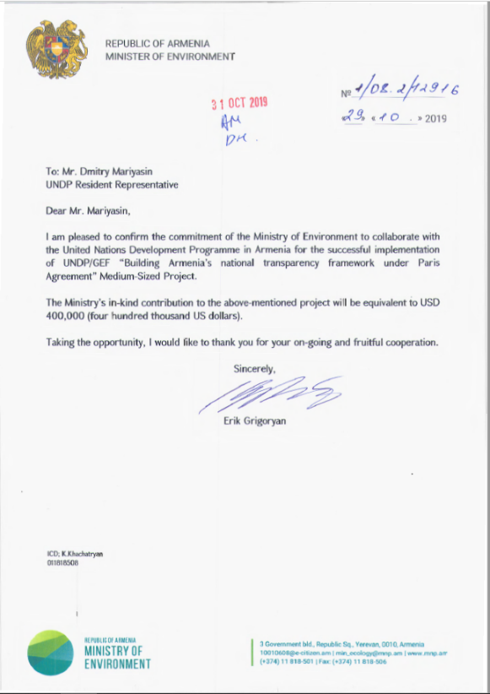
Annex 10: Co-Financing Letters from the Ministry of Environment and UNDP
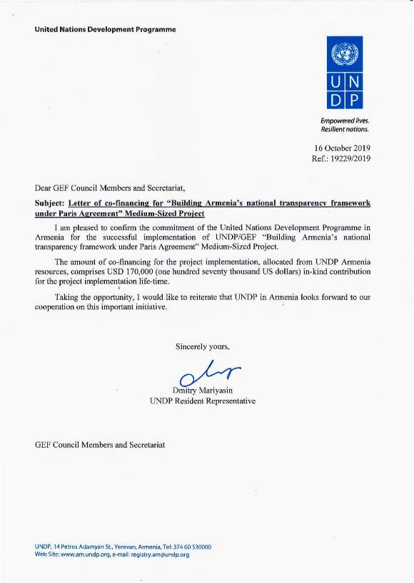

Annex 11: Theory of Change

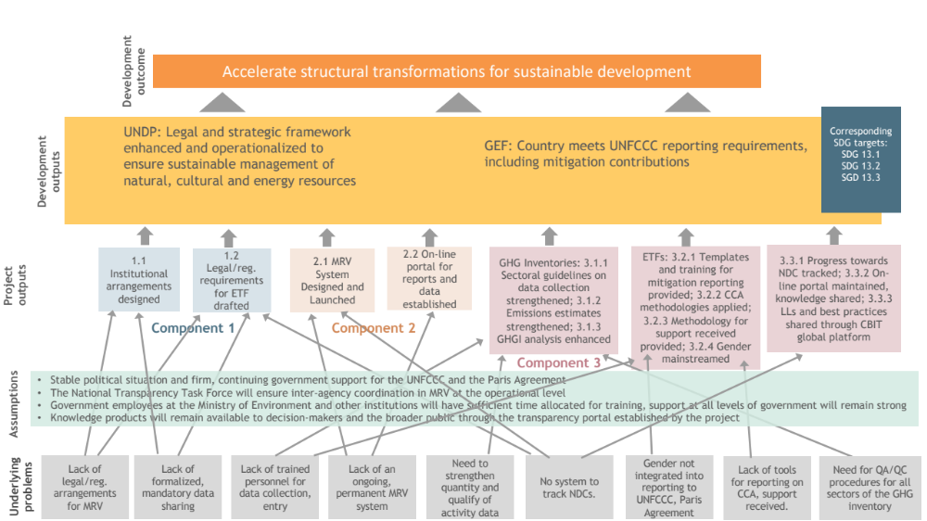

Annex 12: GEF Core indicators

Core Indicator 11 | Number of direct beneficiaries disaggregated by gender as co-benefit of GEF investment |  |  |  |  | (Number)
 |  |  | Number
 |  |  | Expected |  | Achieved
 |  |  | PIF stage | Endorsement | TE
 |  | Female | 65 | 65
 |  | Male | 55 | 55
 |  | Total | 120 | 120

Annex 13: GEF 7 Taxonomy

Level 1 | Level 2 | Level 3 | Level 4
Influencing models
 | Transform policy and regulatory environments
 | Strengthen institutional capacity and decision-making
 | Convene multi-stakeholder alliances
 | Demonstrate innovative approaches
 | Deploy innovative financial instruments
Stakeholders
 | Indigenous Peoples
 | Private Sector
 |  | Capital providers
 |  | Financial intermediaries and market facilitators
 |  | Large corporations
 |  | SMEs
 |  | Individuals/Entrepreneurs
 |  | Non-Grant Pilot
 |  | Project Reflow
 | Beneficiaries
 | Local Communities
 | Civil Society
 |  | Community Based Organization
 |  | Non-Governmental Organization
 |  | Academia
 |  | Trade Unions and Workers Unions
 | Type of Engagement
 |  | Information Dissemination
 |  | Partnership
 |  | Consultation
 |  | Participation
 | Communications
 |  | Awareness Raising
 |  | Education
 |  | Public Campaigns
 |  | Behavior Change
Capacity, Knowledge and Research
 | Enabling Activities
 | Capacity Development
 | Knowledge Generation and Exchange
 | Targeted Research
 | Learning
 |  | Theory of Change
 |  | Adaptive Management
 |  | Indicators to Measure Change
 | Innovation
 | Knowledge and Learning
 |  | Knowledge Management
 |  | Innovation
 |  | Capacity Development
 |  | Learning
 | Stakeholder Engagement Plan
Gender Equality
 | Gender Mainstreaming
 |  | Beneficiaries
 |  | Women groups
 |  | Sex-disaggregated indicators
 |  | Gender-sensitive indicators
 | Gender results areas
 |  | Access and control over natural resources
 |  | Participation and leadership
 |  | Access to benefits and services
 |  | Capacity development
 |  | Awareness raising
 |  | Knowledge generation
Focal Areas/Theme
 | Integrated Programs
 |  | Commodity Supply Chains (Good Growth Partnership)
 |  |  | Sustainable Commodities Production
 |  |  | Deforestation-free Sourcing
 |  |  | Financial Screening Tools
 |  |  | High Conservation Value Forests
 |  |  | High Carbon Stocks Forests
 |  |  | Soybean Supply Chain
 |  |  | Oil Palm Supply Chain
 |  |  | Beef Supply Chain
 |  |  | Smallholder Farmers
 |  |  | Adaptive Management
 |  | Food Security in Sub-Sahara Africa
 |  |  | Resilience (climate and shocks)
 |  |  | Sustainable Production Systems
 |  |  | Agroecosystems
 |  |  | Land and Soil Health
 |  |  | Diversified Farming
 |  |  | Integrated Land and Water Management
 |  |  | Smallholder Farming
 |  |  | Small and Medium Enterprises
 |  |  | Crop Genetic Diversity
 |  |  | Food Value Chains
 |  |  | Gender Dimensions
 |  |  | Multi-stakeholder Platforms
 |  | Food Systems, Land Use and Restoration
 |  |  | Sustainable Food Systems
 |  |  | Landscape Restoration
 |  |  | Sustainable Commodity Production
 |  |  | Comprehensive Land Use Planning
 |  |  | Integrated Landscapes
 |  |  | Food Value Chains
 |  |  | Deforestation-free Sourcing
 |  |  | Smallholder Farmers
 |  | Sustainable Cities
 |  |  | Integrated urban planning
 |  |  | Urban sustainability framework
 |  |  | Transport and Mobility
 |  |  | Buildings
 |  |  | Municipal waste management
 |  |  | Green space
 |  |  | Urban Biodiversity
 |  |  | Urban Food Systems
 |  |  | Energy efficiency
 |  |  | Municipal Financing
 |  |  | Global Platform for Sustainable Cities
 |  |  | Urban Resilience
 | Biodiversity
 |  | Protected Areas and Landscapes
 |  |  | Terrestrial Protected Areas
 |  |  | Coastal and Marine Protected Areas
 |  |  | Productive Landscapes
 |  |  | Productive Seascapes
 |  |  | Community Based Natural Resource Management
 |  | Mainstreaming
 |  |  | Extractive Industries (oil, gas, mining)
 |  |  | Forestry (Including HCVF and REDD+)
 |  |  | Tourism
 |  |  | Agriculture & agrobiodiversity
 |  |  | Fisheries
 |  |  | Infrastructure
 |  |  | Certification (National Standards)
 |  |  | Certification (International Standards)
 |  | Species
 |  |  | Illegal Wildlife Trade
 |  |  | Threatened Species
 |  |  | Wildlife for Sustainable Development
 |  |  | Crop Wild Relatives
 |  |  | Plant Genetic Resources
 |  |  | Animal Genetic Resources
 |  |  | Livestock Wild Relatives
 |  |  | Invasive Alien Species (IAS)
 |  | Biomes
 |  |  | Mangroves
 |  |  | Coral Reefs
 |  |  | Sea Grasses
 |  |  | Wetlands
 |  |  | Rivers
 |  |  | Lakes
 |  |  | Tropical Rain Forests
 |  |  | Tropical Dry Forests
 |  |  | Temperate Forests
 |  |  | Grasslands
 |  |  | Paramo
 |  |  | Desert
 |  | Financial and Accounting
 |  |  | Payment for Ecosystem Services
 |  |  | Natural Capital Assessment and Accounting
 |  |  | Conservation Trust Funds
 |  |  | Conservation Finance
 |  | Supplementary Protocol to the CBD
 |  |  | Biosafety
 |  |  | Access to Genetic Resources Benefit Sharing
 | Forests
 |  | Forest and Landscape Restoration
 |  |  | REDD/REDD+
 |  | Forest
 |  |  | Amazon
 |  |  | Congo
 |  |  | Drylands
 | Land Degradation
 |  | Sustainable Land Management
 |  |  | Restoration and Rehabilitation of Degraded Lands
 |  |  | Ecosystem Approach
 |  |  | Integrated and Cross-sectoral approach
 |  |  | Community-Based NRM
 |  |  | Sustainable Livelihoods
 |  |  | Income Generating Activities
 |  |  | Sustainable Agriculture
 |  |  | Sustainable Pasture Management
 |  |  | Sustainable Forest/Woodland Management
 |  |  | Improved Soil and Water Management Techniques
 |  |  | Sustainable Fire Management
 |  |  | Drought Mitigation/Early Warning
 |  | Land Degradation Neutrality
 |  |  | Land Productivity
 |  |  | Land Cover and Land cover change
 |  |  | Carbon stocks above or below ground
 |  | Food Security
 | International Waters
 |  | Ship
 |  | Coastal
 |  | Freshwater
 |  |  | Aquifer
 |  |  | River Basin
 |  |  | Lake Basin
 |  | Learning
 |  | Fisheries
 |  | Persistent toxic substances
 |  | SIDS : Small Island Dev States
 |  | Targeted Research
 |  | Pollution
 |  |  | Persistent toxic substances
 |  |  | Plastics
 |  |  | Nutrient pollution from all sectors except wastewater
 |  |  | Nutrient pollution from Wastewater
 |  | Transboundary Diagnostic Analysis and Strategic Action Plan preparation
 |  | Strategic Action Plan Implementation
 |  | Areas Beyond National Jurisdiction
 |  | Large Marine Ecosystems
 |  | Private Sector
 |  | Aquaculture
 |  | Marine Protected Area
 |  | Biomes
 |  |  | Mangrove
 |  |  | Coral Reefs
 |  |  | Seagrasses
 |  |  | Polar Ecosystems
 |  |  | Constructed Wetlands
 | Chemicals and Waste
 |  | Mercury
 |  | Artisanal and Scale Gold Mining
 |  | Coal Fired Power Plants
 |  | Coal Fired Industrial Boilers
 |  | Cement
 |  | Non-Ferrous Metals Production
 |  | Ozone
 |  | Persistent Organic Pollutants
 |  | Unintentional Persistent Organic Pollutants
 |  | Sound Management of chemicals and Waste
 |  | Waste Management
 |  |  | Hazardous Waste Management
 |  |  | Industrial Waste
 |  |  | e-Waste
 |  | Emissions
 |  | Disposal
 |  | New Persistent Organic Pollutants
 |  | Polychlorinated Biphenyls
 |  | Plastics
 |  | Eco-Efficiency
 |  | Pesticides
 |  | DDT - Vector Management
 |  | DDT - Other
 |  | Industrial Emissions
 |  | Open Burning
 |  | Best Available Technology / Best Environmental Practices
 |  | Green Chemistry
 | Climate Change
 |  | Climate Change Adaptation
 |  |  | Climate Finance
 |  |  | Least Developed Countries
 |  |  | Small Island Developing States
 |  |  | Disaster Risk Management
 |  |  | Sea-level rise
 |  |  | Climate Resilience
 |  |  | Climate information
 |  |  | Ecosystem-based Adaptation
 |  |  | Adaptation Tech Transfer
 |  |  | National Adaptation Programme of Action
 |  |  | National Adaptation Plan
 |  |  | Mainstreaming Adaptation
 |  |  | Private Sector
 |  |  | Innovation
 |  |  | Complementarity
 |  |  | Community-based Adaptation
 |  |  | Livelihoods
 |  | Climate Change Mitigation
 |  |  | Agriculture, Forestry, and other Land Use
 |  |  | Energy Efficiency
 |  |  | Sustainable Urban Systems and Transport
 |  |  | Technology Transfer
 |  |  | Renewable Energy
 |  |  | Financing
 |  |  | Enabling Activities
 |  | Technology Transfer
 |  |  | Poznan Strategic Programme on Technology Transfer
 |  |  | Climate Technology Centre & Network (CTCN)
 |  |  | Endogenous technology
 |  |  | Technology Needs Assessment
 |  |  | Adaptation Tech Transfer
 |  | United Nations Framework on Climate Change
Nationally Determined Contribution
Capacity Building Initiative for Transparency (CBIT)
 |  |  | Paris Agreement
 |  |  | Sustainable Development Goals
 |  | Climate Finance (Rio Markers)
 |  |  | Climate Change Mitigation 1
 |  |  | Climate Change Mitigation 2
 |  |  | Climate Change Adaptation 1
 |  |  | Climate Change Adaptation 2

Annex 14: Partners Capacity Assessment Tool and HACT assessment
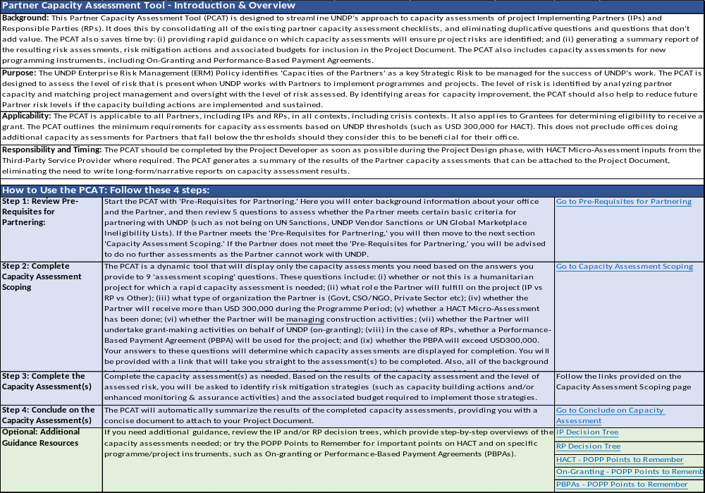
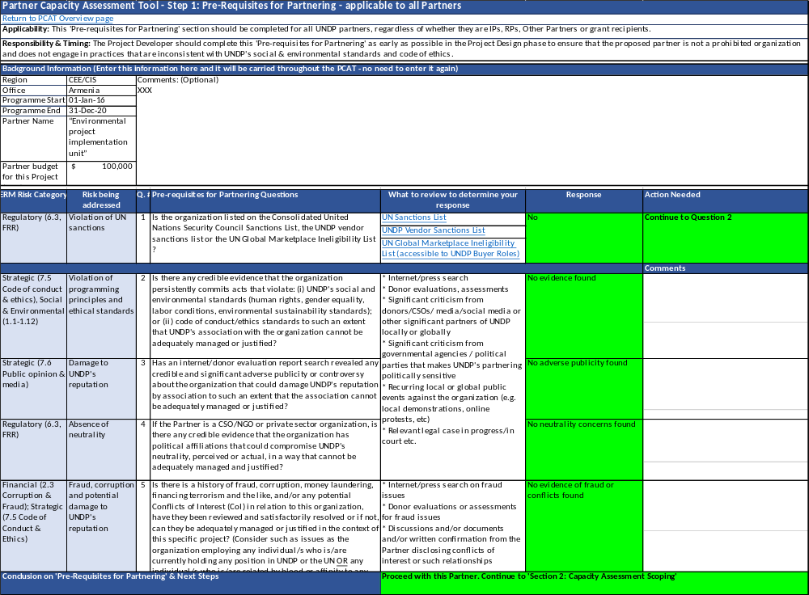
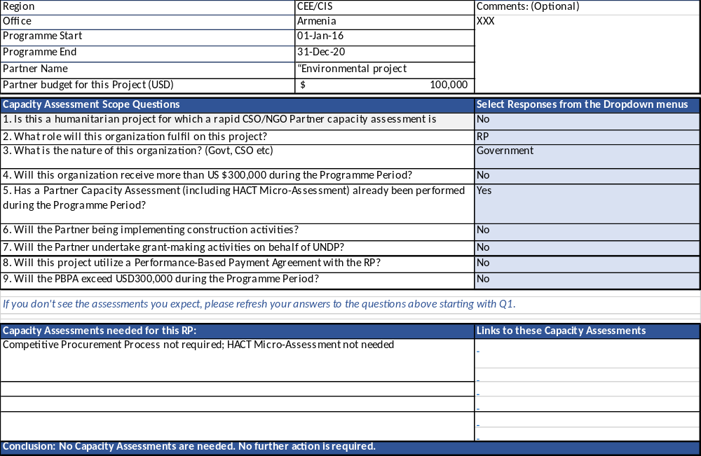
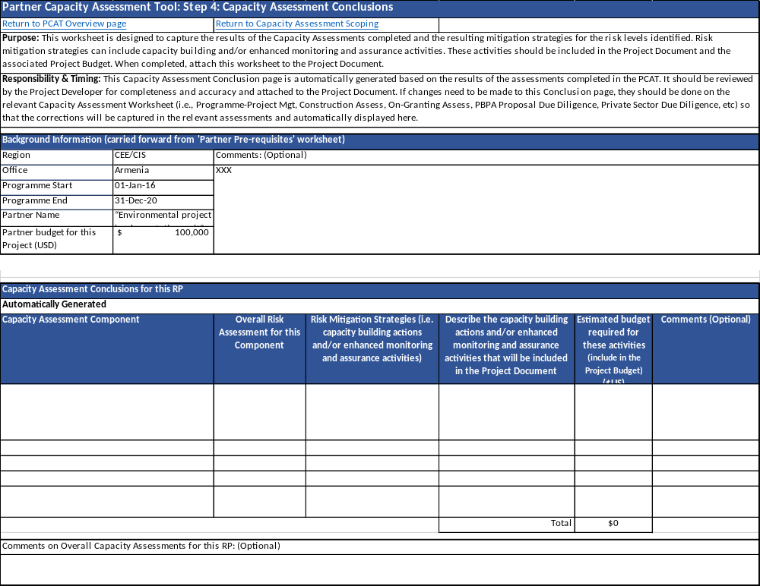
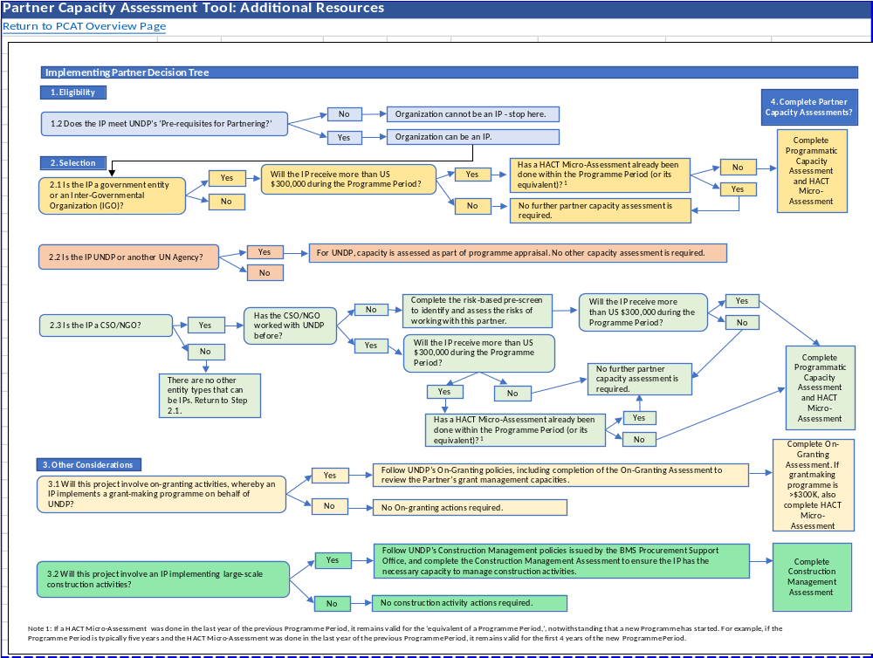
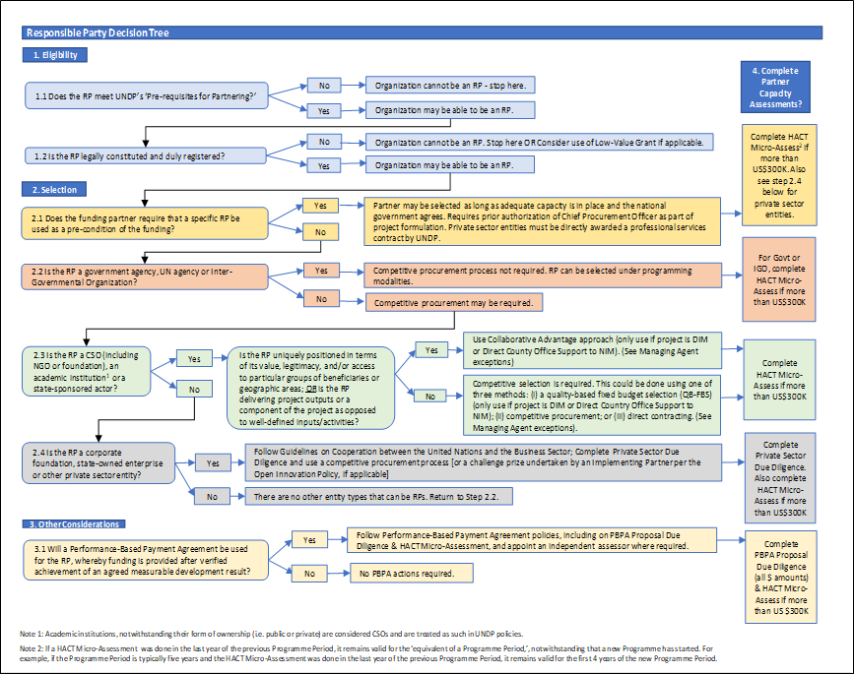
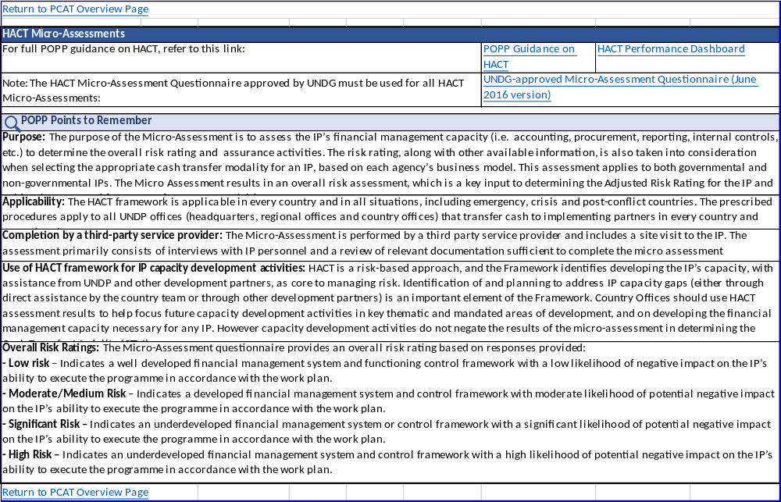
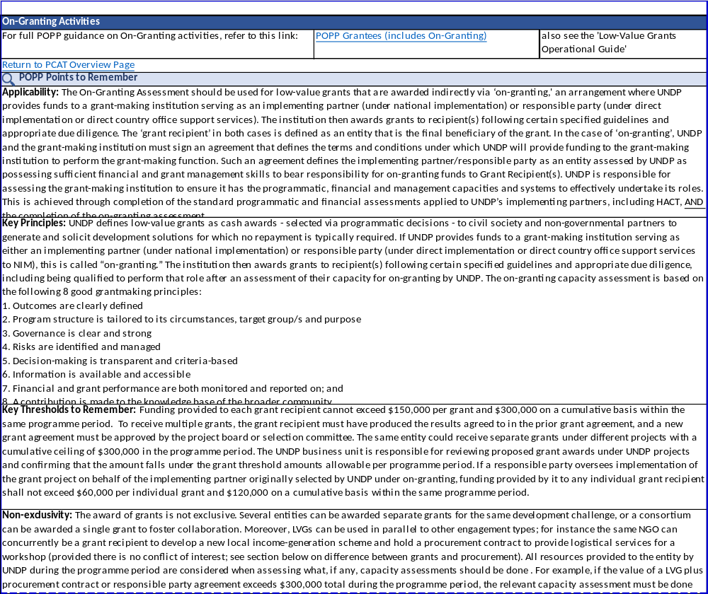
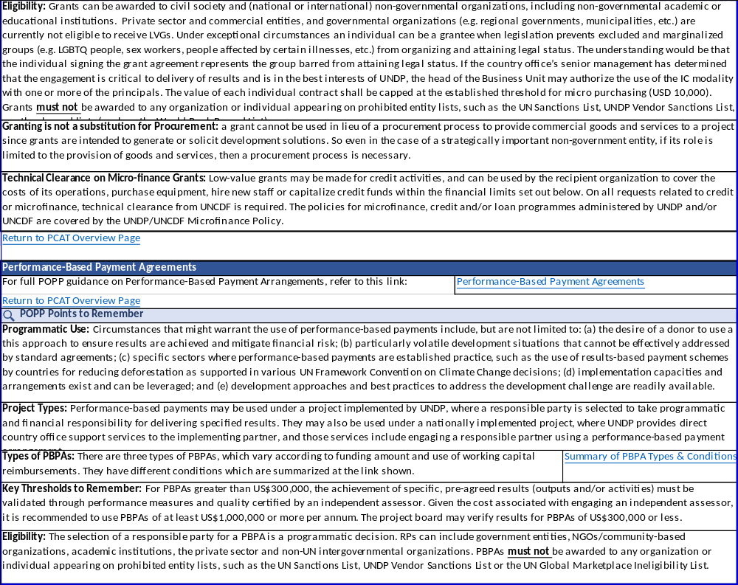

HACT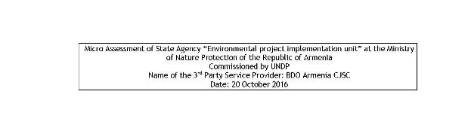
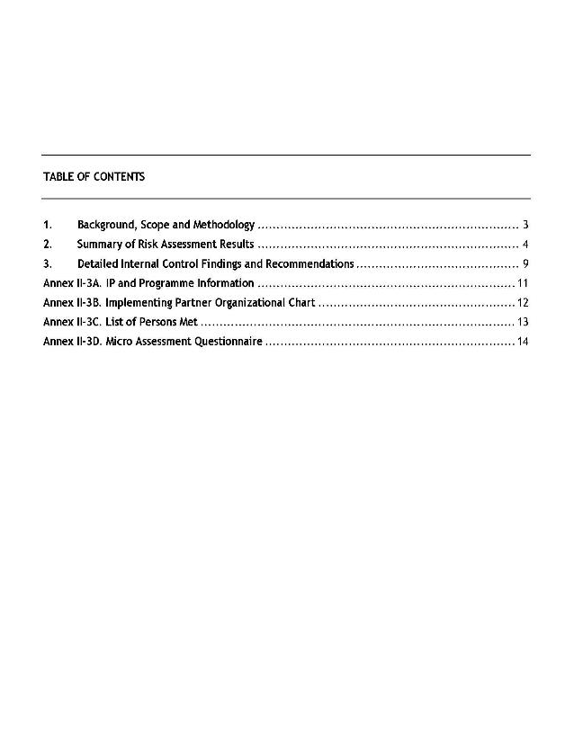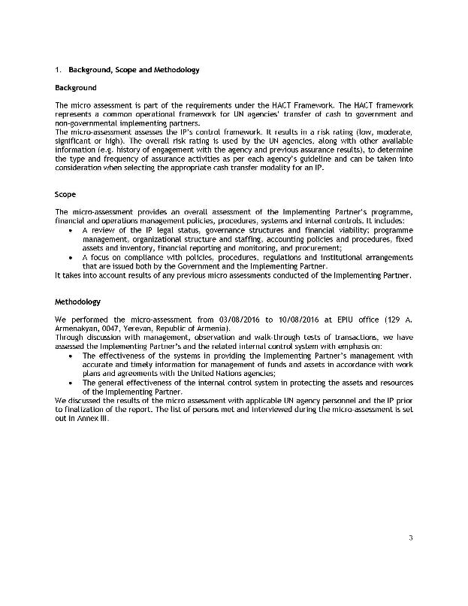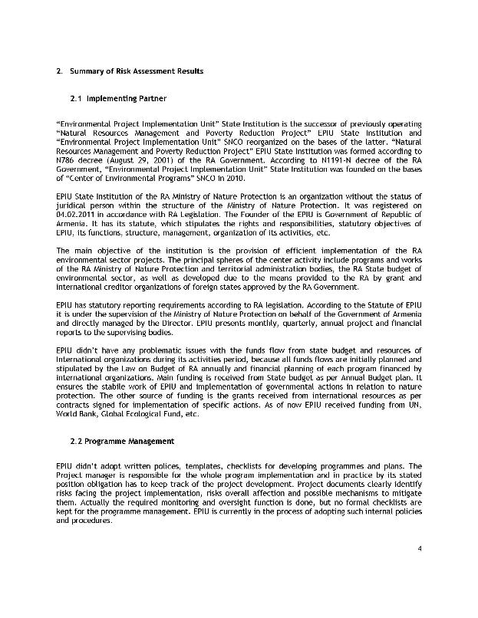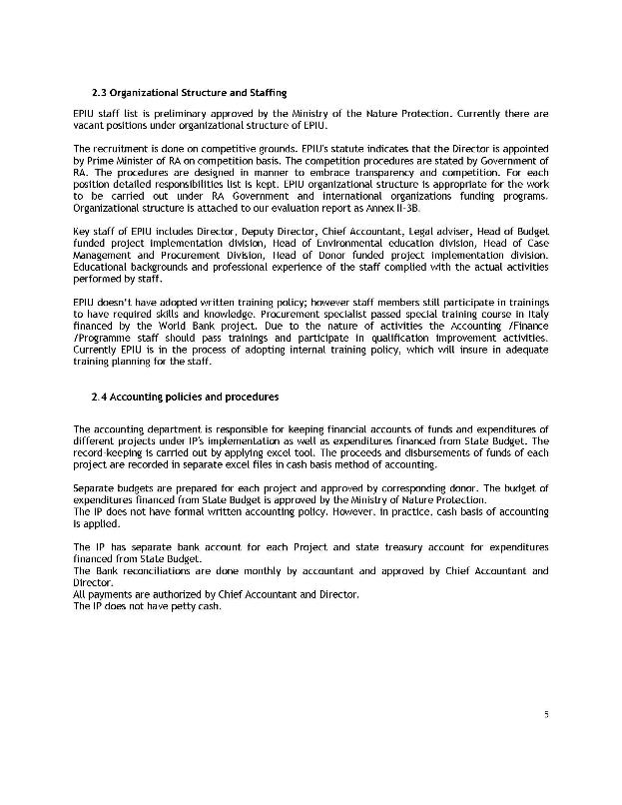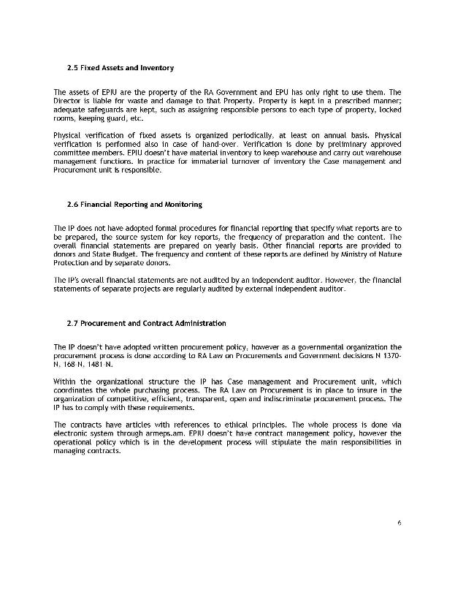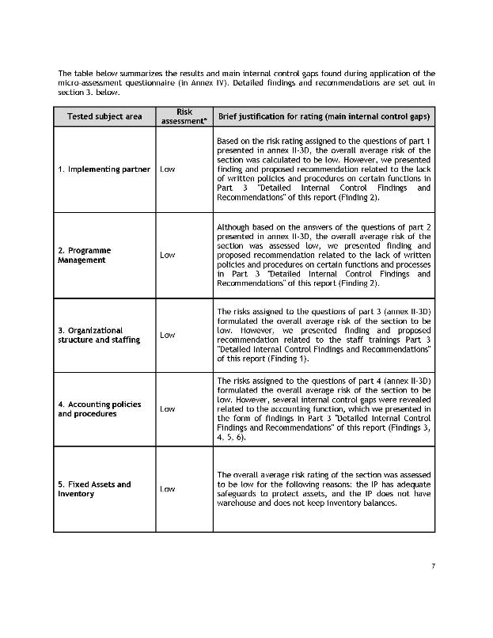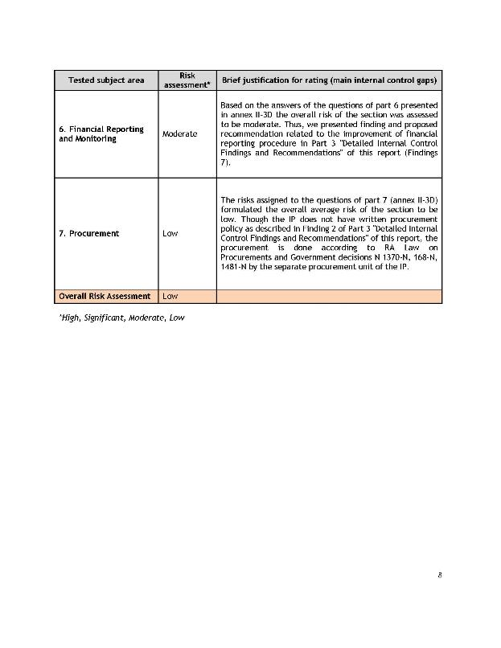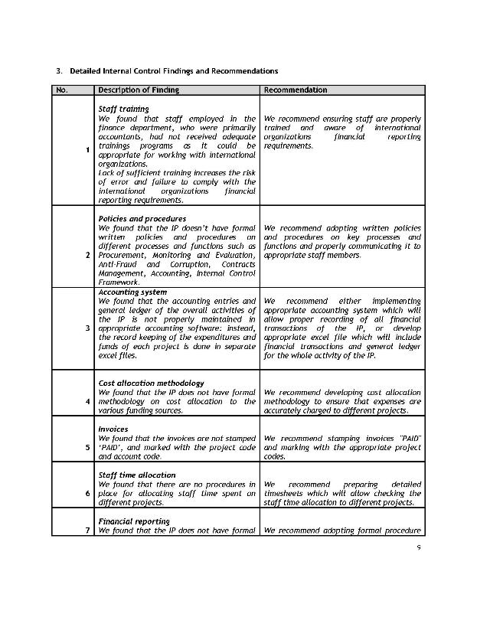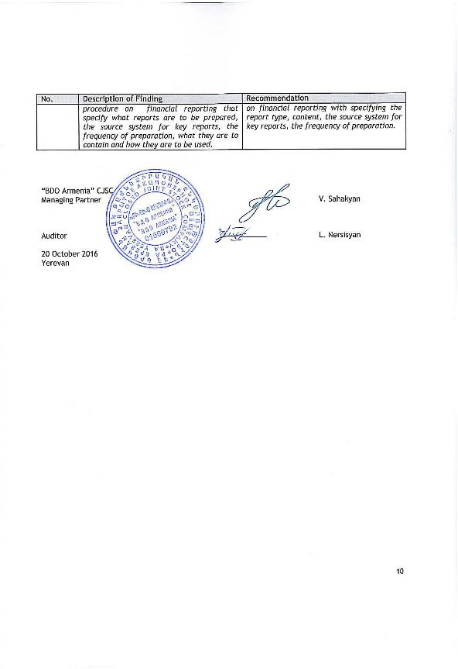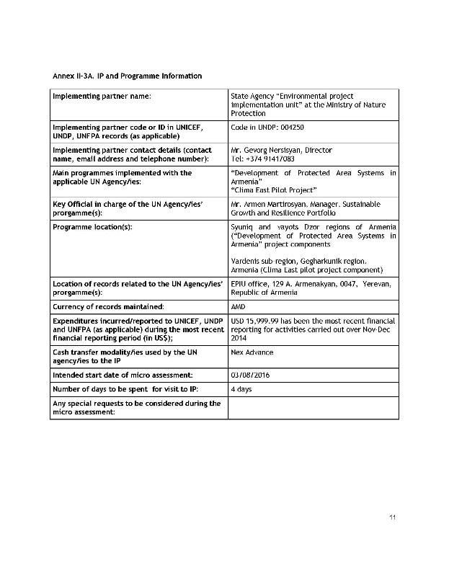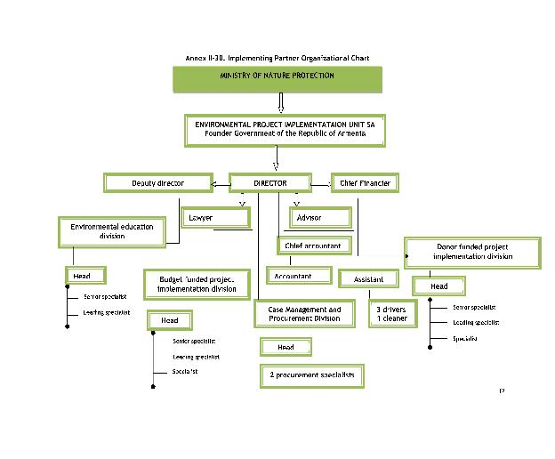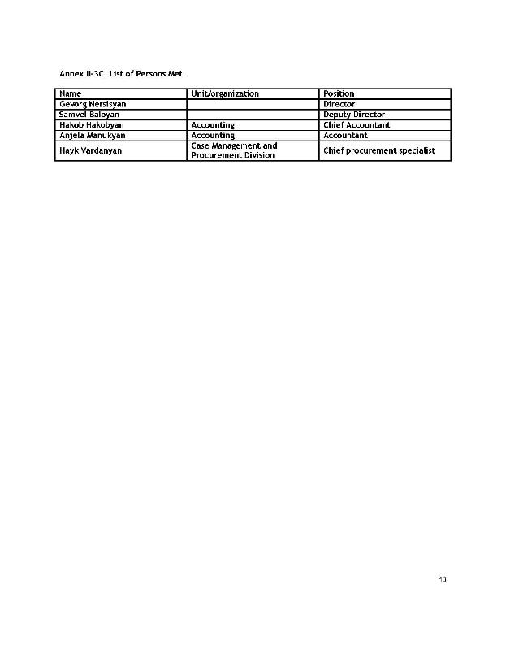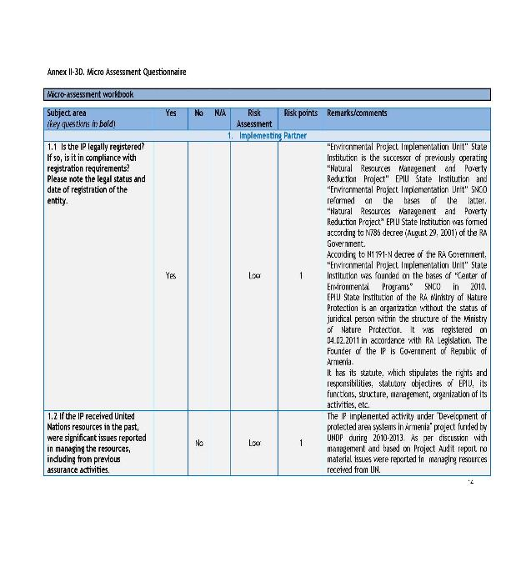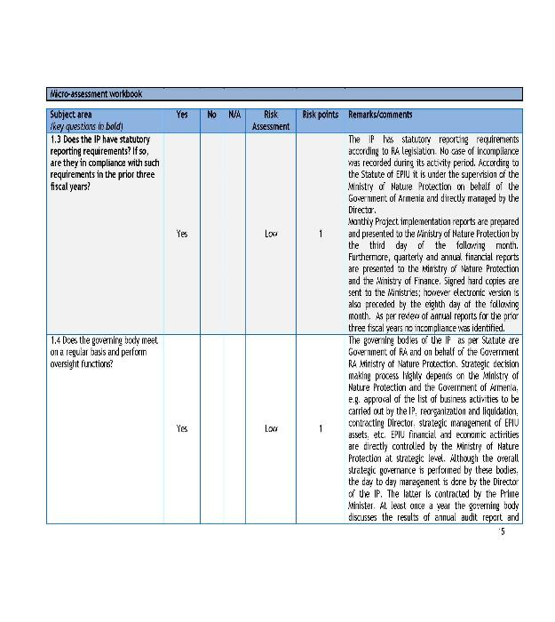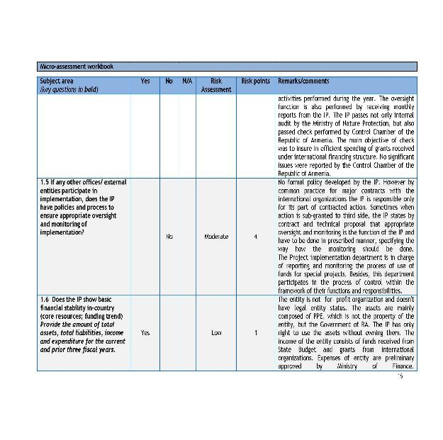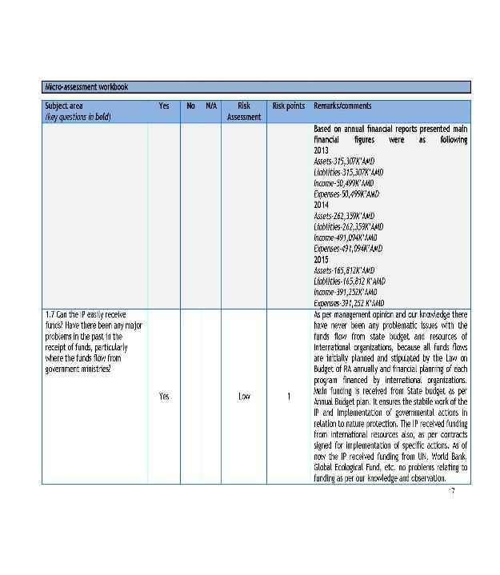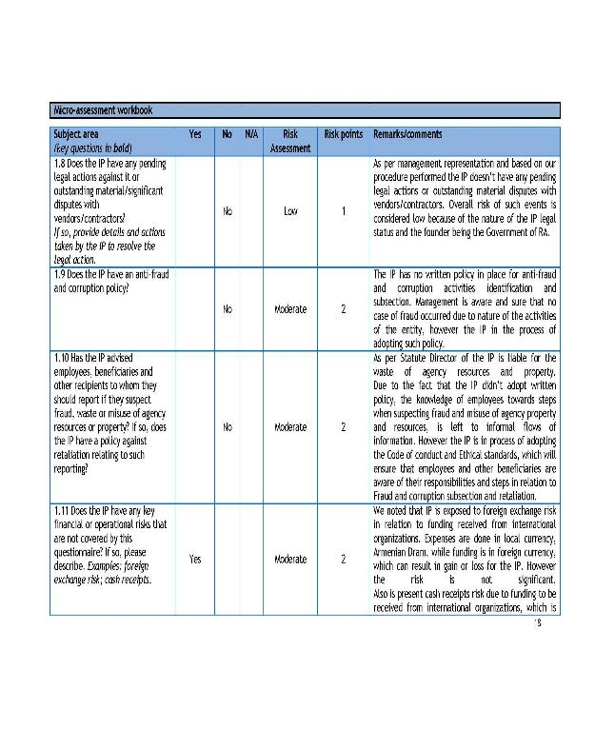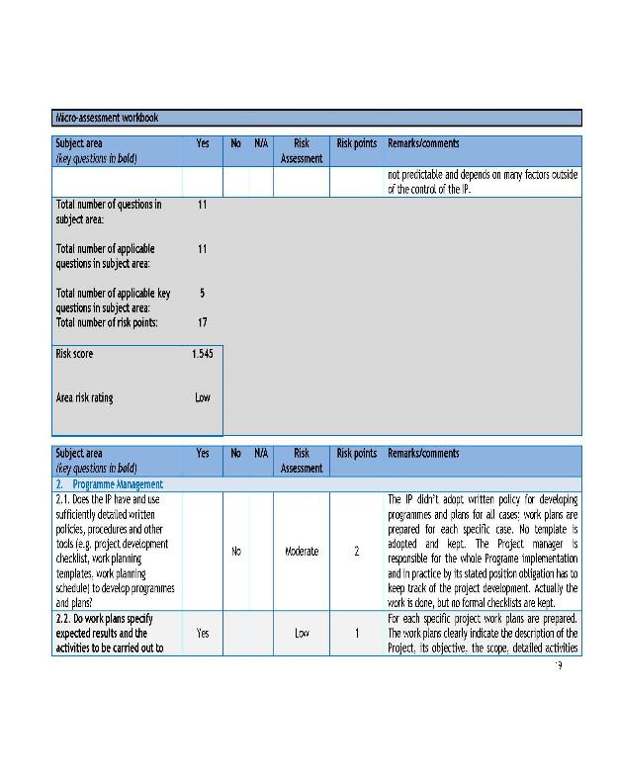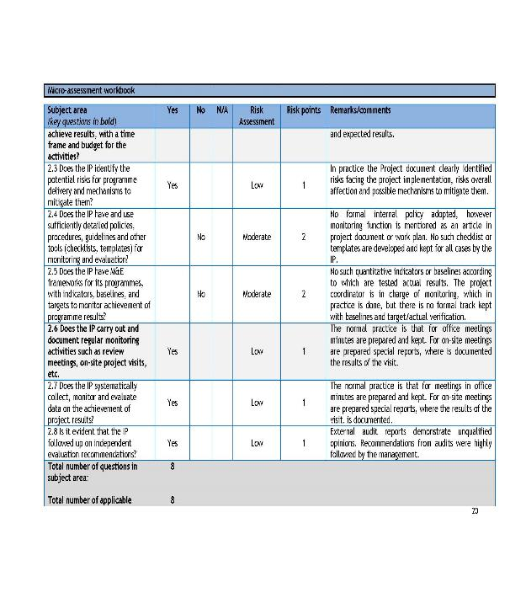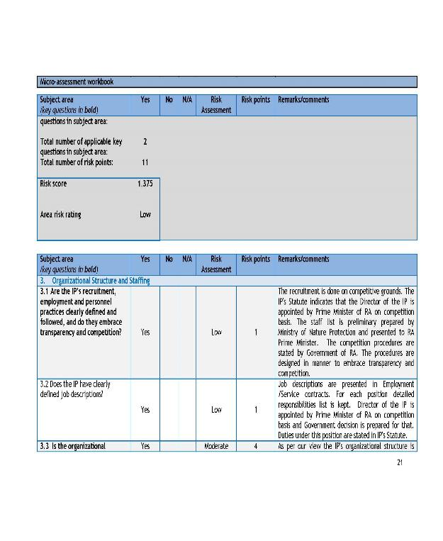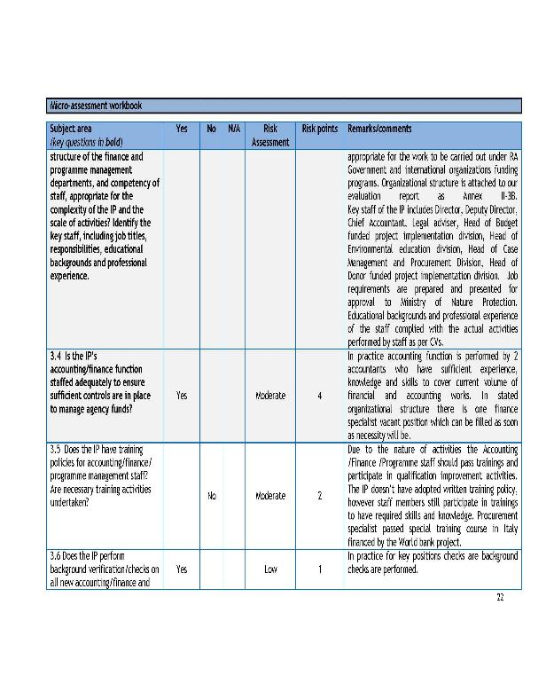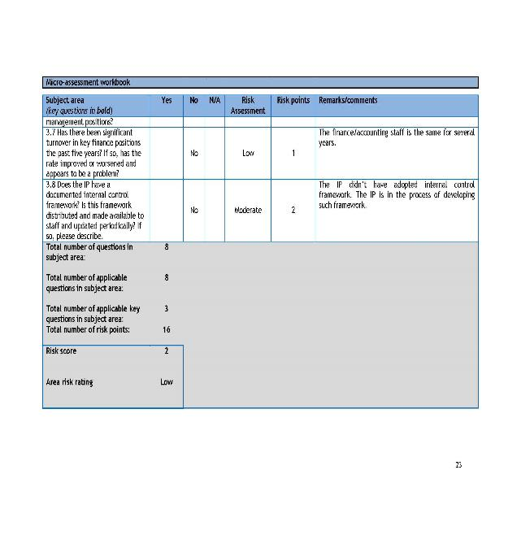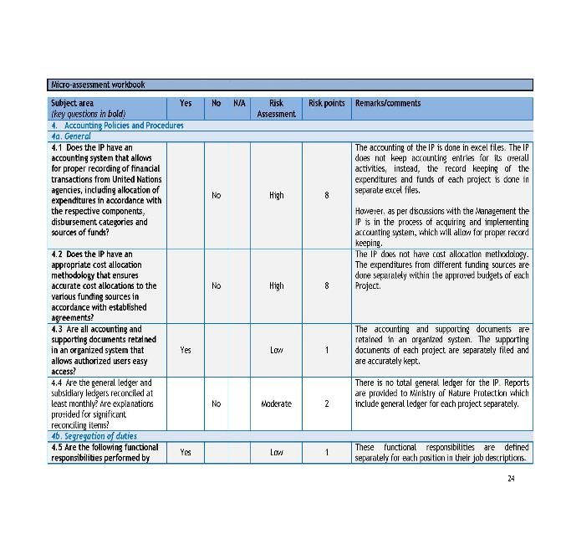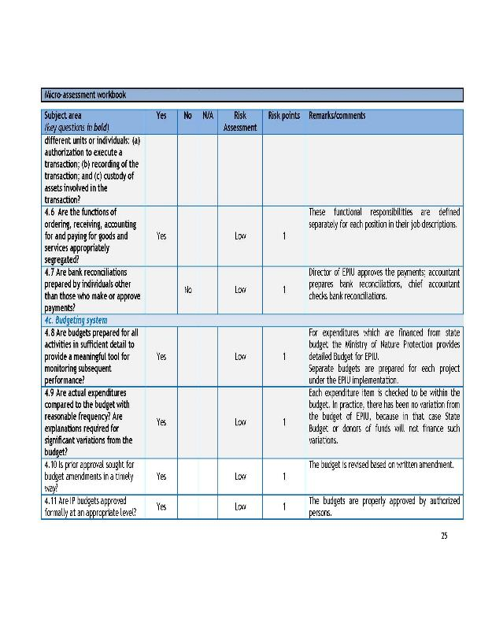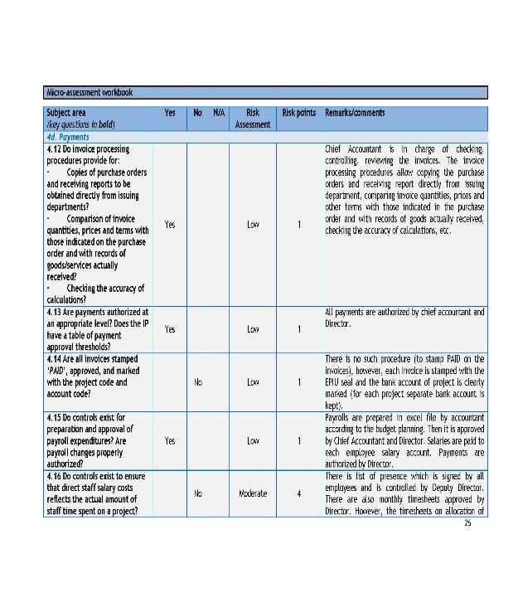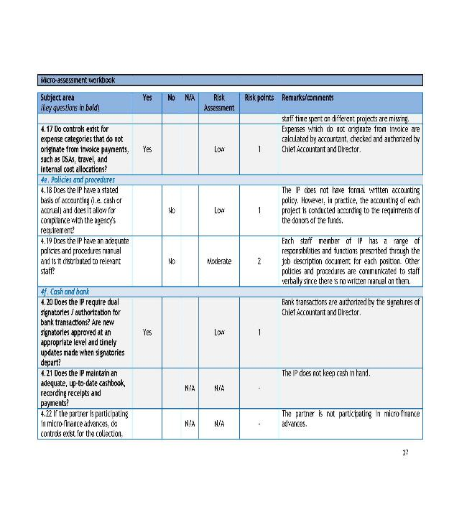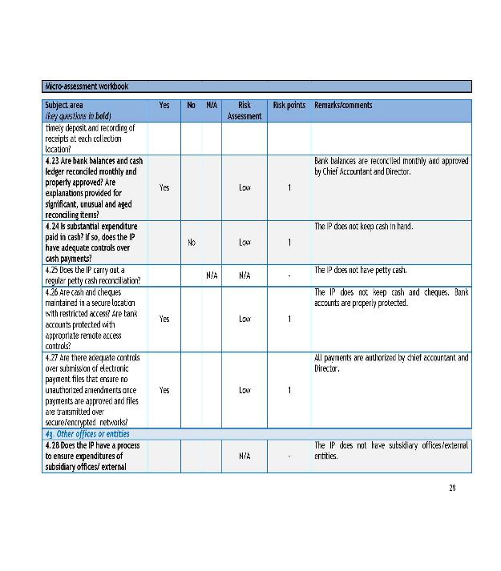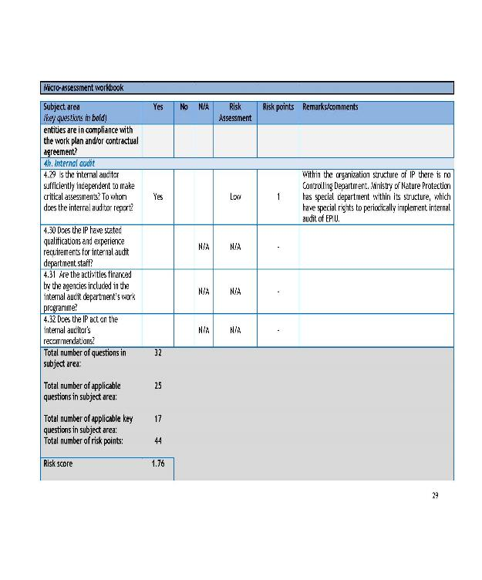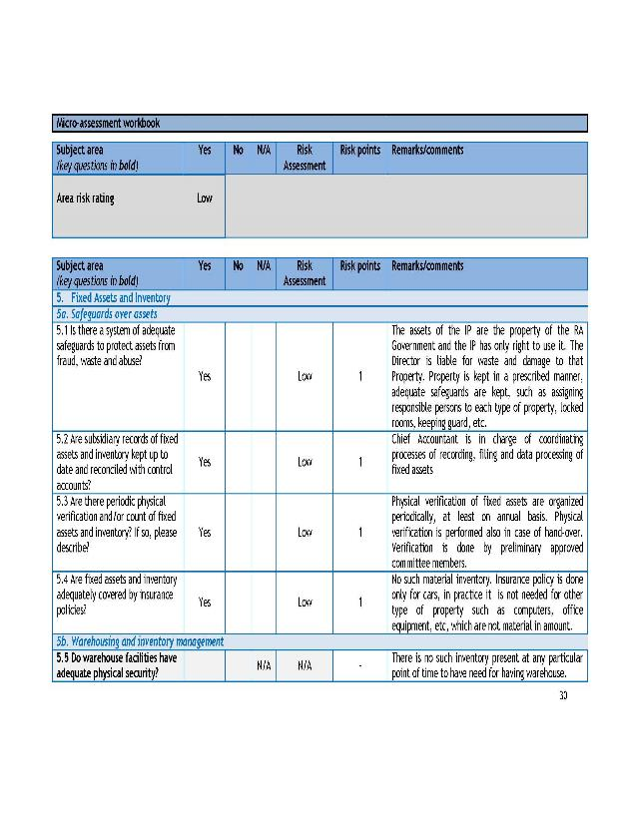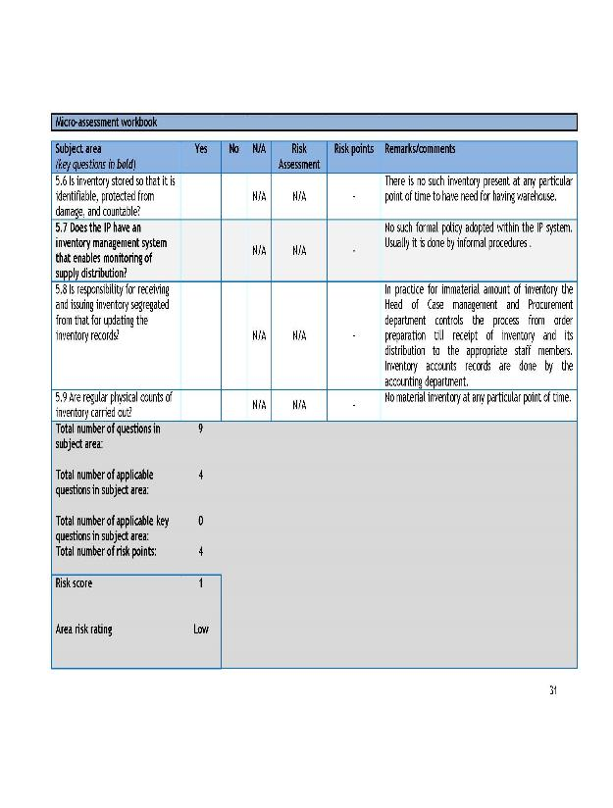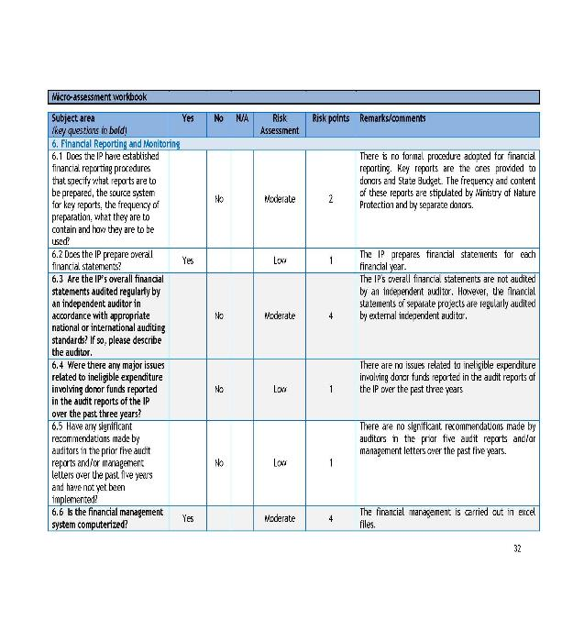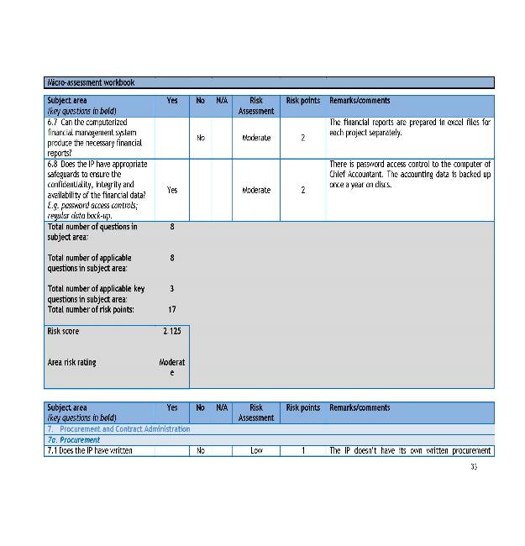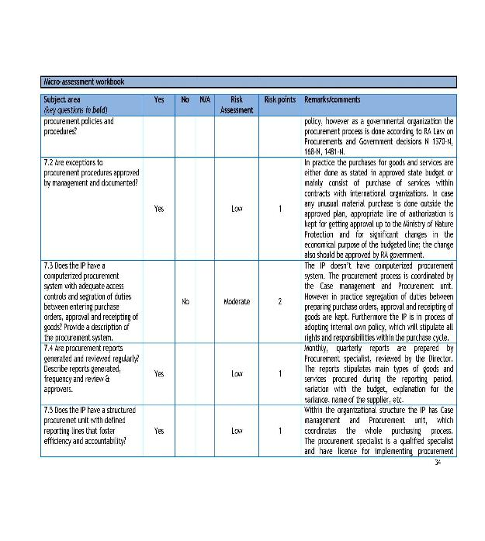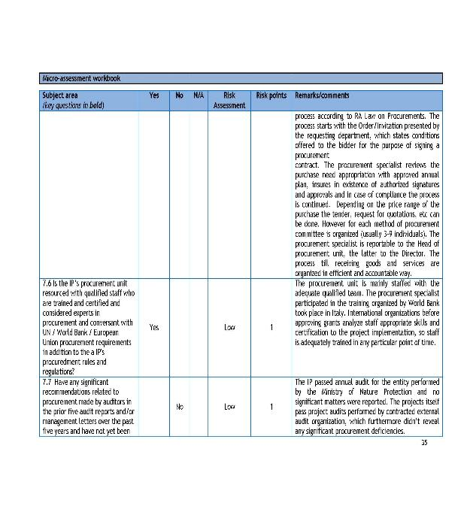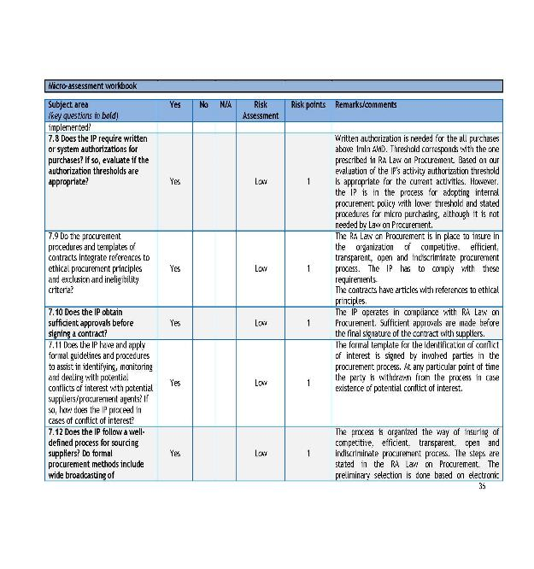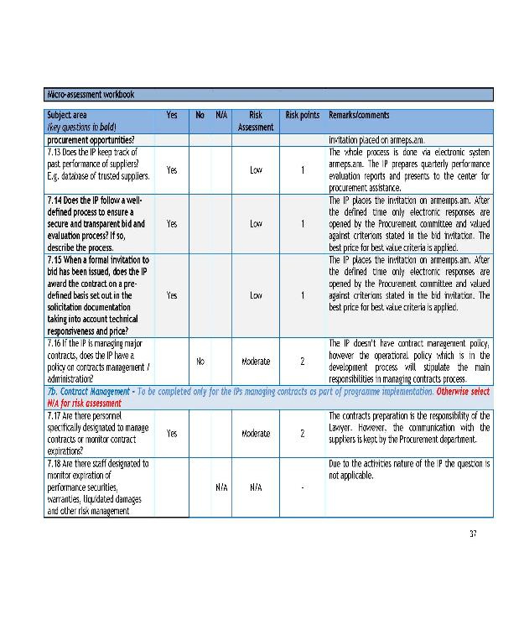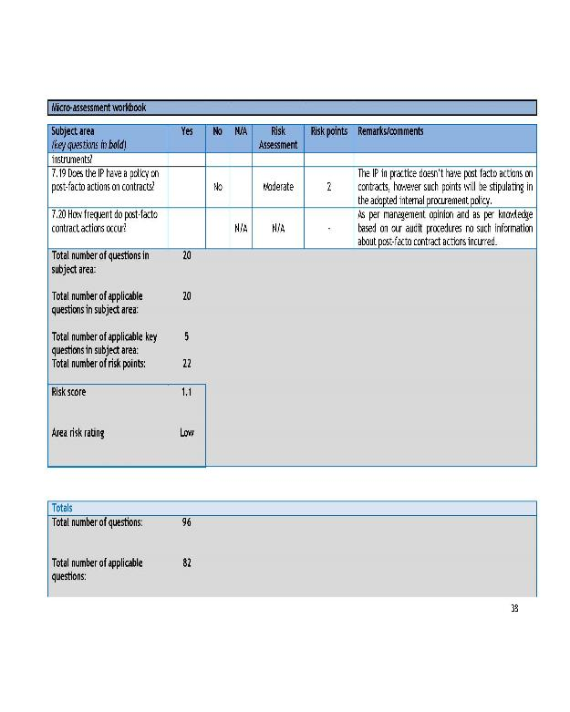

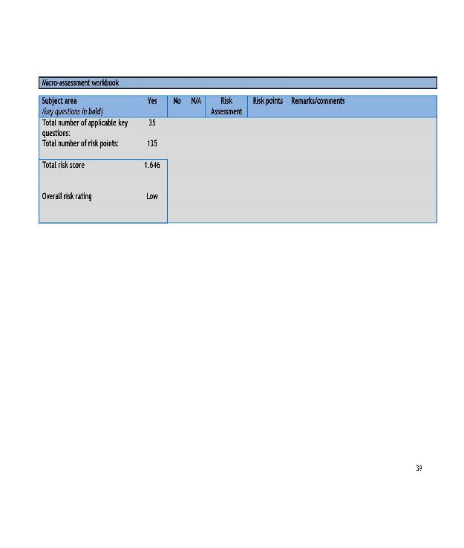

Annex 15: UNDP Project Quality Assurance Report

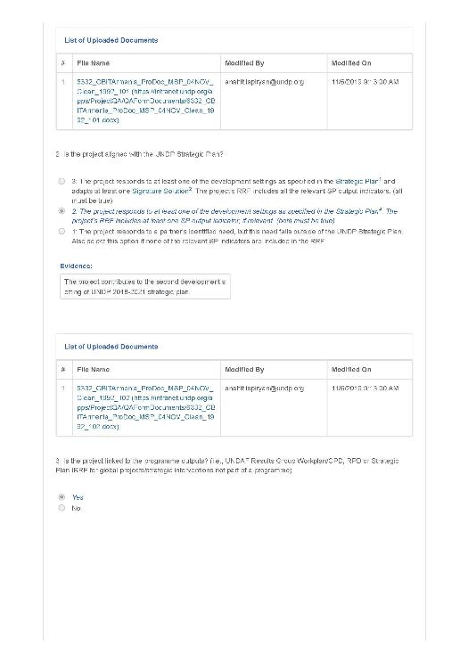
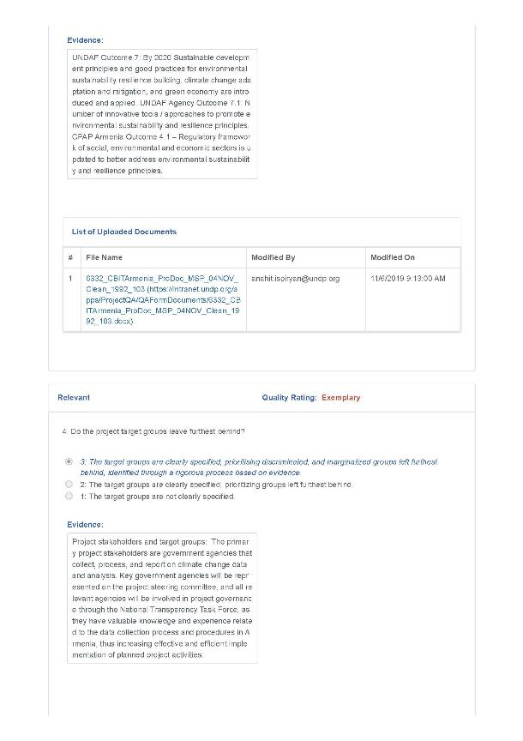
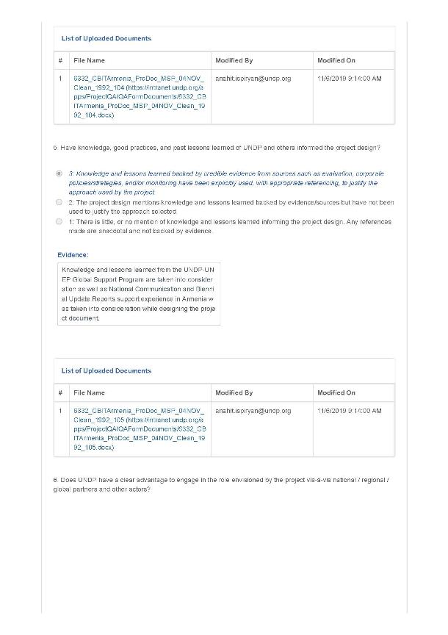
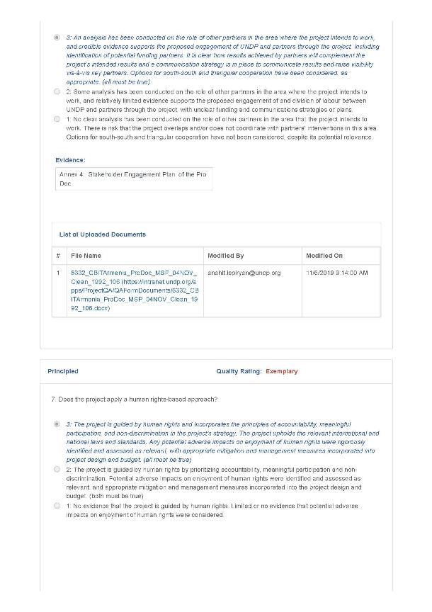
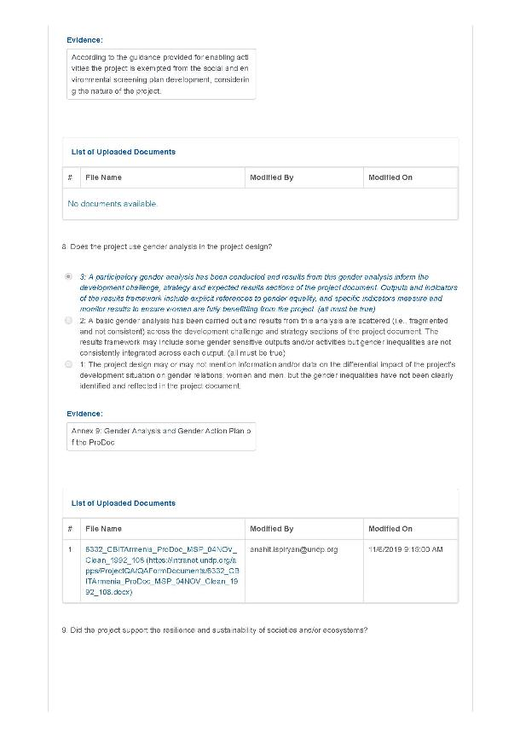
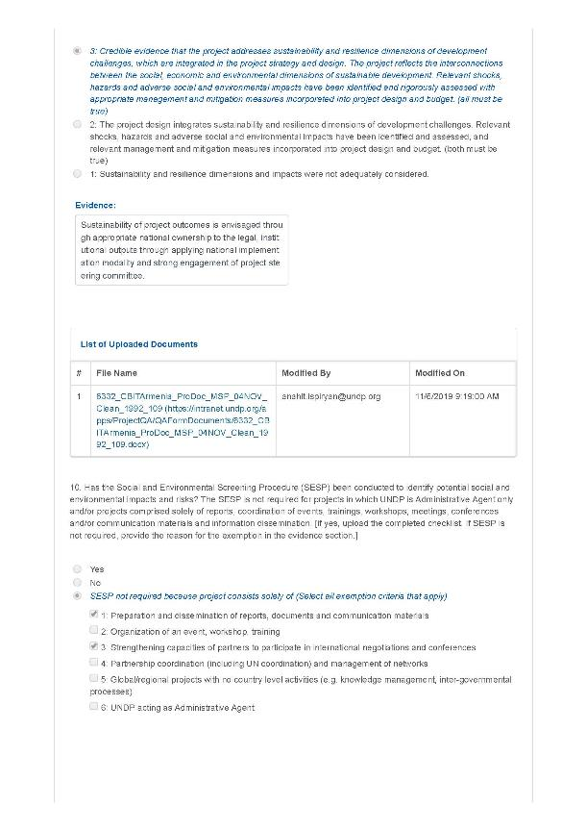
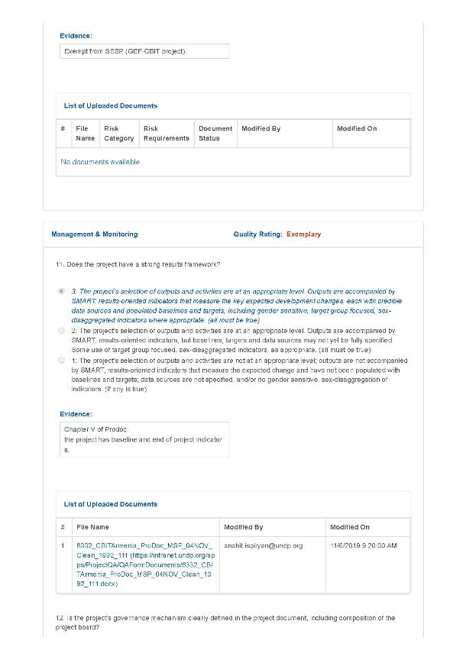
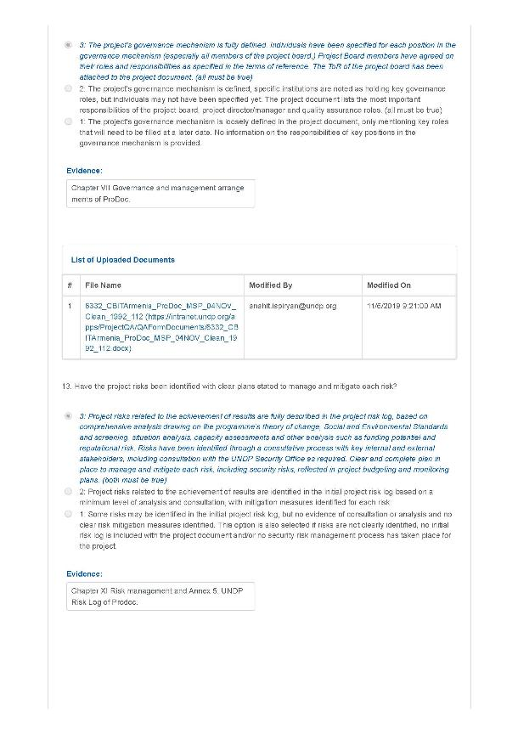
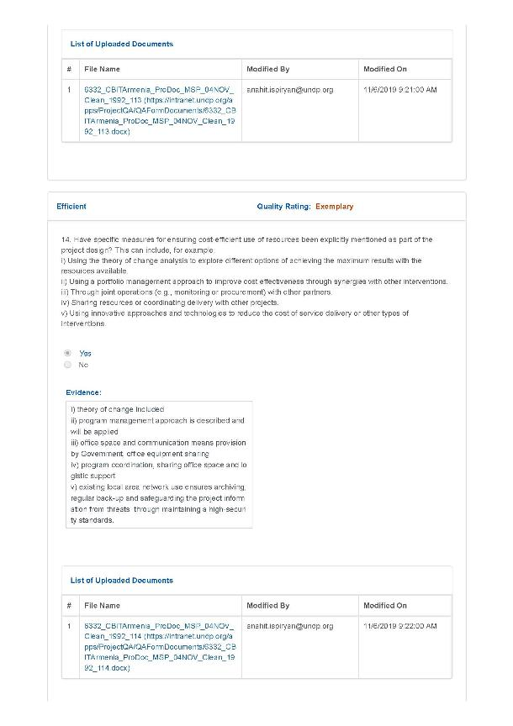
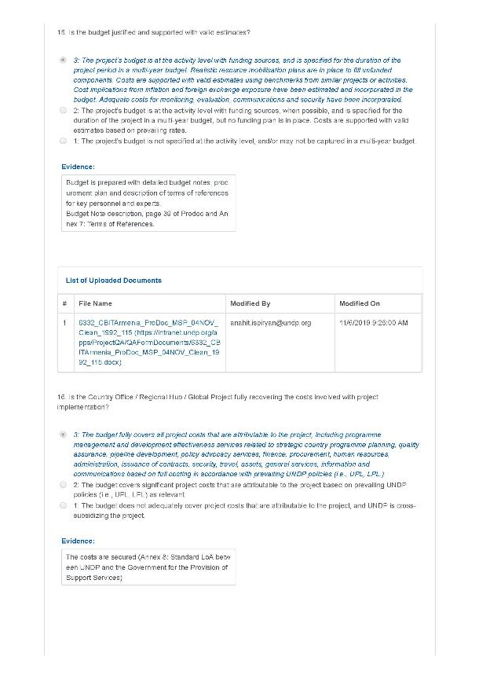
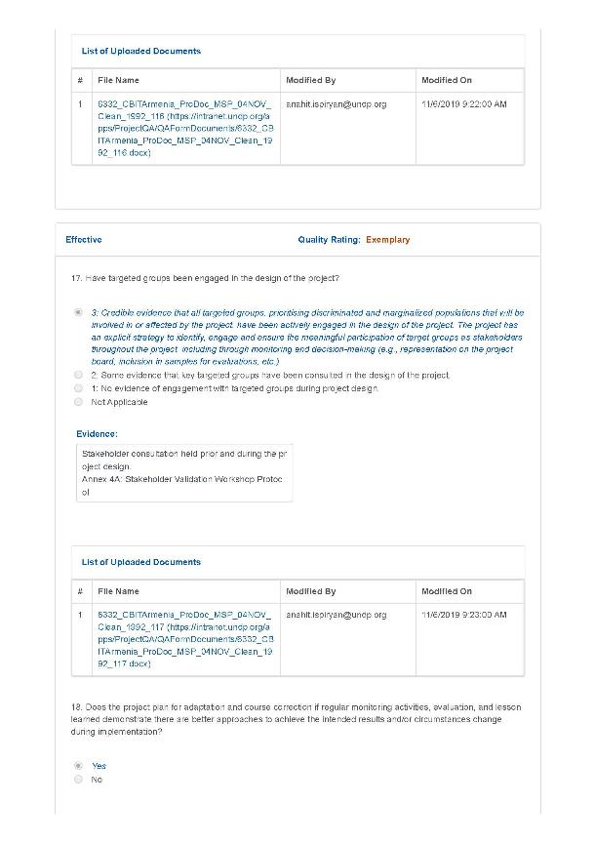
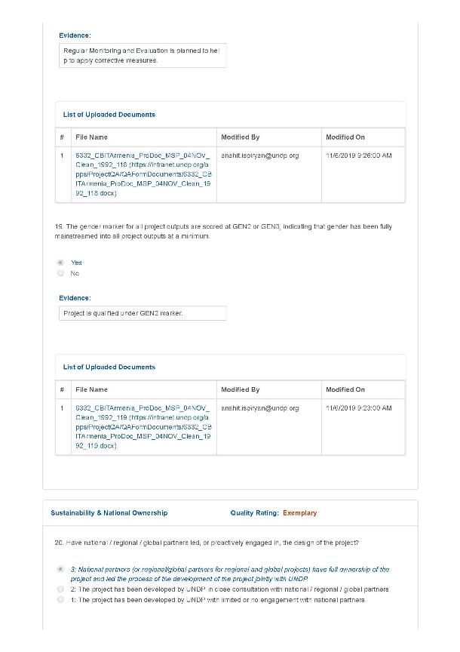
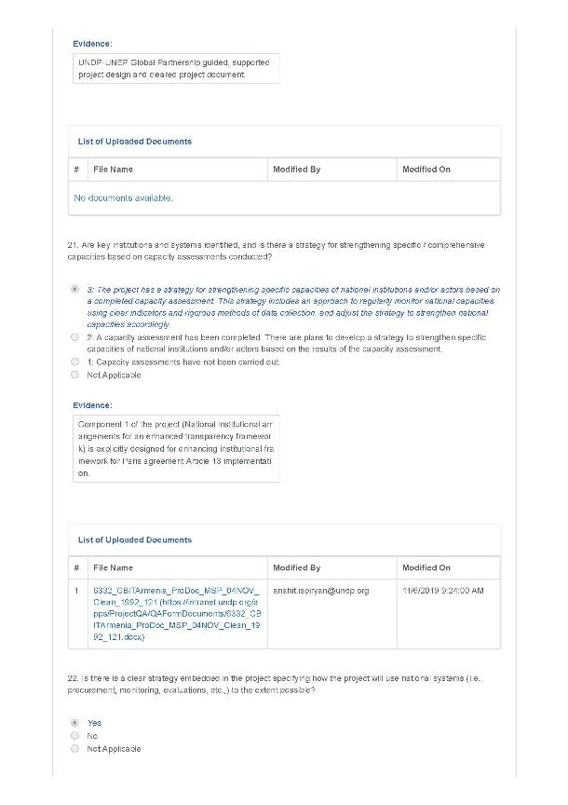
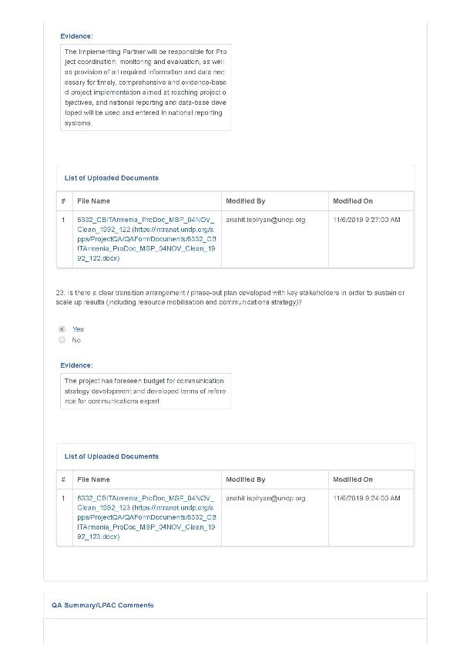


UNESCO (1999) Guidelines on Gender-Neutral Language.
https://panorama.solutions/en
https://www.covenantofmayors.eu/plans-and-actions/good-practices.html
See https://www.thegef.org/gef/policies_guidelines
See http://www.undp.org/content/undp/en/home/operations/transparency/information_disclosurepolicy/
See https://www.thegef.org/gef/policies_guidelines
Or equivalent for regional or global project
The costs of UNDP CO and UNDP-GEF Unit’s participation and time are charged to the GEF Agency Fee.
See https://popp.undp.org/_layouts/15/WopiFrame.aspx?sourcedoc=/UNDP_POPP_DOCUMENT_LIBRARY/Public/PPM_Project%20Management_Closing.docx&action=default.
Data collection methods should outline specific tools used to collect data and additional information as necessary to support monitoring. The PIR cannot be used as a source of verification.
The following indicators complement outcome-level indicators with explicit attention to gender, which are already included in the project framework (Indicators 1, 6, 10, and 13).
GEF (2018). GEF Policy on Gender Equality.
World Bank (2016). Armenia Country Gender Assessment: The State of Gender Equality in Armenia.
HH ILCS, Armstat, 2008 and 2017 in Armstat (2018) Women and Men in Armenia: 2018.
Armstat (2018): 49-52.
World Bank (2016): 1.
Armstat (2018): 96.
OECD 2016. http://www.genderindex.org/ranking. Accessed May 4, 2018.
World Economic Forum (2017). Global Gender Gap Report.
UN Treaty Collection. https://treaties.un.org/Pages/ViewDetails.aspx?src=TREATY&mtdsg_no=IV- 8&chapter=4&lang=en and UN Women.
Council of Europe. Chart of signatures and ratifications of Treaty 005. http://www.coe.int/en/web/conventions/full- list/-/conventions/treaty/005/signatures?p_auth=s9uNDfa4.
Council of Europe. Chart of signatures and ratifications of Treaty 210. http://www.coe.int/en/web/conventions/full- list/-/conventions/treaty/210/signatures?p_auth=XNywEMSD
Republic of Armenia Gender Policy Strategic Action Plan for 2011-2015. http://www.un.am/res/Gender%20TG%20docs/national/2011-2015_Gender%20Policy_NAP-Eng.pdf.
http://www.undp.org/content/undp/en/home/sustainable-development-goals/goal-5-gender-equality/targets.html Accessed November 30, 2018.
ADB (2015): Armenia: Country Gender Assessment: 65.
http://www.ysu.am/gender/
UN Women (2017). “New Guidebook Launched to Boost Gender Mainstreaming.” https://unfccc.int/news/new-guidebook-launched-to-boost-gender-mainstreaming. Accessed December 2018.
UNFCCC (2018). FCCC/CP/2017/11/Add.1: 16.
Paris Agreement (2015). Preamble.
Ibid., Articles 7 and 11.
Nelson, G. (2015). Gender-Responsive National Communications Toolkit. UNDP
Huyer, S. (2016). Gender Equality in Climate Change Action: Planning for Gender-Responsive Nationally Determined Contributions. UNDP.
Mirzakhanyan (2019).
http://www.am.undp.org/content/armenia/en/home/stories/support-to-rural-communities--energy-efficient-greenhouses-.html Accessed December 2018.

